EVALUATION OF SOME ELECTROCARDIOGRAPHIC PARAMETERS OF KITTEN AND ADULT ANGORA CATS

Normal Electrocardiogram of Angora cats

Nurgul Atmaca^{1*} Ozkan Simsek¹ Sevket Arikan¹ Ruhi Kabakci¹

Two table and one figure was presented in the manuscript.

¹ Kirikkale University Faculty of Veterinary Medicine, Department of Physiology, 71451, Yahsihan-Kirikkale, Turkey.

*Corresponding author:
Assist. Prof. Dr. Nurgül Atmaca
e-mail: nurgulzengin@yahoo.com
tel no: +90 318 357 42 42/ 3306
fax no: +90 318 357 33 04

Abstract: Electrocardiography (ECG) used in the determination of cardiac abnormalities and is a fundamental part of clinical evaluation. The aim of this study was to determine reference ranges of ECG parameters in kitten and adult Angora cats and to check effect of age upon different ECG parameters.
In this study 14 kittens aged 2.5-3 months old and 14 adult cats aged between 2-3 years of age, a total of 28 healthy Angora cats were used. The three standard bipolar limb leads (I, II, III) and augmented unipolar limb leads (aVR, aVL, aVF) were recorded with the cats in right lateral recumbency position.
Duration and amplitude of P, T waves and QRS complex, PR and QT intervals, heart rhythm, the mean electrical axis (MEA) and heart rate were measured in lead II. In addition, in all leads were determined, configurations of P wave, QRS complex and T wave. Data was evaluated with Mann-Whitney U test because it was not provided in the normality of assumptions. The mean heart rate was 204.71±25.27 beats/ min in kittens and 182.07±14.54 beats/min in adult cats. The average value of the MEA was 103.36±25.32° in kittens and 80.21±19.53° in adult cats. Data from kitten and adult age groups were compared; R and T wave amplitude, PR interval and heart rate and MEA values were found to be statistically different.
As a result, this present study revealed ECG values of both kitten and adult Angora cats. In addition, some parameters were observed to change depending on the age.
Keywords: Angora cat, electrocardiogram, heart rate, mean electrical axis, wave.

Introduction

Electrocardiography (ECG) is the reflection of heart’s electrical activity and one of the basic methods used for evaluation of cardiac disease (Harvey et al., 2005; Camacho et al., 2010). Electrocardiography is commonly used especially in small animals to diagnose and monitor arrhythmias and conduction disorders, myocardial hypertrophy, electrolyte disorders, pericardial and pleural effusions, and heart rate (Harvey et al., 2005).

Previous studies on heart’s electrical activity in animals have been mainly concentrated on dogs (Bernal et al., 1995; Hanton and Rabemampianina, 2006; Atmaca and Emre, 2010), horses (Lombard et al., 1984; Ayala et al., 1998), and goats (Ahmed and Sanyal, 2008; Pogliani et al., 2013; Atmaca et al., 2014). Studies have demonstrated that breed and age in dogs (Atmaca and Emre, 2010; Avizeh et al., 2010) and breed in goats (Mohan et al., 2005; Ahmed and Sanyal, 2008; Pogliani et al., 2013; Atmaca et al., 2014) affect electrocardiographic parameters and particularly alter duration, amplitude, configuration of electrocardiographic waves, and mean electrical axis. In addition, it has been stressed that the functional changes brought about by age in cats and dogs should be known (Avizeh et al., 2010). However, a study investigating cardiac physiology in neonatal period showed a leftward shift of heart’s electrical axis and a progressive decrease in S wave amplitude despite a progressive increase in R wave amplitude between 1-30 days after birth. Although there exist studies in the literature that have investigated the effects of computerized versus conventional electrocardiographic method (Camacho et al., 2010), different body positions (Harvey et al 2005), and standard extremity derivation system versus orthogonal derivation system (Rogers and Bishop 1971) on electrocardiographic parameters, these studies have mainly focused on comparison of one method with another. Studies that have specifically investigated the effect of breed factor on electrocardiographic parameters are very limited in number (Kilicalp and Cinar, 2003).

The first aim of this study was to determine heart rhythm, heart rate, the values of normal ECG waves, and mean electrical axis (MEA) in Angora cats of varying age. The second aim of this study was to provide clinicians with reference values to aid in diagnosis and prognosis of cardiac diseases in this species.

Materials and Methods
The study protocol was in accordance with the guidelines for animal research and approved by the Ethical Committee of the Kirikkale University (11/194). All cats were submitted to a physical examination and appeared to be normal and healthy. In the study kittens aged 2.5-3 months (n=14) and adult aged between 2-3 years (n=14), a total of 28 healthy Angora cats were used. The 3 standard bipolar limb leads (I, II, III) and the augmented unipolar limb leads (aVR, aVL, aVF) were recorded with the cats in right lateral recumbency position, without sedation and under minimal restraint, using alligator clip electrodes with a little cardiac gel applied just proximal to the olecranon on the caudal aspect of the appropriate forelimb and over the patellar ligament on the cranial aspect of the appropriate hindlimb, respectively, according to the Tilley method (1992). All the ECG recordings were made during the morning hours, using a 3-channel electrocardiograph (Edan Instruments, Inc, VE-300, China). All recordings were standardized at 1 mV = 10 mm, with a chart speed of 50 mm/s.
The morphology of P waves, QRS complexes, and T waves were analyzed in all leads. Cardiac rhythm, heart rate, amplitude and duration of P, QRS and T waves, as well as the PR interval and QT interval, were calculated in lead II. The mean electrical axis for each individual was determined from the net amplitude of the QRS complex in leads I and III.
Statistical analysis
Data processing was performed with the SPSS 15.0 (SPSS, Inc., Chicago, IL, USA). The electrocardiographic parameters were evaluated with Mann-Whitney U test because it was not provided in the normality of assumptions. P values less than 0.05 were considered as significant for all statistical calculations. The data were expressed as mean±standart deviation.

Results
The ECG amplitude and duration parameters derived from the recorded lead II are shown in Table 1.
All of the animals had sinus rhythm. The mean heart rate was 204.71 per minute in kittens and 182.07 per minute in adults. The minimum and the maximum values of mean electrical axis were obtained between 90° to 160° in kittens and 45° to 120° in adult cats (Table 2).
The P wave was predominantly positive in standard bipolar leads and aVF and negative polarities in aVR and aVL of all cats. In kittens, the predominant pattern of waveforms of the QRS complexes were qr and QS in aVR and aVL and, whereas in standard bipolar leads and aVF, the pattern was usually rs. In adults, predominant QRS morphology were observed qr morphology in lead I and aVL, and R morphology in lead II and lead III and QS in aVR and r in aVF. In all cats, polarities of T wave was determined as positive in leads I, II, III, aVL and aVF and negative in aVR.
There were significant difference among R and T wave amplitudes, PR interval duration, heart rate and mean electrical axis between kittens and adult Angora cats (P<0.05).
An example of a normal electrocardiogram of kitten and adult Angora cat is shown in Figure 1.
Discussion
It has been reported that structural and functional alterations (Avizeh et al., 2010) in cardiovascular system after birth and breed disparities (Paslawska, 1998) are the two factors that are effective on electrocardiogram configuration. Studies investigating the role of breed disparities in variation among electrocardiographic parameters have mainly focused on dogs (Rezakhani et al., 1990; Oguchi ve Hamlin, 1993; Bernal et al. 1995; Paslawska 1998; Hanton ve Rabemampianina, 2006; Atmaca ve Emre, 2010) and goats (Mohan et al., 2005; Pogliani et al.; Ahmed ve Sanyal, 2008; Atmaca et al., 2014). Furthermore, it has been reported that gender difference has no effect on electrocardiographic parameters (Kilicalp ve Cinar, 2003; Gomes Lourenco ve Ferreira, 2003) while anesthesia may have adverse effects on heart function and may thus affect electrocardiographic parameters (Piskin et al., 1999). As a result of all these factors, the present study did not employ anesthesia administration, but use animals of both genders of the same breed that were grouped into age groups of kitten and adult animals.
In this study, sinus rhythm was observed in all animals as previous studies (Rogers and Bishop, 1971; Tilley, 1992). However, Abbott (2005) and Hanas et al. (2009) reported that sinus arrhythmia predominated in ECG recordings made by ambulatory ECG and Holter recordings, respectively. The reason of the absence of sinus arrhythmia in this study was probably the increased sympathetic system as a result of stress in animals elicited by manual restriction. The obtained heart rate values were consistent with those previously reported for cats (120-240 bpm) (Tilley, 1992; Kilicalp ve Cinar, 2003) and they were higher in kittens (204.71 bpm) compared to adult cats (182.07 bpm). It can be said that a lower heart rate is an expected finding in adults as a result of predominance of parasympathetic system in adult ages in contrast to newborn period when sympathetic system predominates (Davidowski ve Wolf, 1984)
The duration and amplitude of P wave that is indicative of atrial depolarization were similar to reference values reported for cats (Tilley, 1992) and those reported for Van cats (Kilicalp ve Cinar, 2003). When all leads are considered, the P wave configuration was similar to that reported for dogs (Upeniece, 2004), which is usually positive in standard bipolar leads and aVF, negative in aVR, and in both directions in aVL.
Duration and amplitude of QRS complex that shows ventricular depolarization were similar to previously reported values (Tilley, 1992), while R wave amplitude was greater in adult cats than kittens. Such a finding may be explained by the fact that right ventricle is more prominent in newborn but left ventricle becomes predominant with aging (Bernal et al., 1995; Gomes Lourenco ve Ferreire, 2003). When the configuration of QRS complex was analyzed, it was shown that QRS complex usually had a monophasic and diphasic configuration. While the kittens in the present study frequently had a rs configuration especially in lead II, adult animals usually exhibit a R configuration, supporting the notion that left ventricle starts to predominate as the animal ages.
It has been reported that the amplitude of T wave, a marker of ventricular repolarization, is less than 0.3 mV and in the positive direction in cats (Tilley, 1992). In this study, T wave amplitude and duration were similar to those reported in previous studies (Rousselot, 1980). Similar to the report of Kilicalp and Cinar (2003), T wave was negative in aVR and mostly positive but may have been in both directions in other leads. Furthermore, T wave amplitude was greater in adult cats compared to kittens, possibly because of heart’s developmental process.
QT duration that shows duration of ventricular depolarization and repolarization, and PR interval measuring the conduction time of depolarization wave that originates from the sinus node were compatible with those reported by Edwards (1987) and Tilley (1992). PR interval was longer in adult cats compared to kittens. The negative correlation between PR interval and heart rate (Bernal et al., 1995; Hanton ve Rabemampianina, 2006) may be argued as the reason why kittens with lower heart rates has longer PR interval.
It has been reported that the mean electrical axis ranged between 0° and +160° in cats (Tilley, 1992) and +66.5° and +87.5° in Van cats (Kilicalp ve Cinar, 2003). In the present study, the mean electrical axis ranged between 90° to 160° in kittens and 45° to 120° in adult cats,. It was noted that kittens and adult cats had different MEA values. Gomes Lourenco and Ferreira (2003) reported a right to left shift in electrical axis at neonatal period in kittens. The difference between the MEA values in kittens and adult cats determined in this study was thought to be related to age factor.
In conclusion, this study provided some electrocardiographic parameters, heart rate, and mean electrical axis in kittens and adult Angora cats. It also presented aging-related differences in R and T wave amplitudes, PR interval, heart rate, and mean electrical axis. It is expected that the provided parameters would help clinicians both diagnosis and prognosis of cardiac diseases in kitten and adult Angora cats.
Acknowledgements
Financial support for this project (Project No: 2011/34) was provided by the Kirikkale University Research Fund.
Conflict of interest
The authors declare that there is no conflict of interests regarding the publication of this paper.
References
Abbott JA (2005). Heart rate and heart rate variability of healthy cats in home and hospital environments. J. Feline Med. Surg. 7: 195-202.
Ahmed JA, Sanyal S (2008). Electrocardiographic studies in Garol Sheep and Black Bengal goats. Res. J. Cardiol. 1: 1–8.
Atmaca N, Emre B (2010). Some electrocardiographic parameters of the Kangal dogs. J. Anim. Vet. Adv. 9: 949–953.
Atmaca N, Simsek O, Emre B (2014). Some electrocardiographic values of Angora goats. Ankara Univ. Vet. Fak. Derg. 61:15-19.
Avizeh R, Papahn AA, Ranjbar R, Rasekh AR, Molaee R (2010). Electrocardiographic changes in the littermate mongrel dogs from birth to six months of life. Iran. J. Vet. Res. 11(4): 304-311.
Ayala I, Montes A, Benedito JL, Castillo C, Hernandez J, Gutierrez C, Garcia-Partida P (1998). Modifications of the form and amplitude of the electrocardiographic QRS complex during growth in the Spanish-bred horse. J. Vet. Med. A 45: 309–317.
Bernal LJ, Montes AM, Fdez Palacio MJ, Gutierrez P (1995). Electrocardiographic changes in the growing Mastin Espanol. J. Small Anim. Pract. 36: 221–228.
Camacho AA, Paulino D, Pascon JPE, Teixeira AA (2010). Comparison between conventional and computerized electrocardiography in cats. Arq. Bras. Med. Vet. Zootec. 62(3): 765-769.
Davidowski TA, Wolf S (1984). The QT interval during reflex cardiovascular adaptation. Circulation 69: 22-25.
Edwards NJ (1987). Bolton’s handbook of canine and feline electrocardiography, 2nd ed. WB Saunders Company, Philadelphia, 70-71.
Gomes Lourenco ML, Ferreira H (2003). Electrocardiographic evolution in cats from birth to 30 days of age. Can. Vet. J. 44: 914-917.
Hanas S, Tidholm A, Egenvall A, Holst BS (2009). Twenty-four hour Holter monitoring of unsedated healthy cats in the home environment. J. Vet. Cardiol. 11: 17-22.
Hanton G, Rabemampianina Y (2006). The electrocardiogram of the Beagle dog: reference values and effect of sex, genetic strain, body position and heart rate. Lab. Anim. 40: 123–136.
Harvey AM, Faena M, Darke PGG, Ferasin L (2005). Effect of body position on feline electrocardiographic recordings. J. Vet. Intern. Med. 19: 533-536.
Kilicalp D, Cinar A (2003). Investigation of the effects of age, sex and season on electrocardiographs (ECG values) and heart radiographs of healthy Van cats. Turk. J. Vet. Anim. Sci. 27: 101-107.
Lombard CW, Evans, M, Martin L (1984). Blood pressure, electrocardiogram and cardiogram measurements in the growing pony foal. Equine Vet. J. 16: 342–347.
Mohan NH, Niyogi D, Singh HN (2005). Analysis of normal electrocardiograms of Jamunapari goats. J. Vet. Sci. 6: 295–298.
Oguchi Y, Hamlin RL (1993). Duration of QT interval in clinically normal dogs. Am. J. Vet. Res. 54: 2145–2149.
Paslawska U (1998). The electrocardiographic curve of clinically healthy dogs of selected breeds. EJPAU 1: 11–23.
Piskin İ, Sireli M, Sagmanlıgil V, Emre B (1999). The effects of some anaesthetics on the electrocardiograms of guinea pigs. Turk. J. Vet. Anim. Sci. 23(1): 161-166.
Pogliani FC, Birgel Junior EH, Monteiro BM, Grisi Filho JHH, Raimondo RFS (2013). The normal electrocardiogram in the clinically healthy Saanen goats. Pesq. Vet. Bras. 33(12): 1478-1482.
Rezakhani A, Atwell RB, Webster J (1990). Electrocardiographic values of German Shepherd dogs. Aust. Vet. J. 67: 307–309.
Rogers WA, Bishop SP (1971). Electrocardiographic parameters of the normal domestic cat: a comparison of standard limb leads and an orthogonal system. J. Electrocardiol. 4: 315–321.
Rousselot JF (1980). L’electrocardiogramme normal du chat. Rec. Med. Vet. 156(6): 439-442.
Tilley LP (1992). Essentials of canine and feline electrocardiography. 3rd Edn., Philadelphia, Lea and Febiger, 1-252.
Upeniece D (2004). Electrocardiophysiological parameters of the Cocker Spaniel Rottweiler and German Shepherd dogs. Summary of Doctoral Thesis, Latvia University of Agriculture Faculty of Veterinary Medicine Preclinical institute, Jelgava.

Table 1. Amplitude and duration of the various electrocardiographic waves in lead II.
Parameter | Kitten | Adult
P-wave duration (s) | 0.03±0.001  0.02-0.04 | 0.03±0.005  0.03-0.04
P-wave amplitude (mV) | 0.11±0.023  0.10-0.15 | 0.13±0.010  0.05-0.20
QRS-complex duration (s) | 0.03±0.007  0.02-0.04 | 0.03±0.006  0.03-0.04
R- wave amplitude (mV) | 0.36±0.136ª  0.10-0.50 | 0.59±0.233^{b}  0.30-1.10
T-wave duration (s) | 0.03±0.013  0.02-0.06 | 0.04±0.011  0.02-0.06
T-wave amplitude (mV) | 0.09±0.053ª  0.05-0.20 | 0.14±0.079^{b}  0.05-0.30
PR interval (s) | 0.06±0.013ª  0.05-0.10 | 0.08±0.012^{b}  0.06-0.10
QT interval (s) | 0.14±0.018  0.12-0.18 | 0.13±0.019  0.10-0.16
^{a,b:} Data have different superscript letter within the same row were statistically different (P<0.05). The values in the parenthesis indicates range.
Table 2. Values of heart rate and mean electrical axis in Angora cats.
Parameter | Kitten | Adult
Heart rate (beats/min) | 204.71±25.27ª  167-250 | 182.07±14.54^{b}  150-200
Mean electrical axis (°) | 103.36±25.32ª  90-160 | 80.21±19.53^{b}  45-120
^{a,b:} Data have different superscript letter within the same row were statistically different (P<0.05). The values in the parenthesis indicates range.
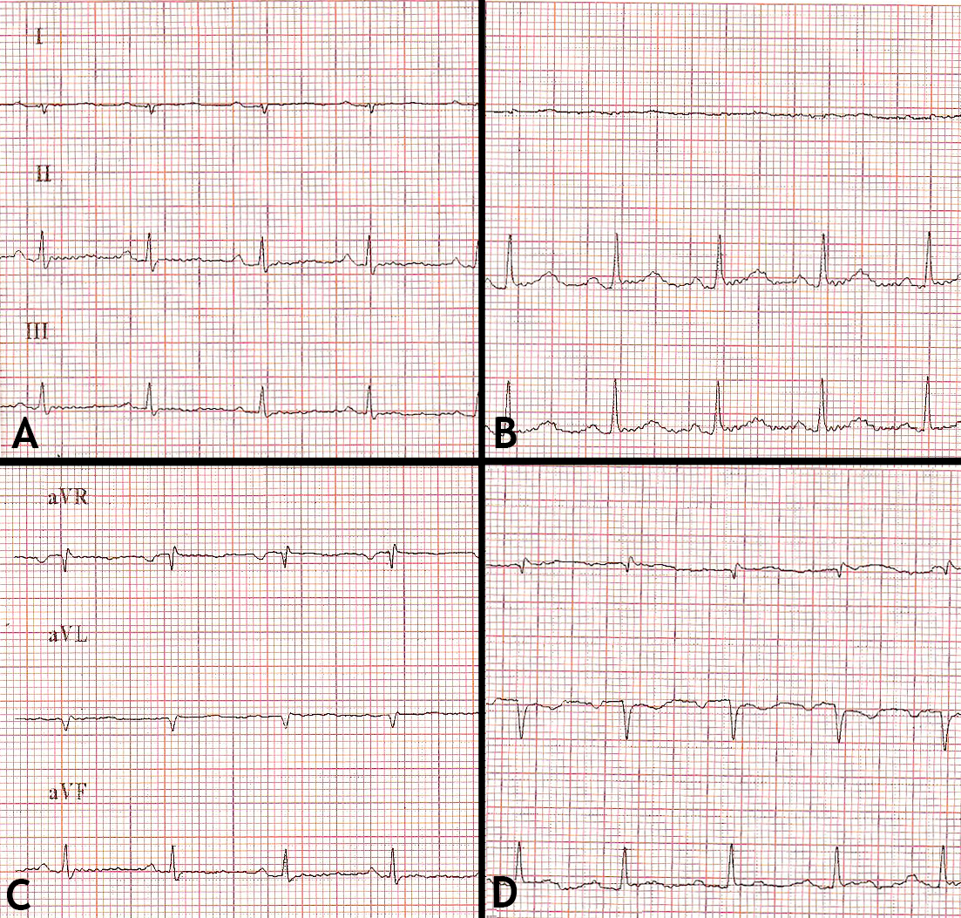
Figure 1 A. Example of kitten ECG (bipolar standard limb leads, 50 mm/s; 10 mm = 1 mV)
B. Example of adult Angora cat ECG (bipolar standard limb leads,50 mm/s; 10 mm = 1 mV)
C. Example of kitten ECG (Augmented unipolar limb leads, 50 mm/s; 10 mm = 1 mV)
D. Example of adult Angora cat ECG (Augmented unipolar limb leads, 50 mm/s; 10 mm = 1 mV).

