HAEMAOLOGICAL STUDIES ON STUNTING SYNDROME IN BROILERS
Muhammad Fiaz Qamar, Hina Aslam and Ayesha Liaqat

¹Department of Zoology, Government College University Lahore
²Department of Zoology, Government College University Lahore
³Department of Zoology, Government College University Lahore

Abstract: Runting Stunting Syndrome (RSS) is a multifactorial disease with many names and faces that had caused considerable economic losses to poultry through reduced uniformity, reduced livability, decreased body weights, elevated feed conversions and many secondary diseases. The aim of current study was to evaluate the effect of stunting syndrome on body weights and haematology in chicks (n=120) of different ages collected from nine (9) different farms. Grouping was done on the basis of age (G1=1-10 days, G2=11-20 days, G3=21-30 days, G4=31-40 days) including both stunted and normal chicks. Body weights of stunted chicks were found significantly reduced (32%) as compared to the normal chicks of the same age. Haematological results exhibited lower levels of haemoglobin (Hb), Total Erythrocyte Count (TEC) and Total Leucocyte Count (TLC) as compared to normal. Absolute Lymphocyte Count (ALC), absolute monocyte count (AMC) and Absolute Eosinophil Count was also found lower than normal. All these changes may interfere with normal digestive processes and normal body functioning resulting in poor weight gain and retarded growth or stunting of chicks.
Key words: Runting stunting syndrome, Haematological studies etc.
Corresponding Author:
Dr. Muhammad Fiaz Qamar
Assistant Professor
Zoology
E_mail: dr.fiazqamar@gcu.edu.pk

Introduction
High demand for chicken meat, early marketing age, rapid return of broiler farms and high profit margins in lowest possible time has increased the popularity of poultry farming. Some of the factors that are important for poultry farming are the flock size, age and weight of chick at the time of marketing, feeding, feed conversion ratio uniformity and mortality. In poultry an unusually small chick is referred as “runt” which means smallest of flock and retardation or hindering of normal growth comes under the term “stunting”. A condition in which members of a flock appear with relatively smaller bodies due to retarded growth is called Runting Stunting Syndrome (RSS).¹⁾
Runting stunting syndrome (RSS) was first described in 1940´s, then became popular to the commercial industry and has been reported variously around the world since 1970´s.²⁾ RSS had caused economic hardships in the poultry industry through reduced uniformity, reduced livability, decreased body weights, elevated feed conversions and many secondary diseases.³⁾ Many descriptive terms have been used for this disease as Helicopter disease⁴⁾ and Brittle bone disease, while Pale bird syndrome, and malabsorption syndrome⁵⁾ are also sometimes used to refer RSS.
Smaller than normal feathers may appear on affected chicks that are usually curled at wing tips; therefore, the disease is referred as Helicopter disease. The beaks and legs of effected birds may sometimes appear pale in color and we name it pale bird syndrome. Not all but some of the affected birds may have rickets, weak or broken legs and the syndrome is called Brittle bone disease.⁶⁾ The syndrome is sometimes characterized by the more chances of occurrence (2-15%) in birds of two weeks of age with reduced body weight and poor feathering.⁷⁾
The haematology of stunted chicks is also affected severely by RSS. Different blood parameters may increase or decrease significantly due to retarded or stunted growth. The overall mean values of mean packed cell volume (PCV), total erythrocyte count (TEC) and haemoglobin (Hb) were reduced significantly in stunting birds, suggesting some anemic changes caused by malabsorption. In contrary no changes were observed in PCV value in birds affected with Malabsorption Syndrome (MAS).⁸⁾ The TLC value did not differ significantly, however increased values of AMC, ABC and AHC with decreased levels of ALC were indicators of the infectious nature of the syndrome.⁹⁾ Therefore paleness of legs and beaks of affected chicks may be due to decreased Haemoglobin.
There are large number of possible reasons for RSS including some management issues, environmental challenges, infectious diseases, faulty poultry genetics, nutrition and feeding, and perhaps some other reasons and/or any possible combinations of all these.¹⁾ Some particular chicks were observed more susceptible than others and the males were found affected much severely than females.³⁾
Although the disease may be infectious in nature yet some non-infectious agents cannot be ignored. Infectious agents mostly viruses have been isolated as etiological agents, specifically rotaviruses, reoviruses, astroviruses and some other small rounded viruses present in the intestines and intestinal contents of infected chicks by using some isolation techniques or direct electron microscopy.¹⁰⁾ Bacteria often isolated from the intestines of RSS affected birds often cause secondary infections.²⁾
Appearance and disappearance of RSS is equally sudden making difficult to decide about the effective control measures. Although there is no satisfactory treatment or vaccination for this disease yet but proper poultry house management, strict hygienic and sanitary measures, biosecurity procedures, good parent nutrition and egg selection reduce the possibility of exposure and incidence of disease.
OBJECTIVE
The aim of current research was to differentiate between the haematological parameters of affected and healthy broilers by Runting Stunting Syndrome, to study the epidemiological factors contributing to the occurrence/causation of syndrome and to develop a strategy for the effective control of RSS.
MATERIALS AND METHODS
Study area and Time Period
The survey based study was conducted during the period of January 2012 to July 2012 on the stunted chicks of one to forty days of age. These chicks were procured randomly from some different commercial poultry farms around the local area. The names of farms visited for the collection of chicks include: ZZAAXX protein farm (Court Radha Kishan), Bhullar protein farm (Court Radha Kishan), Al-Rehman protein farm (Soya Asal), Dua protein farm (Murid ke), Al-Rehmat protein farm (Saggiyan), Gill protein farm (Kot Mehtab khan), Al-Habib protein farm (Raiwand), Geo protein farm (Lallyani), University Diagnostic Lab (University of Veterinary and Animal Sciences Lahore).
Sampling
Twelve (19 days old) chicks were collected from ZZAAXX protein farm (Court Radha kishan). Twenty six chicks were collected from Bhullar protein farm (Court Radha Kishan). Out of these 26 half of the chicks were 7-day old while other half consisted of chicks that were 10 days of age. Twelve chicks that were 40 days old were collected from Al-Rehman protein farm (Soya Asal). From Dua protein farm (Murid ke) twenty five chicks were collected (ten chicks were 32-days old and fifteen chicks were 35 days old). Thirty chicks of 26 and 28 days of age (fifteen for each age) were collected from Al-Rehmat protein farm (Saggiyan). Twelve (14 days old) chicks and twelve (11 days old) chicks were collected from Gill protein farm (Kot Mehtab khan) and Al-Habib protein farm (Raiwand) respectively. Thirteen (4 day old ) and ten (22 days old) chicks were collected from Geo protein farm (Lallyani) and University Diagnostic Lab (University of Veterinary and Animal Sciences Lahore) respectively.
Poultry Rearing
Collected chicks were divided into four groups. Each group contained 30 chicks. Grouping was done on the basis of age. Each group was divided into 3 sub groups. Six stunted and four normal chicks of same age were kept in each sub group. So, 18 stunted and 12 normal chicks were present in each group. 4, 7 and 10 days old chicks were kept in 1st group (G1:1-10 days of age). 2nd group (G2:11-20 days of age) contained 11, 14 and 19 day old chicks. 3rd group (G3:21-30 days of age) contained 22, 26 and 28 day old chicks. 32, 35 and 40 day old chicks were kept in 4th group (G4:31-40 days of age). Total number of groups, age of chicks and total number of chicks in each age group are given in table 1.
Maintenance and Care
Chicks of different age groups were collected from different locations (farms) at different times where they were provided with standard poultry feed and fresh water ad lib. Feed of chicks were formulated by specified nutrient levels that were needed for optimum performance. Usual diets of chicks consisted of principal sources of energy as cereals (wheat and maize), oil seed meals, animal proteins and pulses. Additional sources of energy as fats or oils were added and diets were routinely supplemented with a specific amount of additives that included minerals, amino acids, vitamins, medications, growth promoters and enzymes. Fresh water and optimum temperature (27-37°C) were also provided to chicks. Nearly similar optimum conditions were found at each farm from where the chicks were collected.
Clinical Signs
Chicks collected have reduced or very less body weights. Bodies of affected chicks were smaller as compared to the normal members of relevant age. Abnormal and malposition of feathers and in some cases feathers may disappear from neck and shoulders. Uneven growth rate, poor performance, beaks and legs were pale in color. Lameness and reluctant to move as they move or walk by jumping. Uneven food conversion ratios were also found.
Blood Sampling
Blood sampling of stunted chicks was done on alternate days from alternate groups. These groups included both stunted and normal chicks. Blood volume is 10% of the body weight and amount of blood that can be safely collected is 10% of that blood. Blood samples were collected from blood vessels. The right jugular vein is easily assessable. Other sites of vein puncturing are wing vein (brachial, basilica or cutaneous ulnar). Blood samples were also sometimes obtained by slaughtering birds; the blood was collected by heart puncture.
Chicks were slaughtered and blood was collected by 3cc syringe and was stored in EDTA coated blood sampling tubes.
Haematological Studies
By using an automated haematological counter SYSMAX E-5000 fresh blood was tested for haematological studies. Following parameters were studied: Haemoglobin (Hb), Total erythrocyte count (TEC), Total leucocytes count (TLC), Absolute lymphocyte count (ALC), Absolute monocyte count (AMC) and Absolute eosinophil count (AEC).
Statistical Analysis
Mean weights with standard errors were calculated for different groups of RSS affected chicks and normal chicks. Mean of body weights of stunted and normal chicks were compared by using T-test. Percent reduced body weights were also found for stunted chicks. Mean values with standard errors were calculated for each parameter of haematology and their means were compared by T-test.
All the data collected was analyzed statistically by using software, SPSS 18.0 ver. to calculate using the appropriate statistical techniques.
RESULTS
1-40 day old chicks were divided into 4 groups. Grouping was done on the basis of age (table 4.1). The chicks of different age groups were examined for clinical signs and body weights.
Clinical Observations
In different groups, chicks with smaller size and remarkably reduced body weights have signs of listlessness, diarrhea, presence of undigested feed particles in feces, yellow orange feces, elevated food conversion ratios and lameness( in only few cases) were observed. Affected chicks were difficult to catch on farms as they were very active. These chicks when chased frequently, escape underneath their larger flock mates.
Body Weight
Body weights of chicks were measured using weighing scale. Body weights of stunted and normal chicks are given in table 4.2. Weights of stunted chicks (1-40 days of age) were found significantly reduced (32%) as compared to the normal members (table 4.3).
In G1 (1-10 day old chicks) the mean live body weights of stunted chicks were found lower (36%) as compared to normal. Average body weights observed for the normal chicks of 1-10 days of age ranges from 98 (gms) to 271 (gms) with 179.67 (gms) mean body weights while for stunted chicks of G1 average body weight ranges from 34 (gms) to 105 (gms) with 66.3 (gms) mean body weight. Weight of the stunted chicks was found significantly reduced as compared to normal.
In G2 (11-20 days) the mean live body weights were also found lower (33%) as compared to normal. Average body weights observed for the normal chicks of 11-20 days of age ranges from 311 (gms) to 749 (gms) with 503.67 (gms) mean body weights while for stunted chicks of G1 average body weight ranges from 118 (gms) to 232 (gms) with 169.3 (gms) mean body weight. Weight of the stunted chicks was found significantly reduced as compared to normal.
The stunted chicks of G3 (21-30days) were also found with recued body weights (28.3%) as compared to the normal chicks. Average body weights observed for the normal chicks of 21-30 days of age ranges from 816 (gms) to 1417 (gms) with 1164 (gms) mean body weights while for stunted chicks of G1 average body weight ranges from 245 (gms) to 418 (gms) with 329.67 (gms) mean body weight. Weight of the stunted chicks was found significantly reduced as compared to normal.
Similarly in G4 (31-40 days), the stunted chicks were also found with lower body weights (31.9%) as compared to normal chicks. Average body weights observed for the normal chicks of 31-40 days of age ranges from 1747 (gms) to 2425 (gms) with 2058 (gms) mean body weights while for stunted chicks of G1 average body weight ranges from 541 (gms) to 772 (gms) with 658 (gms) mean body weight. Weight of the stunted chicks was found significantly reduced as compared to normal.
Haematological Findings
Values for different blood parameters were noted by using a haematological analyzer (sysmax E 5000). RBCs were corrected for NRBCs. Haematological findings were given in table 4.4 and graph 4.2.
Haemoglobin (Hb)
Haemoglobin value as noted by the analyzer for the normal chicks was 11.0±0.21 (g/dl), while for the stunted chicks this value was found lower 6.93±0.17g (g/dl). The difference in Hb value was found significantly lower for stunted chicks. It may be suggestive of anemic changes or pale bodies of stunted chicks.
Total Erythrocyte Count (TEC)
Values provided by the analyzer for total erythrocyte count for normal chicks was 3.19±0.11 (10⁹)/l while for stunted chicks it was 2.5+11 (10⁹)/l. RBCs in stunted chicks were also found lower than normal.
Total Leucocytes Count (TLC)
Analyzer had provided the leukocyte count for normal chicks 28.56±1.8 (10¹²) while for stunted chicks the leucocytes count was 45.3±1.3 (10¹²)/l. Stunted chicks were exhibited to have higher values for TLC as compared to normal.
Absolute Lymphocyte Count (ALC)
As noted by the analyzer the lymphocytes were observed 35% for stunted chicks. Absolute lymphocyte count for stunted chicks was 16.5±2.03 (10¹²)/l while for normal chicks ALC was 17.49±0.89 (10¹²)/l. ALC for stunted chicks was found lower than normal.
Absolute Monocyte Count (AMC)
By using analyzer monocytes were estimated 3.97% for stunted absolute monocyte count for stunted chicks was 1.8±0.09 (10¹²)/l while for normal chicks estimated AMC was 1.49±0.03 (10¹²)/l. Monocyte count was found higher than normal.
Absolute Eosinophil Count (AEC)
Eosinophils for stunted chicks were estimated (1.5%) with the help of analyzer. Absolute count for eosinophils was observed 0.7±11 (10¹²)/l for stunted chicks while for normal chicks estimated value AEC was 1.29±011 (10¹²)/l. AEC was also found lower in stunted chicks than normal.
DISCUSSION
Runting stunting syndrome (RSS) is a complex syndrome of young broiler chickens. It is known by various names as Malabsorption Syndrome (MAS), Brittle bone disease, infectious proventriculitis and helicopter disease very often characterized in 2-15% birds with lower body weights and poor feathering at about 2 weeks of age.⁷⁾
The present study deals with the body weights and haematology of stunted chicks (exhibited poor or retarded growth). During our studies on stunting syndrome multiple factors were seen to be involved with retarded growth.
In present study chicks of different age groups, with smaller size and retarded growth were observed. In present study the body weights of stunted chicks were compared with normal chicks of the same age and the mean live body weights of stunted chicks were found significantly reduced (32%) as compared to the normal chicks of same age (1-40 days old). In G1 (1-10 day old chicks), the mean body weights observed for stunted chicks was found significantly lower (36%) as compared to normal. Similarly in G2 (11-20 days old chicks), G3 (21-30 days old chicks) and G4 (31-40 days old chicks) stunted chicks were also found with 33%, 28.3% and 31.9% reduced body weights as compared to normal members of each respective group.
Decreased weight gain was also observed.^{5,11,12)} Some investigator¹ also have reported about 30 points reduced body weights in RSS cases or when the chicks were raised on built up litter from RSS affected farms. Severe runting less than a third of lower body weights were also seen in affected flocks. The mean live weights of stunted chicks in affected flocks were found 31-37% of normal chicks in field observations while significant weight reductions (42-7% and 35-38%) were observed in experimental cases of chicks inoculated with whole intestinal homogenates and bacterial free intestinal homogenates.¹³⁾ These field observations were found in agreement with the results of present studies.
In 5 day and 14 day old chicks inoculated intestinal homogenates caused significant mean live weight reductions (23.8% and 17.7%) while inoculating with pancreatic homogenates significant mean live weight reduction (8.8%) was also seen.⁷⁾ These observations were not similar to our findings because inoculated chicks might received various tissue homogenates of infected chicks as compared to naturally affected RSS chicks observed in this study.
In present study in addition to smaller size and recued body weights other clinical signs were also noted. Feather development was also found poor. Pale bodies with signs of listlessness and diarrhea were observed. Stunted chicks were found active and difficult to catch and all these observation were in agreement with information provided in previous studies.^{8, 5, 14)}
Most (but not all) of the stunted chicks exhibited paleness and poor feather development with broken shafts.⁸⁾ Elevated food conversions and poor feathering was also observed by Page et al. (1982).⁵⁾ The chickens with infectious stunting syndrome were observed very active as compared to their pen mates.¹⁴⁾ All these information were found in agreement with the observations provided in present study. Most of the RSS affected chicks as studied in the present case were characterized by diarrhea and/or growth depression also observed by Otto.¹⁵⁾
Poor feather development, lower body weight and voracious appetites as observed in present study were also found similar to the findings of Reece (2011).¹⁶⁾ The syndrome had been described as the disease with many names and faces so mostly the names are given on the basis of clinical presentations. Due to abnormal or retarded feathering in stunted chicks the disease is known as helicopter disease while due to pale bodies of stunted chicks the disease is sometimes referred as pale bird syndrome.
Haematology or blood study is an essential medical science applied to the diagnosis and treatments of various disorders related to blood. Basic procedures such as complete blood count (CBC) including the measurement of various parameters as platelets, Red blood cells RBCs, (erythrocytes), white blood cells (Leukocytes) and absolute count of eosinophils, basophils, neutrophils, monocytes and lymphocytes. Haemoglobin level, total erythrocyte count, absolute leucocyte count, and absolute eosinophil count were found decreased while total leucocyte count and absolute monocyte count was found higher.
Erythrocytes also called red blood cells are highly specialized for their principal function of transport of oxygen and carbon dioxide. RBCs are enucleated biconcave discs ellipitical cells with pink cytoplasm and basophilic nuclei.
The fully differentiated erythrocyte consists of an outer plasma membrane enclosing haemoglobin and limited number of enzymes necessary for membrane integrity and gas transport. The binding, transport and delivery of oxygen by haemoglobin are not dependent on erythrocyte metabolism. However erythrocytes utilize energy in maintenance of electrolyte gradients across plasma membrane and Hb in reduced active from. After haemolysis of RBCs, Hb is removed and broken down into haeme and globin. The oven all mean haemoglobin and total erythrocyte count (TEC) were found significantly recued in the blood of stunted chicks. If haemoglobin concentration of red blood cells is below the standard limit then anemia is considered to be present.¹⁷⁾ These results were found similar to the finding of Rani et al., (2011)⁹⁾ who found the decreased values of Hb and TEC and relate them with anemic changes caused by malabsorption syndrome.
All living bodies have specialized system for combating toxic and infections agents. Leucocytes (WBCs) comprise the mobile units of body’s protective system.¹⁸⁾ They are almost round in shape and are of 5 different types that are traditionally divided into gnanulocytes (Neutrophils, Basophils and Eosinophils) and agranulocytes also called mononuclear leucocytes (Lymphocytes and monocytes).¹⁷⁾ Leucocytes constitute an important part of body defenses against foreign invaders. Generally leucocytes perform their appropriate functions in specific tissues and use the blood just as a vehicle for transit between site of formation, activity and storage. The values for total leucocyte count as obtained in present study were significantly higher than normal are in agreement with the studies of Rani et al., (2011).⁹⁾ The increase in WBCs could be due to many reasons including stress and infection.¹⁹⁾ In present study the infected organisms were found with damaged tissues and release of increased number of leukocyte might be a response to infection or injury.
Basophils are the least common type²⁰⁾ that contain histamine and hepraine in their granules while neutrophils are the most common type of leucocytes in blood. In circulation, the neutrophils are attracted by bacterial infections. Reflecting their increased number in circulation eosinophils are considered haemeostatic regulators of inflammation.²⁰⁾ Eosinophils number was found higher in many types of parasitic disease and defense against these parasites, in present study the eosinophil count was found less than normal as studied by Rani et al., (2011).⁹⁾ The reason may be that the mechanism of tissue damaging as determined histopathologically was higher as compared to the defense against parasites causing damages.
Monocytes are the largest of white cells. They respond to the presence of invading microorganisms, inflammation by migration into the tissues and necrotic materials.²⁰⁾ lymphocytes are the smallest cells in the white cell series. Their increased number was seen during viral infections also playing part in immunological defense mechanism.²⁰⁾
The lymphocyte count was found lower indicating that chicks may have a lower immunological defense mechanism but this report could not provide any evidence for infectious agents. The values for AMC were also found higher. The results for ALC were also found similar to the findings of Rani et al., (2011)⁹⁾ but the results for AMC were different. The reason may be the variations in environmental or management factors or the infection of chicks due to involvement of different pathogens. Severity of disease and immunity in chicks also varies causing different results.
Conclusion
RSS is a multifactorial disease. Haematological changes may affect the immunity of RSS affected chicks resulting in poor weight gain and delayed or retarded growth. High cull rates, greater than expected variations in weights, reduced weight for age and sale of small chicks lead to considerable economic losses. Proper vaccination or treatment of affected organs may help reduce the chances of RSS.
REFERENCES
- Zavalla G, and Sellers H, poultry professional issue, 85, 1-4 (2005)
- Rebel JMJ, Balk FRM, Post J, Hemert VS, Zakarias B, and Stockhofe, world´s poultry science, 62,1 7-19 (2006).
- ZAVALA G, and Barbosa T, “Runting and stunting in broiler chickens”, Apinco-Facta, (May, 2006).
- Kouwenhoven B, Davelar FG, and Van W, Avian Pathology, 7, 183-187 (1978).
- Page RK, Fletcher OJ, Rowland GN, Gaudry D, and Villegas P, 1982, Avian Diseases, 26, 618-624 (1982).
- Clarck FD, Jones FT, Avian advice, 1, 7-9 (2008).
- Smart IJ, Barr DA, Reece RL, Forsyth WM and Ewing I, Avian Pathology, 17, 617-627 (1988).
- Ruff MD, 1982, Avian Diseases, 26, 852-859 (1982).
- Rani MP, Ahmad NN, Prasad E, and Latha SC, Veterinary world, 4, 124-125 (2011).
- Sellers H, Linneman E, Icard AH, and Mundt E, Vaccine, 28, 1253-1263 (2010).
- Rudas P, Saliya G, and Szabo J, Avian Diseases, 30, 293-297 (1986).
- Jindal N, Patnayak DP, Ziegler AF, Lago A, and Goyal SM, Poultry science, 88, 949-958 (2009).
- Nilli H, Jahantigh M, and Nazifi S, Comp. clin. pathol., 16, 161-166 (2007).
- Riddle C, and Derow D, Avian Diseases, 29, 107-115 (1985).
- Otto P, Liebler-tenorio EM, Elschner M, Reetz J, Lohren U, and Diller R, Avian Diseases, 50, 411-418 (2006).
- Reece R, Infectious stunting syndrome of chickens (In AVPA), 2011.
- Turgeon ML, “Clinical Haematology: theory and procedures”, 3rd ed. Lippincot williams and wilkins; London. 3, pp. 96 (1999).
- Guyton AC, “Text book of medical physiology”, 9th ed. W.B. Saunder Company London (1999).
- Ganog WF, “Review of medical physiology”, 19th ed. Appleton and Lange, A Singh and Shaster company (1991).
- Young B, and Heath JW, “Wheather´s functional histology: a text and colour atlas”, 4th ed. Churchill livingstone, New York, pp. 46-64 (2000).

Table 4.1 Age groups of chicks
Sr. no | No. of groups | Age of chicks (days) | No. of stunted samples in each group  n = 18* | No. of normal samples in each group  n =12* | Total number of chicks  n =30 | Total no. of chicks in each group
1. | G1 | 4 7  10 | 6  6  6 | 4  4  4 | 10  10  10 | 30
2. | G2 | 11  14  19 | 6  6  6 | 4  4  4 | 10  10  10 | 30
3. | G3 | 22  26  28 | 6  6  6 | 4  4  4 | 10  10  10 | 30
4. | G4 | 32  35  40 | 6  6  6 | 4  4  4 | 10  10  10 | 30
5. | G | 1-40 | 72 | 48 | 120 | 120
*18 stunted and 12 normal chicks were taken in each group.

Table 4.2 Body Weights of normal and stunted samples in different chicks
No. of Groups | Age of chicks (days)  n = 30 | Average weight observed for normal chicks (gms)  n = 18 | Average weight observed for stunted chicks (gms)  n = 12
G1 | 4  7  10 | 98  170  271 | 34  60  105
G2 | 11  14  19 | 311  451  749 | 118  158  232
G3 | 22  26  28 | 816  1259  1417 | 245  326  418
G4 | 32  35  40 | 1747  2003  2425 | 541  661  772

Table 4.3 % age Reducing in weights of stunted Samples
Age groups | Average weight of normal chicks  n=18  Mean±SE | Average weight of stunted chicks  n=18  Mean±SE | % reduced weight of stunted chicks
G1 | 179.67±21.39 | 66.3±7.11 | 36%*
G2 | 503.67±55.07 | 169.3±11.45 | 33%*
G3 | 1164±76.70 | 329.67±17.14 | 28.3%*
G4 | 2058±84.28 | 658±22.87 | 31.9%*

* Significant weight loss.

Table 4.4: Haematological parameters (Mean and SE) of stunted and control chicks
Haematological parameters | Stunted chicks  Mean±SE | Normal chicks  Mean±SE | P-value
Hb (g/dl) | 7.8±0.17 | 11.02±0.21 | 0.000*
TEC(10¹²/l) | 2.5±0.11 | 3.19±0.11 | 0.000*
TLC(10⁹/l) | 45.3±1.3 | 28.56±1.8 | 0.001*
ALC(10⁹/l) | 16.51±2.03 | 17.49±0.89 | 0.002*
AMC(10⁹/l) | 1.8±0.09 | 1.49±0.03 | 0.000*
AEC(10⁹/l) | 0.7±0.11 | 0.52±0.07 | 0.004*

*Significant

Figure 1:

Figure 1 showing graphical representations of the weights of normal and stunted chicks

Figure 2:

Figure 2 Showing graphical representations of the haematological parameters of Normal and Stunted Chicks

Figure 3:

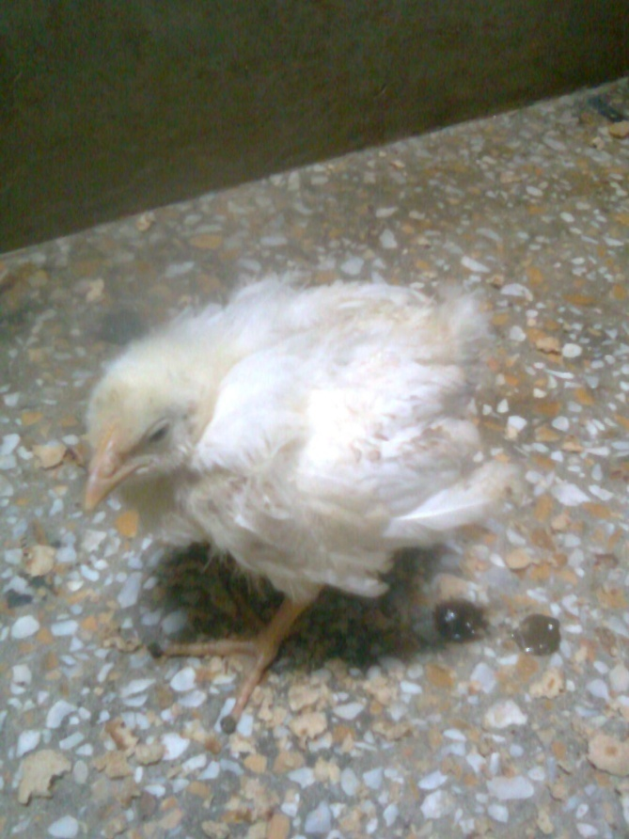
Figure 3 showing A stunted helicopter chicken

Figure 4:
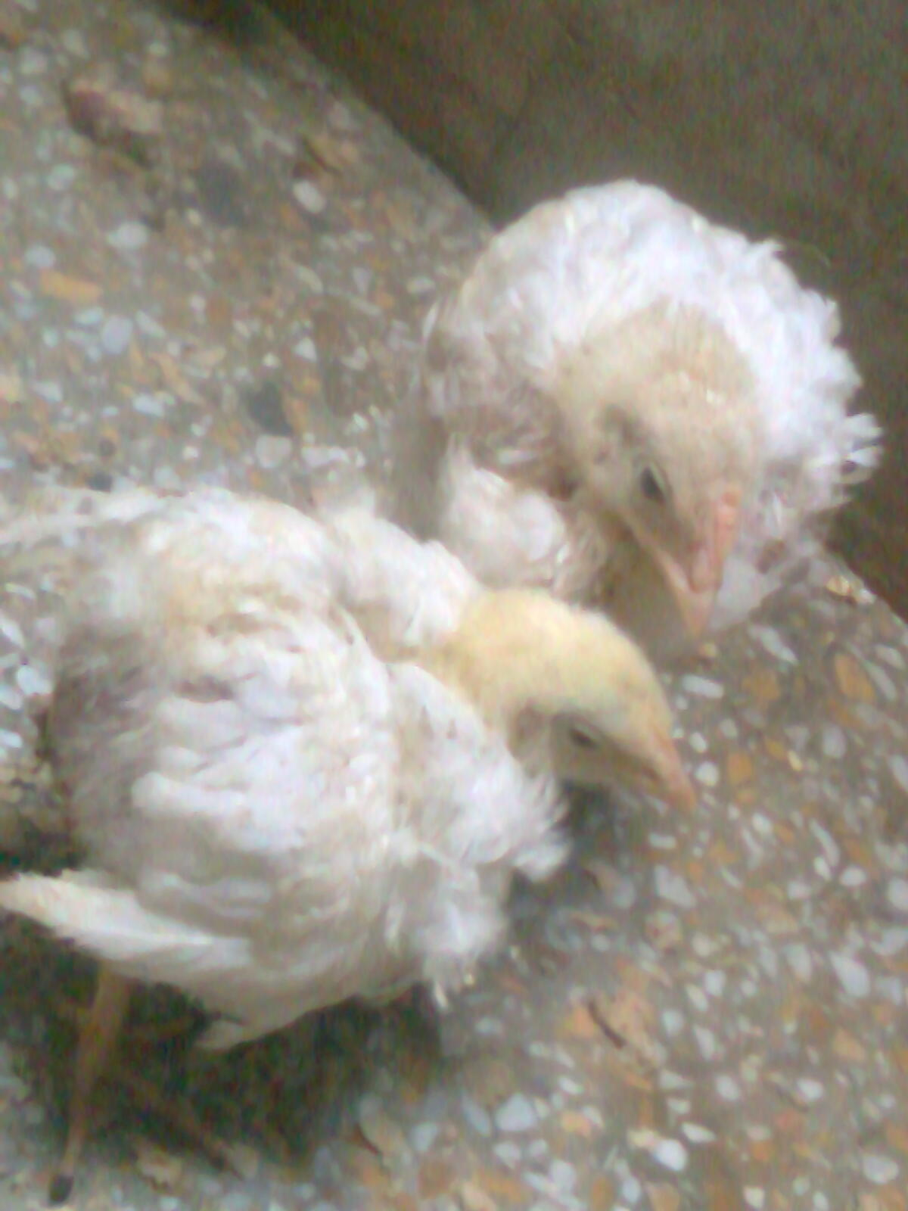
Figure 4 Showing Stunted chicks showing retarded feathering

Figure 5:
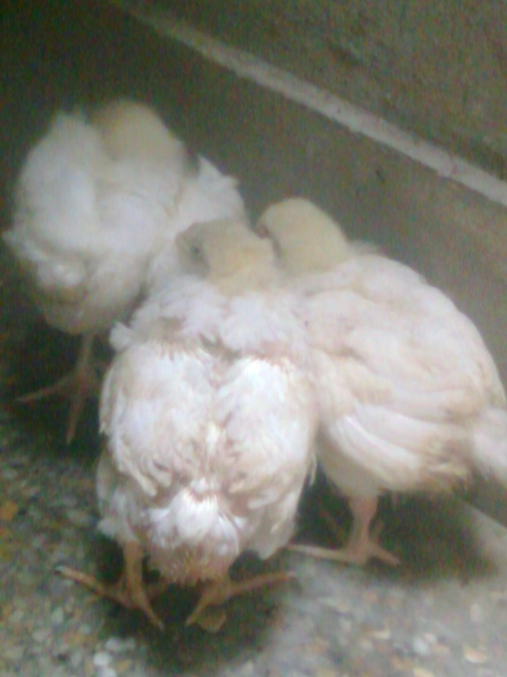
Figure 5 Showing Growth retardation with abnormal feather growth

Figure 6:
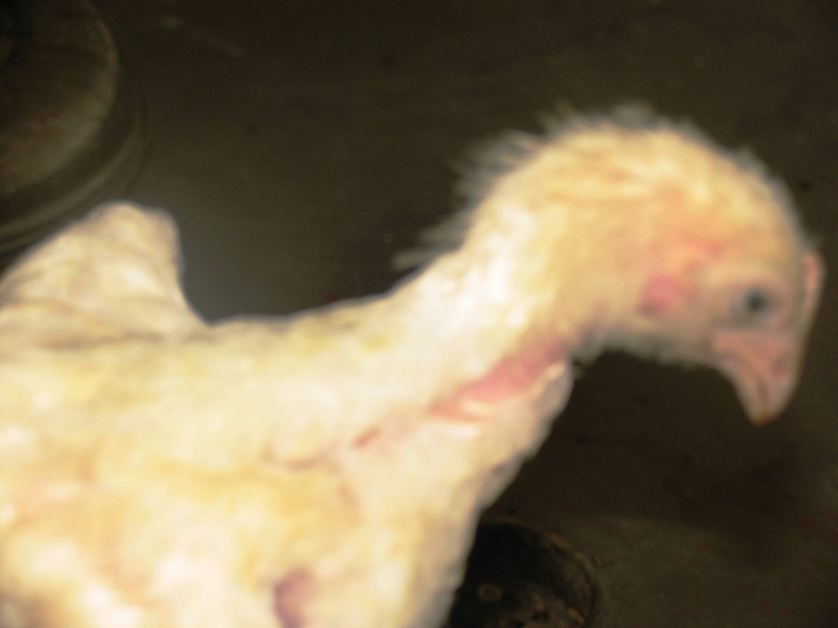
Figure 6 showing stunted chick

