Prevalence and in vitro culture of Trichostrongylus spp. in goat at trishal, Mymensingh, Bangladesh
Running title: Prevalence and in vitro culture of Trichostrongylus spp. in goat
Author’s name: SM Fazly Rabby Rajib, Anita Rani Dey, Nurjahan Begum, Md. Abdul Momin and Md. Hasanuzzaman Talukder
Number of table: Five (05)
Number of figures: Three (03)
Address of Author:
SM Fazly Rabby Rajib: Department of Parasitology, Faculty of Veterinary Science, Bangladesh Agricultural University, Mymensingh-2202.
Anita Rani Dey: Assistant Professor, Department of Parasitology, Faculty of Veterinary Science, Bangladesh Agricultural University, Mymensingh-2202.
Nurjahan Begum: Professor, Department of Parasitology, Faculty of Veterinary Science, Bangladesh Agricultural University, Mymensingh-2202.,
Md. Abdul Momin: Department of Parasitology, Faculty of Veterinary Science, Bangladesh Agricultural University, Mymensingh-2202.
Md. Hasanuzzaman Talukder: Professor, Department of Parasitology, Faculty of Veterinary Science, Bangladesh Agricultural University, Mymensingh-2202.
Corresponding author: Email: anitadey.dpp.vet@gmail.com. Fax: +880-91-615510. Telephone: (091) 67401-6
Abstract
Trichosrtongylus spp., Looss, 1905 is one of the important nematode of alimentary canal that causes a great harm to the ruminants. The study was undertaken to determine the prevalence of Trichostrongylus spp. and effects of temperature, pH, humidity, light and dark, nutrient and other media on the hatching of eggs, the development and survival of larvae of Trichostrongylus spp. Samples were collected from different villages and slaughter houses of Trishal, Mymensingh, during the period from January to May 2014. A total of 82 fecal and 67 visceral samples (abomasum, small intestine and large intestine) were collected. Overall prevalence was 20.72% and 14.93% for fecal samples and visceral samples, respectively. Young (23.64%) were 1.78 times more susceptible to Trichostrongylus infection than adult (14.82%) and which was statistically significant. It was also revealed that females (23.08%) were 1.31 times more susceptible than male (18.61%) and which was statistically significant (p <0.001). Here, we incubated eggs at different temperature gradients, humidity and pH in phosphate buffer saline (PBS), tap water (TP) and normal saline (NS) and PBS with 5%, 10% and 15% serum. Maximum (46.67%) hatching of eggs observed at 18°C on day 5. and development of eggs arrested at 4°C temperature. No development and hatching occurred at pH 2. Hatching of eggs were better on day 6 in all cases and highest hatching rate observed at pH 6.0 (32.30%). Maximum hatching of eggs (42.86%) were recorded at relative humidity of >80%- 90% at day 5. There was no significant effect of light on the development and hatching of eggs of Trichostrongylus spp. Maximum eggs hatched in PBS containing 15% serum (46.67%). Moreover, in this medium, survival rate of larvae was also highest (19.08%). So, it is concluded that PBS containing 15% serum may be used as a suitable media for hatching of eggs and survival of larvae.
Key words: Prevalence, In vitro, culture, Trichostrongylus spp., goat

INTRODUCTION

Bangladesh is a developing country where goat ranks second in position in terms of meat, milk, and skin production, representing about 28%, 23% and 28% respectively of the total livestock in Bangladesh (Banglapedia /goat/2013). But the productions are hindered by various types of infection and parasitic infection is most common. Geographical location and agro-ecological condition of Bangladesh are highly conducive to the growth and multiplication of a large number of parasite species. Trichosrtongylus spp., Looss, 1905 is one of the important nematode of alimentary canal that causes a great harm to the ruminants. Nematodes especially Trichosrtongylus spp. is prevalent worldwide (Dhar et al., 1982; Ha and Vu, 2013; Rehbein et al., 2012). It is understandable that Trichostrongylus spp. is one of the common, pathogenic and also most prevalent nematodes recorded in Bangladesh. The development, distribution, or migratory behavior of the free living stages (i.e. eggs, developing and infective larvae) of gastro-intestinal nematodes on pasture is primarily weather related. Environmental factors influenced both the development and survival of the larvae on pasture and their distribution on the herbage. In the pasture, deposited eggs hatch and develop to the infective L3 stage. Under optimal conditions as moisture and temperature, larvae of Trichostrongylus spp. reach the infective stage in approximately 5-6 days. Developmental time varies from one geographic region. Eggs hatch and develop more slowly at lower temperatures. The rate of development increases to a maximum at higher temperatures after which development will be adversely affected and death of the larvae occurs (Soulsby, 1982). The primary factors that affect the hatching of eggs, development and survival larvae are temperature and moisture dependent and vary according to the parasite. In vitro information about effects of temperature, pH, humidity, light and nutrients on the hatching of eggs and survival of larvae of Trichostrongylus spp. are essential to study the biology of the parasite. By considering these facts, the present study has been designed to determine the Prevalence and to investigate the effects of temperature, p^{H}, nutrients, humidity and light on the hatching of eggs and survival of larvae of Trichostrongylus spp.

MATERIALS AND METHODS
3.1. Study area
The study was carried out in different villages and slaughter houses of Trishal in Mymensingh district. Identification, hatching and observation of larvae were performed in the laboratory, Department of Parasitology, Bangladesh Agricultural University, Mymensingh.
3.2. Study period
The study was conducted from January to May 2014.
3.3. Collection of fecal sample
Eighty two (82) fecal samples were collected directly from the rectum of goats. After collection, samples were placed in a polythin bag and packed tightly by mixing with 10% formalin and brought to laboratory of the Department of Parasitology, BAU, Mymensingh.
3.4. Collection of visceral sample
Sixty seven (67) visceral samples (abomasum, small and large intestine) were collected. After collection, sample was packed in a plastic bag and brought to laboratory of the Department of Parasitology, BAU, Mymensingh. Collections of parasites from intestine were made following the standard procedure described by Rahman (1969). Identification of species with sex differentiation was based on the morphology as described by Soulsby (1982).
3.5. Recovery of eggs
Matured eggs were recovered directly from the ovipositing female (Trichostrongulus spp.). For this, female parasites were crushed by using sterile mortar and pestle containing necessary amount of phosphate buffer solution (PBS). Debris was picked up with needles and the contents were transferred to a clear Petri dish through sieving. The suspension was gently stirred to make uniform solution. Eggs were counted by modified McMaster technique (Thienpont et al., 1979).

3.6. Effects of temperature
To study the effects of temperature, the pre-counted numbers of eggs were suspended in a Petri dish containing culture media and incubated at various temperatures (37°C, 27°C, 18°C, 8⁰C and 4°C) up to 8 days. Identification of different of stages was made on the basis of morphological descriptions described by Anon (1977), Soulsby (1982) and Rahman et al., (1996). Different stages of larvae were detected and percentages of larvae survivality were counted.
3.7. Effects of pH
To study the effects of p^{H}, the different p^{H} levels (2.0, 4.0, 5.0, 6.0, 7.0, 8.0 and 9.0) of the culture media were adjusted by adding glacial acetic acid or by adding Sodium hydroxide in PBS drop by drop with the help of dropper and stirred the media. The p^{H} was detected by p^{H} meter. Pre-counted eggs were mixed in the culture media having above mentioned p^{H} levels and kept in room temperature. Observations were made by dissecting microscope in every 24 hours up to 7 days.
3.8. Effects of humidity
To determine the effects of relative humidity, the pre-counted number of eggs were mixed in the PBS and incubated at 70% -<80% and >80%-90% of relative humidity at constant 26⁰C temperature. Developmental stages were observed by dissecting microscope at 24 hours at regular interval up to 7 days.
3.9. Effects of light
There were two groups of samples and each containing three media to identify the light effect on those groups. Pre-counted number of eggs counting culture media was covered with hard paper to make dark condition having facilities for air exchange keeping in room temperature. Control media was also kept in room temperature at light condition. Then observation was made in similar manner up to 8 days.
3.10. Effects of different media
To find out a suitable media for the cultivation of eggs, pre-counted eggs were cultured in phosphate buffer solution (PBS), normal saline (NS) and tap water (TW) and incubated at room temperature (26⁰C) and pH 6.5 in 80-95% Relative humidity and observed in similar procedure.
3.11. Effects of different nutrients
For the preparation of different nutrient media, 5%, 10%, 15% serum of goat was added separately to the PBS. A pre-counted number of eggs were suspended in each and every culture medium mentioned above and all were incubated at room temperature up to 8 days. Then the percentage of hatching eggs was calculated at every 24 hours at regular intervals.
3.12. Statistical analysis
Student t-test was used to determine the significance among the different variables (Steel and Torrie, 1980).
RESULTS AND DISCUSSION
4.1 Prevalence of Trichostongylus spp. in goats
In the present study, overall prevalence of Trichostongylus spp. in fecal sample and visceral sample were 20.73% (17/82) and 14.93% (10/67), respectively. (Fig. 1). More or less similar findings in fecal sample survey was also observed by Ha and Vu (2013). But the present study differs with Achi et al., (2003); Abebe and Esayas (2001); Patel et al., (2001) and Mostafa et al., (1996) who observed the prevalence rate were 46%, 64.3%, 9.2% and 10%, respectively.
Females (23.08%) were 1.31 times more susceptible than male 18.61% and which was statistically significant (p <0.001) (Fig. 2). The exact cause of higher rate of infection of Trichostronglus spp. cannot be explained, but in general, higher level of prolactin and progesterone hormone suppress the immune system of the individual and make the individual more susceptible to any infection (Lloyd,1983).
During this study, it was also recorded that young (23.64%) were 1.78 times more prone to Trichostongylus spp. infection than adult (14.82%) and it was statistically significant (p < .0011) (Fig. 3).This may be due to low level of immunity in young animal.

4.2 In vitro culture of Trichostrongylus spp. in goats
4.2. 1. Maximum eggs were hatched at 18⁰C temperature
In the present study, developments of eggs were arrested at 4⁰C temperature and failed to develop even when returned to room temperature (15-20°C) during the period of observations up to 15 days. Better results were observed at 37⁰C temperature but maximum (46.67%) hatching of eggs were at 18⁰C on day 5. Detail shown in Table-1.
In the present study, No development were observed at low temperature (4⁰C). Ross and Small (1980) and Tripathi (1980) had similar observation. The exact mechanism of inactivation of eggs at lower temperature is not known but may be due to cold injury which squeezed the germinal mass and the eggs were devitalized. At 8⁰ C, hatching of eggs started at day 3 which was relatively delayed than in other temperature. This finding conformed to the findings of Soulsby (1982) recorded that low temperature retarded the development of eggs and below 9°C, little development took place. In the present study, maximum hatching was observed at 18°C on day 5. Minato et al., (2008) found that 15°C temperature was shown to favor direct development, producing infective larvae. Islam and Ahmed (1987) observed that eggs hatched at 15-34°C in 6 days which support the present study. At 27°C temperature, 4.76% eggs were hatched at day 2 and maximum 38.09% of eggs hatched at day 5 and larvae attained infective stage at day 5. Whereas Rahman et al., (1996) found that eggs were hatched within 1-2 days at 26°C and reached at the infective stage within 3-4 days. Tripathi (1977) made similar observations of this author where he mentioned that 20°C -30°C was the most suitable temperature for hatching and development of Trichostrongylus spp.

4.2.2. pH 6.0 is optimum for development and hatching of Trichostrongylus spp.
In this study, development and hatching of eggs was not observed in p^{H} 2.0. Hatching of eggs were initiated from day 2 only in p^{H} 6.0 and P ^{H} 7.0. Highest hatching was observed at p^{H} 6.0 (32.30%) and lowest was at p^{H} 4.0 (5.17%) at day 6 and day 7, respectively. (Table-2)
During this study, hatching of eggs did not occur at p^{H} 2.0. Sommerville and Murphy (1983) also support this observation and interpret as it might be due to coagulation of germinal mass of the eggs due to high acidic p^{H} level of the media. Ashad et al., (2011) and Strinfellow (1986) found that maximum hatching of eggs and development of Trichostrongylus spp. larvae occurred at pH 6.0-7.0 which also support the present observation. Again developments were decreased at pH 9 (Table-2), which is possibly for the denaturation of egg mass in alkaline pH.
4.2.3. Favorable (>80-90%) R H is necessary for hatching of eggs of Trichostrongylus spp.
Maximum (42.86%) eggs were hatched at >80-90 relative humidity at day 5 and minimum (14.28%) were observed at 70-<80 relative humidity on day 3. Eggs were arrested their development on day 1 and 2 in both cases. (Table-3)
In this study, maximum (42.86%) eggs were hatched in case of relative humidity >80-90% which are less than the finding of Rahman et al., (1996), Rossanigo and Gruner (1994) and Berbigier et al., (1990) who found that optimum egg hatching and larval development and survival was 49.03%, 54% and 74%, respectively in the temperature range from 15°C to 20°C and at humidity from 79.5 to 95.5%.
4.2.4. Dark condition is favorable for hatching
Dark and light had no significant effect on development and hatching of eggs of Trichostrongylus spp. It was observed that no eggs were developed on first two days in both cases. But developments were better in dark than light in all the observed day (Table-3). Islam and Ahmed (1987) and Ashad et al., (2011) also found that dark condition was more effective than light on the hachability of eggs of Trichostrongylus spp.

4.2.5. Maximum hatchability and survivality on PBS
Hatching of eggs were initiated at day 3 in all media such as Phosphate buffer saline (PBS), normal saline (NS) and tap water (TW). Initially, the rate of hatchability was relatively higher in PBS (16.67%) followed by TW (14.29%) and NS (7.10%). On three culture media, maximum hatchability was observed in PBS (38.89%) on day 5. It was found that 22.94% larvae survived in PBS whereas in NS and TW, 8.34% and 6.47% larvae survived, respectively at day 8. (Table-4)
During this study, hatchability and survivality was maximum in PBS. These results were clearly similar to the results obtained by Islam et al., (2005) who achieved the highest L3 yield in PBS (23.82%). In this study, No develop were occurred in first two day. This observation differs with Veglia (1916) who found that L1 hatched from eggs within 14-17 hours. The variation in development and hatching of eggs may be due to other condition applied.

4.2.6. Nutrient is essential on the hatching of eggs and the survival of the larvae of Trichostrongylus spp.
In this study, hatching was initiated from day 2 and gradually increased in all the media but best result was found in PBS containing 15% serum which was initiated as 13.33% at day 2 and finally reached 46.67% at day 5. Death of larvae initiated at day 6 in all media; survival and longevity of larvae also maximum (19.08%) in PBS containing 15% serum (Table-5). PBS containing 15% serum is comparatively more enriched than the other. This enriched media ensured a balanced environment and provide protein and several vitamins. Paul (1965) supports the finding who recorded the increased survival of larvae in a uniform manner in a medium containing plentiful food source.

ACKNOWLEDGEMENTS
Respected teachers in the department of Parasitology for their kind help.

CONFLICT OF INTEREST
There is no conflict of interest.

REFERENCES
Abebe W, Esayas C (2001). Survey of ovine and caprine gastrointestinal helminthosis in eastern part of Ethiopia during the dry season of the year. Rev. Med, Vet. 152: 379-384.
Achi YL, Zinsstag J, Yeo N , Dea V, Dorchies P (2003). Epidemiology of parasites of sheep and goats from savannah area in Cote d'Ivoire. Rev. Med Vet. 154: 179-188.
Anon (1977). Manual of Veterinary Parasitology Laboratory Techniques. 2nd edn. (HMSO) Her Majesty’s stationary Office. Roben dene Amersham Ltd. England, pp. 14-23
Ashad FA, Anisuzzaman, Begum N, Dey AR, Mondal MMH (2011). Factors affecting the development and hatching of eggs and the survival of infective larvae of Haemonchus contortus in laboratory condition . Progress. Agric. 22(1 & 2): 75 – 83.
Banglapedia.htm/goat/2013
Berbigier P, Gruner L, Mambrini M, Sophie SA (1990). Faecal water content and egg survival of goat gastro-intestinal strongyles under dry tropical conditions in Guadeloupe. Parasitol Res. 76: 379-385.
Dhar DN, Sarma RL, Bassal GC (1982). Gastro-intestinal nematodes in sheep in Kashmir.Vet. Parasit. 11: 273- 277.
Ha TH, Vu DD (2013). Observations on Parasitism of goats raised in Bavi district (Hatay province). Khoa Hoc KyThuat Thu Y Veterinary Sciences and Techniques. 10: 36-41.
Islam K S, Ahmed S (1987). Effect of temperature, light and darkness on the hatching of eggs and development of L3 larvae of gastrointestinal helminths and migratory behavior of larvae in grass blades. Indian Journal of Parasitology. 11: 45-49.
Islam M K, Begum N, Alim M A, Mondal M M H (2005).A simple method for harvesting the third-stage infective larvae of trichostrongylid nematodes of ruminants and their implications in the screening of pesticides. Bangladesh Veterinary Journal, 39: 49-58.
Lloyed (1983). Effect of pregnancy and lactation of infection .Vet. immunol. and immunopathol. 4: 153-176
Minato K, Kimura E, Shintoku Y, Uga S (2008). Effect of temperature on the development of free-living stages of Strongyloides ratti. Parasitol. Res. 102: 315-319.
Mostafa M, McKellar QA, Alam MN (1996). Epidemiology of gastrointestinal helminth parasites in small ruminants in Bangladesh and there anthelmintic therapy SPCSR, ACAIR Publication, Australia. 74: 105-108.
Patel MD, Nauriyal DS, Hasnani JJ, Gupta RS (2001). Prevalence of gastrointestinal parasitism in goats maintained under semi intensive and field management systems. Indian J. Vet Med. 21: 99-101.
Paul H S (1965). In vitro Cultivation Procedures for Parasitic Helminths. Advances in Parasitology Academic Press. London, 3: pp. 159-218.
Rahman MH (1969). Taxonomic study of the helminth parasites encountered in the abomasums of ruminants in East Pakistan. M. Sc. Thesis, Department of Parasitology, Bangladesh Agricultural University, Mymensingh.
Rahman MH, Mondal MMH, Ahmed S (1996). Introduction to helminth parasites of Animals and birds in Bangladesh. First Edition. Mr. Taehsins Mostafa, Pvt. Ltd.
Rehbein S, Visser M, Winter R (2012). Helminths of goats in Germany. Berliner and Munchener Tierarztliche Wochenschrifi. 111: 427-431.
Rose J H, Small A J (1980). Observations on the development and survival of the free-living stages of Trichostrongylus spp. both in their natural environments out-of-doors and under controlled conditions in the laboratory. Parasitol. 8:507-17.
Rossanigo CE, Gruner L (1994). Relative effect of temperature and moisture on the development of strongyle eggs to infective larvae in bovine pats in Argentina. Vet. Parasitol. 55(4): 317-325.
Sommerville R I, Murphy CR (1983). Reversal of order of ecdysis in Haemonchus contortus (Nematoda). J. Parasitol. 69(2): 368-371.
Soulsby EJL (1982). Helminth, Arthropod and Protozoa of Domesticated Animals. 7thedn.,BailliereTindall, London, pp.809.
Steel RJ, Torrie DS (1980). Statistics of Veterinary and Animal Science, l^{st} Edition, Blackwell Science Ltd., USA, pp. 41-49.
Stringfellow F (1986). Cultivation of Haemonchus contortus (Nematoda: Trichostrongylidae) from infective larvae to the adult male and the egg-laying female. J. Parasitol. 72(2): 339-345.
Thienpont D, Rochette F, Van POFJ (1979). Diagnosing Helminthiasis through Coprological Examination. Janseen Research Foundation, Beerse, Belgium.
Tripathi JC (1977). Effect of different temperatures, on the eggs of gastrointestinal nematodes of goats under laboratory conditions. Indian J. Anim. Sci. 47(11): 739-742
Tripathi JC (1980). Effect of different temperatures, on the eggs of gastrointestinal nematodes of goats under controlled conditions. Int. Vet. Journal. 57: 719-723
Veglia F (1916). The anatomy and life history of Haemonchus contortus. The Third and Fourth Reports of the Director of Veterinary Research. Union of South Africa, pp. 349-500.

FIGURES AND TABLES

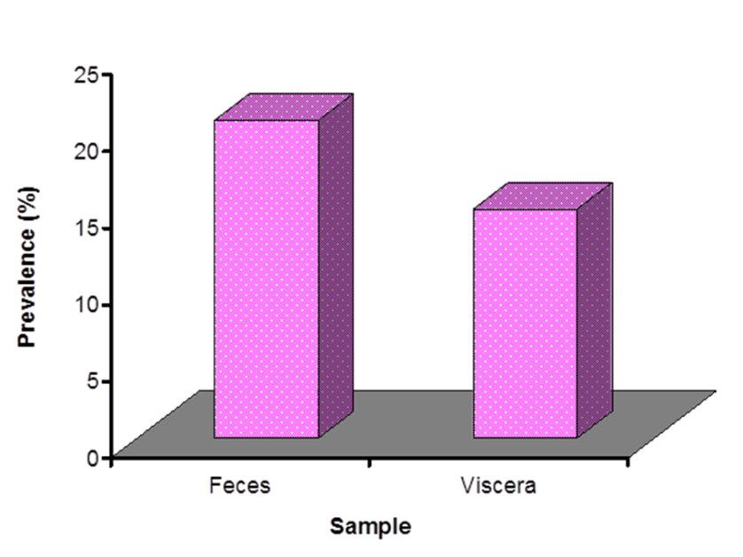
Fig 1: Over all prevalence of trichostrongylus spp. in goats

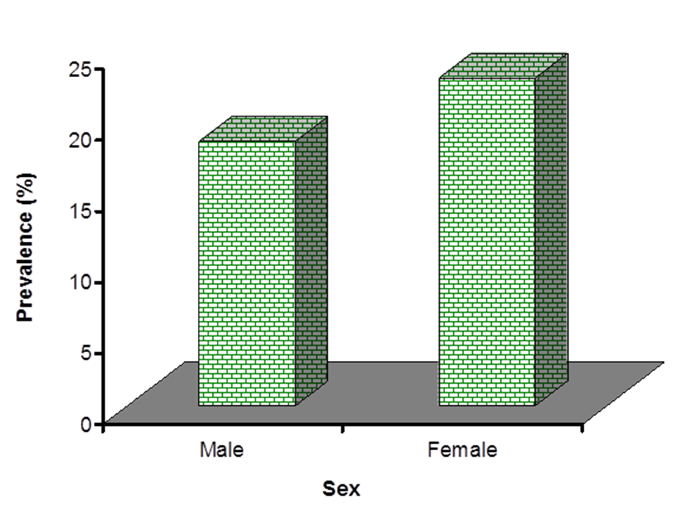
Fig2: Sex related prevalence of Trichostrongylus spp. in goats

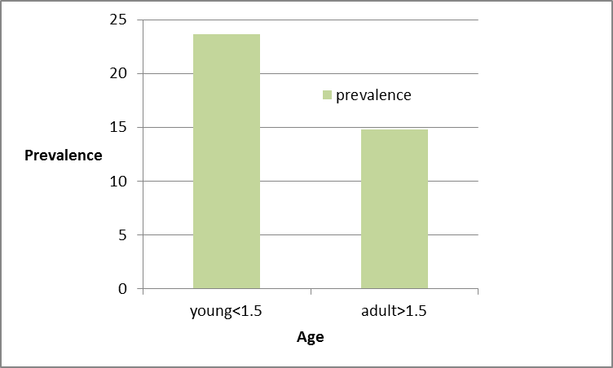
Fig 3: Age related prevalence of Trichostrongylus spp. in goats

Table 1. Effects of Temperature on the hatching of eggs of Trichostrongylus spp.

Temperature (⁰C) | Hatching of egg(%)
Temperature (⁰C) | Day
Temperature (⁰C) | D1 | D2 | D3 | D4 | D5
4 | - | - | - | - | -
8 | - | - | 11.11 | 16.67 | 22.23ª
18 | - | 13.33ª | 20.00 | 33.33 | 46.67^{b}
27 | - | 4.76ª | 14.28 | 23.81 | 38.09^{b}
37 | - | 18.75ª | 31.25 | 37.50 | 43.75^{ab}

Values in the same column having different superscript are statistically significant (p<0.05).

Table 2. Effects of pH on the hatching of eggs of Trichostrongylus spp.

Observations | Effect of different pH
Observations | 2.0 | 4.0 | 5.0 | 6.0 | 7.0 | 9.0
Day 1 | - | - | - | - | - | -
Day 2 | - | - | - | 12.00 | 7.98 | -
Day 3 | - | 6.12ª | 14.50^{b} | 18.34 ª | 17.38 ª | 14.70 ^{b}
Day 4 | - | 8.67 ª | 18.26 ^{b} | 25.56 ª | 21.78 ª | 14.88 ^{ab}
Day 5 | - | 14.78 ª | 22.30 ^{b} | 28.37 ª | 29.90 ª | 15.44 ^{b}
Day 6 | - | 19.60 ª | 24.49 ^{b} | 32.30 ª | 29.19 ª | 18.34 ^{b}
Day 7 | - | 5.17^{ab} | 5.90 ª | 14.80 ª | 17.03 ª | 10.17 ^{ab}

Values in the same row having different superscript are statistically significant (p<0.05).

Table 3. Effects of humidity, dark and light on the hatching of eggs of Trichostrongylus spp.

Day | Effect of different humidity (%) |  | Effect of light
Day | 70-<80 (N=21) | >80- 90(N=21) | Dark (%)(N=16) | Light (%)(N=16)
Day 1 | - | - | - | -
Day 2 | - | - | - | -
Day 3 | 14.28ª | 23.81 ^{b} | 12.50 | 6.25
Day 4 | 23.81 ª | 38.09 ^{b} | 25.00 | 12.50
Day 5 | 33.33 ª | 42.86 ^{b} | 43.75 | 31.25
Day 6 | 38.09 | - | 18.75 | 12.50

Values in the same row having different superscript are statistically significant (p<0.05).
N= number of eggs

Table 4. Effects of media on the hatching of eggs and survival of larvae of Trichostrongylus spp.

Media | Observations (%)
Media | Hatching of eggs |  |  |  |  | Survival of larvae
Media | D1 | D2 | D3 | D4 | D5 | D6 |  | D7 |  | D8
 |  |  |  |  |  | d | l | d | l | d | l
Normal Saline (NS) | - | - | 7.10 | 14.30 | 28.57ª | 7.14 | 21.42 | 10.42 | 16.15 | 19.23 | 8.34ª
Phosphate Buffer Solution (PBS) | - | - | 16.67 | 27.77 | 38.89 ^{b} | 7.00 | 30.99 | 10.34 | 24.08 | 12.18 | 22.94^{b}
Tap Water (TW) | - | - | 14.29 | 19.04 | 28.57 ^{ab} | 5.99 | 22.58 | 14.90 | 13.67 | 22.10 | 6.47 ª

Values in the same row having different superscript are statistically significant (p<0.05).
d= dead, l= live, D= day of experiment
N= number of eggs

Table 5. Effects of nutrients on the hatching of eggs and survival of larvae of Trichostrongylus spp.

Media | Observations (%)
Media | Hatching of eggs |  |  |  |  | Survival of larvae
Media | D1 | D2 | D3 | D4 | D5 | D6 |  | D7 |  | D8
 |  |  |  |  |  | d | l | d | l | d | l
PBS+ 5% serum | - | 10.00 | 15.00 | 25.00 | 30.00ª | 3.12 | 20.44 | 7.38 | 14.14 | 11.46 | 12.24 ª
PBS+ 10% serum | - | 11.11 | 26.66 | 38.89 | 44.45 ª | 3.96 | 28.79 | 4.09 | 17.43 | 10.60 | 18.90 ^{b}
PBS+ 15% serum | - | 13.33 | 27.78 | 40.00 | 46.67 ^{b} | 3.02 | 29.43 | 6.66 | 23.59 | 10.50 | 19.08 ª

Values in the same row having different superscript are statistically significant (p<0.05).
d= dead, l= live, D= day of experiment
N= number of eggs

