Molecular characterization of growth hormone gene in exotic and crossbred pigs
P. Kaushik, S. Naskar, P. J. Handique, H. Rahman, A. Das, A. K. Das
National Research Centre on Pig (ICAR), Rani, Guwahati 781131, Assam
Abstract
Growth hormone (GH) plays a central role in growth and production through its influence on important metabolic activities in mammals which prompted its wide commercial use including use as a candidate marker. In present experiment, polymorphism at exon 1 and 2 of Growth Hormone gene (GH) was studied using PCR–RFLP in crossbred and exotic pigs, commonly found in north east India. Restriction enzyme digestion of 607 bp PCR amplicon with ApaI, HaeII, DdeI and MspI revealed 3, 3, 3 and 1 genotyopes, respectively. Comparison of obtained sequences revealed large scale nucleotide and residue substitutions. Observed polymorphism may be associated with wide variability in growth (rate) of different breeds of pig.
Key words: GH, PCR-RFLP, pig, polymorphism.

Growth hormone (GH) is a peptide hormone which regulates growth and many other metabolic activities in mammalian species (Sterle, 1995). Administration of GH to grower pigs results in increased growth rate and muscle mass with corresponding decrease of fat accretion (Bonneau, 1991; Mikel et al; 1993). The Growth Hormone gene (GH) pathway contains various other interdependent genes, such as GHR, GHRH, GHRHR, IGF-1, P1T1 and Somatostatin, which are considered as potential candidate markers because of their important physiological role in growth and associated traits. Among them, GH has attracted maximum interest because of its central role in growth and production (Nielson and Larsen, 1991). The porcine GH, located provisionally on chromosome 12pl.2~1.5 (Yerle et al., 1993; Cheng et al., 2000), consists of five exons with a transcribed area of 1.7 kb (Vize and Wells, 1987). In the present study, polymorphism in first and second exons of GH is reported in crossbred vis-à-vis exotic pigs, available in north eastern part of India.
Materials and Methods
Venous blood was collected from 60 randomly selected and unrelated crossbred (Hampshire x Ghungroo) and exotic pigs (Hampshire and Duroc), maintained at Institute pig breeding farm of National Research Centre on Pig, Guwahati. All the animals were maintained under uniform managemental condition. Genomic DNA was isolated using modified phenol and chloroform method (Sambrook and Russell, 2001). To amplify genomic region of GH spanning over first and second exons, primers (Forward: 5' TTATCCATTAGCACATGCCTGCCAG 3', Reverse: 5' CTGGGGAGCTTACAAACTCCTT 3') were designed on the basis of available pig sequence (GenBank Acc. No. M17704). PCR amplification was carried out in a total volume of 25 µl with 100 ng DNA template, 1x PCR buffer, 1.5 mM MgCl₂, 200 µM of each dNTPs, 20 pmol of each primer and 1 unit of Taq DNA polymerase. Polymerase chain reaction (PCR) was carried out using a thermal cycler with following conditions- initial denaturation at 95° C for 5 min, followed by 30 cycles of 95° C for 45 sec, annealing at 59° C for 45 sec, extension at 72° C for 1 min, and a final extension at 72° C for 3 min. Restriction enzyme (RE) digestion of amplified products was carried out using ApaI, HaeII, DdeI and MspI as per manufacturer’s instructions.
PCR amplified products of representative samples of different breeds revealing different genetic patterns were purified using High Pure PCR Product Purification Kit (Roche), and were sequenced from both directions in automated DNA sequencer. The obtained sequences were annotated using NCBI-BLAST and DNASTAR software, and submitted to NCBI GenBank with accession numbers JX435115-9.
Results and Discussion
A PCR amplicon of 607 bp, spanning over exon 1 and 2, interspersed by intron, was amplified. The amplified products were digested with RE ApaI, HaeII, DdeI and MspI, revealing 3, 3, 3 and 1 genotyopes, respectively (Fig 1 and 2). Digestion of GH amplicon (607 bp) with ApaI revealed presence of two alleles - A1 (450/157 bp) and A2 (400/157/50 bp), whereas HaeII digestion showed presence of alleles - H1 (607 bp) and H2 (450/120/37 bp) (Fig 1). On digestion of GH amplicon with DdeI, presence of two alleles - D1 (400/120/87 bp) and D2 (350/150/107 bp) was revealed, whereas MspI digestion showed presence of one allele (407/200 bp) only (Fig 2). Highest frequency of ApaI/A1 allele was observed in Duroc (0.55) and A2 in Hampshire x Ghungroo pigs (0.6). HaeII/H1 allele had highest frequency of 0.65 in Hampshire x Ghungroo and H2 in Duroc pigs (0.75). D1 allele (DdeI/D1) was found in highest frequency in Hampshire (0.55), whereas D2 in Hampshire x Ghungroo pigs (0.6).
Sequence analyses (NCBI GenBank Acc. No. JX435115-9) using NCBI-BLAST and DNASTAR software confirmed the observed restriction patterns obtained through PCR-RFLP. The PCR amplicon of 607 bp of GH consisted of first exon (10 bp) superseded by 180 bp of intron, and second exon (161 bp) superseded and succeeded by 244 and 13 bp of introns, respectively. The deduced amino acid (partial) consisted of 57 residues corresponding to initial 57 residues (N-terminus) of GH cDNA molecule (Acc. No. M17704). The nucleotide and deduced amino acid sequences of GH obtained from our study (GenBank Acc. No. JX435115-9) were compared with GH sequences of pig available in public database (e.g. GenBank Acc. No. JX131324, EU684426-33, EU684446) based on BLAST score. High degree of homogenicity was observed amongst the compared nucleotide sequences (97.9-99.7). A total of 19 nucleotide substitutions were observed across the sequences compared, out of which eight substitutions were in exon 2 region. Comparison of deduced amino acid sequences revealed substitutions of six residues (9 Ala→Val, 22 Arg→Gln, 25 Gly→Asp, 42 Arg→Pro, 43 Ala→Pro, 54 Tyr→Asp) in our obtained sequences (JX435115-9).
Summary
The present study was designed to characterize GH and identify polymorphism in crossbred and exotic pigs breeds commonly found in north east India. Restriction enzyme digestion using ApaI, HaeII, DdeI and MspI revealed large scale polymorphism in their genomic sequences. Wide differences in growth (rate) commonly observed in the studied pig breeds may be associated with their genetic differences in GH.

References
Bonneau, M. (1991) Regulation of pig growth by somatotropic hormones, the effect of exogenous GRF or pST and administration on performance and meat quality. Pig News and Information, 12 : 39-45.
Cheng WTK, Lee CH, Hung CM, Chang ITJ, and Chen CM. (2000) Growth hormone gene polymorphisms and growth performance traits in Duroc, Landrace and Tao-Yuan pigs. Theriogenology, 54 : 1225-1237.
Mikel, W.B., Althen, T.G., Rogers, R.W., Moore, A.B., Miller, H.W. and Miller, L.F. (1993) Effects of exogenous porcine somatotropin on the carcass composition, hormonal and metabolic profiles, lipogenic capacity and binding of insulin to erythrocyte receptors of fast versus slow-growing swine. J. Anim. Sci. 71 : 1786-1795.
Nielson VH and Larsen NJ. (1991) Restriction fragment length polymorphisms at the growth hormone gene in pigs. Anim. Genet. 22 : 291-294.
Sambrook J. and Russell D.W. (2001) Molecular Cloning: A Laboratory Manual. CSHL Press, New York.
Sterle JA et al. (1995) Effects of recombinant porcine somatotropin on placental size, fetal growth and IGF-I and IGF-II concentrations in pigs. J. Anim. Sci. 73 : 2980-2985.
Vize P.D. and Wells J.R. (1987) Isolation and characterization of the porcine growth hormone gene. Gene 55 : 339-344.
Yerle M et al. (1993) Localization of the porcine growth hormone gene to chromosome 12p1.2-->p1.5. Anim. Genet. 24 : 129-131.

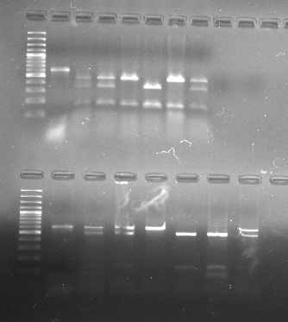
Fig 1: PCR-RFLP of GH using ApaI and HaeII
Upper lane (L): M 100 bp ladder, +3 Kb; L1 undigested PCR amplicon (607 bp); L4 & 6 Allele A1; L5 Allele A2; L2, 3 & 7 Heterozygous (A1A2).
Lower lane (L): L8 undigested PCR amplicon (607 bp); L11 Allele H1; Lane 12 Allele H2; L9 & 10 Heterozygous (H1H2).
M 1 2 3 4 5 6 7
M 8 9 10 11 12
M 1 2 3 4 5 6 7 8 9
M 11 12 13 14 15 16 17

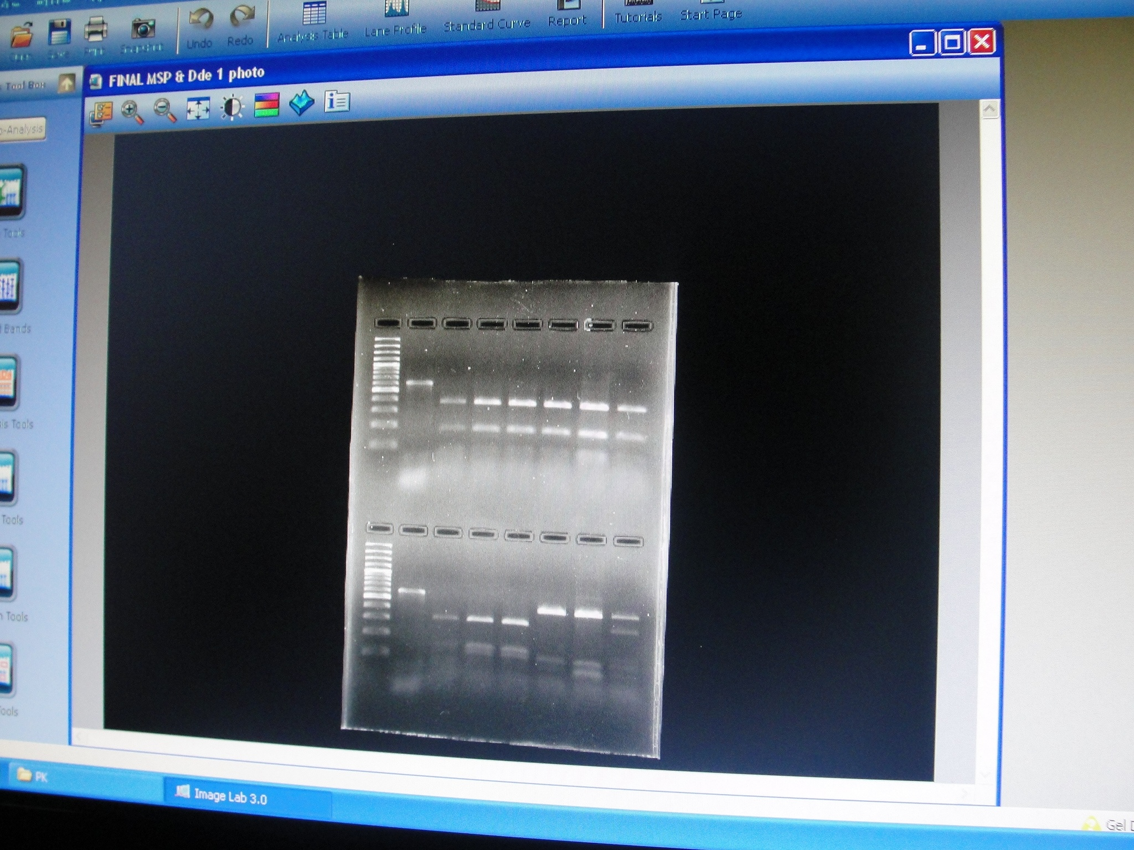
Fig 2: PCR-RFLP of GH using MspI and DdeI
Upper lane (L): M 100 bp ladder, +3 Kb; L1 undigested PCR amplicon (607 bp); L2-7 Heterozygous (M1M2).
Lower lane (L): L8 undigested PCR amplicon (607 bp); L12 & 13 Allele D1; L9-11 Allele D2; L14 Heterozygous (D1D2).
M 1 2 3 4 5 6 7

M 8 9 10 11 12 13 14

Corresponding author: E mail: iiv@rediffmail.com
Dept. of Biotechnology, Gauhati University, Guwahati 781014, Assam
Project Directorate on Animal Disease Monitoring and Surveillance, Hebbal, Bangalore 560024

