Pityriasis in a piglet - A case report
Lathamani. V.S and H.C.Indresh
Assistant Professors, Karnataka Veterinary, Animal and Fisheries Sciences University, Bidar, Karnataka, India
ABSTRCT
A 3 month old cross breed male piglet was presented to the veterinary hospital, C.N.Halli, Tumkur, Karnataka, with a complaint of skin lesions on the ventral aspect of the body since a week. Clinical examination revealed large coalescing ringworm like lesions on ventral abdomen and inner aspect of thighs. The lesions were characterized by ring like small erythematous papules, which form a ring with raised and reddened borders. As the laboratory examination revealed negative results for fungal infection and mite infestation, the condition was diagnosed as Pityriasis Rosea from the physical examination and by recognizing the characteristic lesions. Topical antibiotic cream was given and advised the owner to apply the cream on lesions twice daily, the lesions were started reducing slowly by a week and complete recovery was seen by the end of 6th week.
Key words: Piglet, pityriasis, Erythematous lesions

Pityriasis rosea is a sporadic disease of unknown etiology of pigs, usually 8-14 week old, but occasionally as young as 2 weeks and very rarely in pigs up to 10 months. One or more pigs from the litter may be affected. The disease is mild, but transient anorexia and diarrhea have been reported. But as soon as the skin rash appears, these digestive disturbances disappear. The initial skin lesions were characterized by small erythematous papules, which rapidly expand to form a ring (collarette) with distinct raised borders. The lesions enlarge at their periohery, and adjescent lesions may coalesce. The centre of the lesion is flat and covered with bran- like scale overlying normal skin. The lesions are found predominantly on the ventral abdomen and the inner thighs but occasionally may be seen over the back, neck and legs. Characteristically, there is no pruritus and recovery is spontaneous in 6-8 weeks.
History:
A three month old cross breed male piglet was presented to the Veterinary Hospital, C.N.Halli, Tumkur, with a complaint of skin lesions on the ventral aspect of the body since two weeks. The piglet was weaned and ready to sale. There was no history of diarrhea but the piglet was slightly anorectic. Other piglets of the same age group in the same herd were normal. Owner seeked veterinary assistance because of the appearance of an unsightly skin disease which adversely affected the sale value of the piglet. The animal was already treated with topical antifungal cream for the last one week.
Clinical examination:
Affected piglet had large coalescing ringworm like lesions on ventral abdomen which were spread up to groin region and inner aspect of thighs (fig.1). The lesions were characterized by small erythematous papules, which form a ring with raised and reddened borders. In the centre of the ring a light scab developed and the area was covered with normal bristles. Many ring like lesions of this type coalesced and formed a loose mosaic pattern.
Laboratory findings and Diagnosis:
Brisles and deep skin scrapings were taken from the periphery of the lesion and the samples were heated in 10% sodium hydroxide to remove epithelial debris and a wet mount was examined microscopically to find out mite infestation. The examination revealed negative results for the presence of mites. Even though the lesions were identical to ring worm lesions, it has been ruled out because the lesions were not responding to antifungal cream.
As the other piglets of same herd were normal, we concluded the disease may not be contagious. No infectious agent was found on laboratory examination. So the condition was diagnosed as Pityriasis Rosea from the physical examination and by recognizing the characteristic lesions.
Treatment:
Even though the condition was self limiting topical antibiotic cream was given and advised the owner to apply the cream on lesions twice daily to prevent secondary bacterial infections. The lesions were started reducing slowly by a week and 50% of the lesions disappeared in 3 weeks. Almost complete recovery was seen by the end of 6th week except few lesions in groin region, which become worsen by maggot infestation. Later those wounds were cleaned and treated with meggoticidal sprays regularly and the animal was completely recovered in 6½ weeks.
References:
- Alan R.D. (1995), Skin diseases of Swine, Swine Health and Production, Nov & Dec., 256-261.
- Eddie S. (1988), Pig ailments – Recognition and Treatment, 6th edition, 85-86
Kimura T., Doi K. (2004), Clinical and Histopathological findings in Pustular psoriaform Dermatitis in pigs. J. Vet. Med. Sci., 66(9), 1147-50.
- Reginald T. (1960), Case reports- Pityriasis Rosea in a herd of Swine. Can. Vet. Journal,
Vol.1. No.10. 449-451.
- http://www.merckmanuals.com/vet/integumentary system/ pityriasis rosea in pigs and porcine.

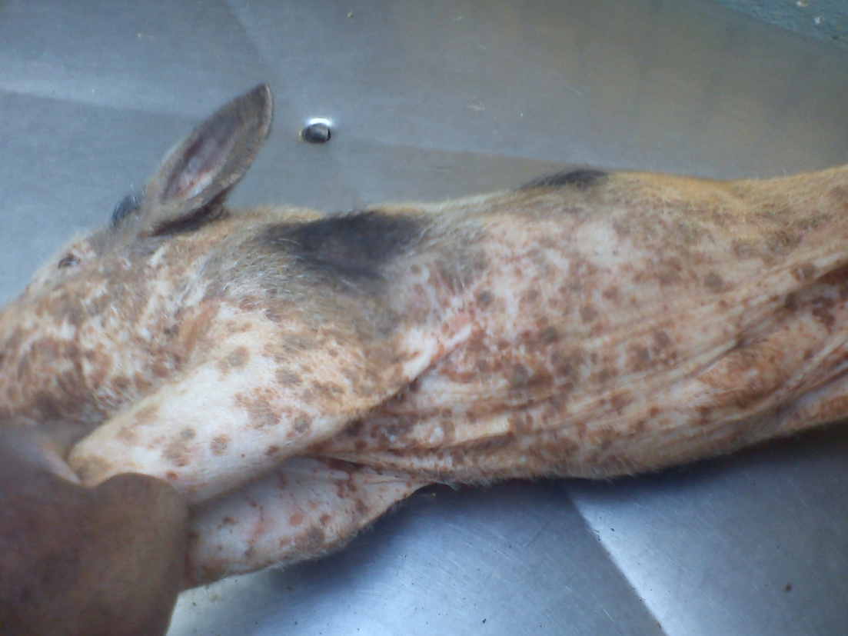

Fig.1 Piglet with Pityriasis skin lesions on ventral side of abdomen, even over neck and legs.

