Inoculation of embryonated eggs
Introduction
The most convenient method of propagating Newcastle disease virus, Avian Influenza and infectious Bronchitis virus in the laboratory is by the inoculation of the allantoic cavity of embryonated eggs.

Incubation of eggs before inoculation
Incubation temperature = 38°C to 39°C.
Humidity should be maintained at 60 to 65 percent. A tray filled with water and placed in the bottom of the incubator is usually sufficient to maintain this level of humidity.
Place the eggs in the incubator with the air sac on top.
Eggs should be turned three times a day.

The anatomy of the embryonated egg
Shell and shell membrane
The membrane is closely attached to the shell. Together they function as an exchange system and gaseous and liquid molecules pass in both directions. This is why eggs must be incubated in humid conditions. Eggs incubated in low humidity will lose moisture and eventually the embryo will die.
Air sac
Eggs have a rounded and a pointed end. The air sac is the space at the rounded end and has a function in respiration and pressure adjustments.
Chorioallantoic membrane and allantoic cavity
The membrane is attached to the embryo and functions to remove soluble, insoluble and gaseous waste products. As the embryo develops, the sac increases in size. The sac contains allantoic fluid into which virus is shed after inoculation of the allantoic cavity. The fluid is harvested for vaccine production.
Some viruses are propagated by inoculation of the chorioallantoic membrane. This involves placing inoculum on the membrane.
Yolk sac
This is also attached to the embryo and contains the nutrient-rich yolk. As the embryo develops, the yolk sac decreases in size to approximately 1 cm diameter 3 days before the embryo hatches.
Amniotic Sac
This sac surrounds the embryo. It is filled with liquid and serves to protect the embryo against physical damage as well as functioning as an area of exchange of molecules. As the embryo develops, the membrane stretches and the amniotic sac is barely visible in the fully developed embryo.
Albumen
The egg white, which consists mainly of protein.

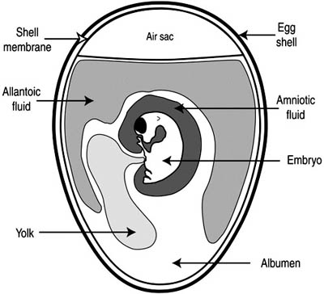

Candling eggs
Candling is the process of holding a strong light above or below the egg to observe the embryo. A candling lamp consists of a strong electric bulb covered by a plastic or aluminium container that has a handle and an aperture. The egg is placed against this aperture and illuminated by the light. If you do not have a candling lamp, improvise. Try using a torch.
Determining the viability of the embryo
Under the candling lamp, the embryo appears as a dark shadow with the head as a dark spot. Healthy embryos will respond to the light by moving. Sometimes the movement is very sluggish and it can take 30 to 40 seconds for the embryo to move when held under the candling lamp. This indicates the embryo is not healthy and the egg should be discarded.
Look carefully at the blood vessels. They are well defined in a healthy embryo. After an embryo has died, the blood vessels start to break down. They then appear as streaks under the shell when viewed under the candling lamp. Candling will also reveal cracks in the eggshells. Eggs with cracked shells should be discarded.
Infertile eggs: These are easy to detect, as the egg is clear. Discard
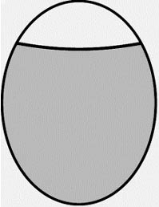
Early deaths: The embryo has developed for several days and then died. Candling will reveal a small dark area and disrupted blood vessels. Often deteriorating blood vessels will appear as a dark ring around the egg. Discard.
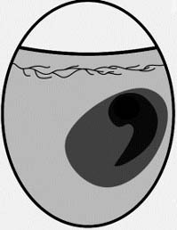
Late Deaths: These are often difficult to tell apart from a viable embryo at the same stage of development. Look for the absence of movement and the breakdown of the blood vessels. Discard
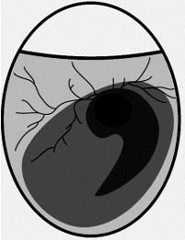
Viable Embryos: These move in response to the light and have well defined blood vessels. Mark the air sac and the inoculation site and then return the eggs to the incubator ready for inoculation.
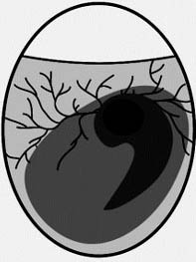
Marking the inoculation site:
1. Hold the blunt end of the egg against the aperture of the candling lamp and note the position of the head of the embryo.
2. Turn the egg a quarter turn away from the head.
3. Draw a line on the shell marking the edge of the air sac.
4. Draw an X approximately 2 mm above this line.
5. The X marks the inoculation site.
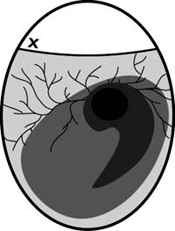

Inoculation of the allantoic cavity
Materials
- Eggs: ten 9-to 11-day old embryonated eggs. Candle the eggs and mark the inoculation sites. Eggs should be placed in an egg rack with the inoculation site uppermost.
- Egg shell punch.
- Cotton wool.
- A 70 percent alcohol solution in water.
- Syringe 1 mL.
- Needles preferably 25 gauge, 16 mm.
- Stationery tape (also called cello or sticky tape) or melted wax to seal the inoculation site.
- Inoculum. This must be free of microbial contamination.
- Discard tray.
Method
1. Use cotton wool and 70 percent alcohol to swab the end of the eggs to be inoculated. Allow the alcohol to evaporate.
2. Swab the eggshell punch with 70 percent alcohol solution. Place used cotton wool in discard tray.
3. Pierce a hole in the end of the egg at the marked inoculation site.
4. Attach needle to 1 mL syringe.
5. Draw inoculum into 1 mL syringe.
6. Keeping the needle and syringe vertical, place the needle through the hole in the eggshell. The needle will need to penetrate approximately 16 mm into the egg to reach the allantoic / Chorioallantoic cavity.
7. Inject 0.2 mL of inoculum into the egg.
8. Withdraw the needle from the egg.
9. Seal the hole in the shell with stationery tape or melted wax.
10. Discard the used needles and syringes.
11. Place the inoculated eggs into a second incubator. Check the temperature and humidity of incubator.
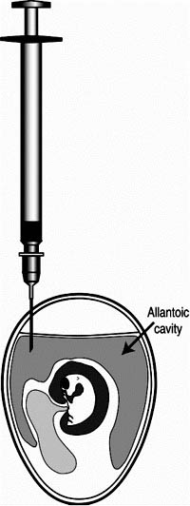

Incubation of eggs after inoculation
Inoculated eggs contain virus and should be placed in a different incubator. Eggs inoculated with virus should not be incubated in the same incubator as non inoculated eggs.
Inoculated eggs are incubated under the same conditions as uninoculated eggs but do NOT turn the eggs.
12. The eggs are candled daily, mortality between days 2 and 7 postinoculation considered to be virus specific.
13. On day 3 PI, 5 eggs are removed from the incubator and are placed at 4 C for 18-24 hr.
14. Harvest the allantoic fluid,
During the harvesting of allantoic fluid steps must be taken to minimize the risk of exposure of the allantoic fluid to environmental contaminants. The following list contains appropriate steps to be taken.
Use aseptic technique to harvest the allantoic fluid.
Harvest the allantoic fluid in a laminar flow cabinet. Routine servicing of the cabinet should be carried out to ensure sterile conditions inside the cabinet.
Remove all materials not associated with the harvesting process from the laminar flow cabinet.
Thoroughly clean the cabinet with disinfectant. Irradiation with UV light prior to harvesting egg will help kill contaminating organisms.
You should wear clean laboratory coats, clean hair covers, facemasks and scrub their hands with an antimicrobial soap.
Harvesting allantoic fluid
Materials
- Forceps or a small pair of scissors
- 70% alcohol
- Cotton wool
- Discard tray
- 50 mL micropipette and tips or a wire loop
- Sterile Pasteur pipettes with short blunt ends
- Sterile containers for receiving the harvested allantoic fluid.
Method
1. Chill eggs at 4°C to kill the embryo and to reduce the contamination of the allantoic fluid with blood during harvesting.
2. Swab each egg with cotton wool soaked with 70 percent alcohol to disinfect and remove condensation from the shells.
3. Remove the eggshell above the air space using forceps, take the top of the shell off and discared.
4. Discard embryos that are visibly contaminated.
5. Collect the allantoic fluid from each egg, keep on Ice. Use a micropipette and sterile tip, sterile glass pipette or Pasteur pipette. Use clean forceps to hold back the membranes as fluid is being drawn off.
6. Centrifuge collected fluids at 1000g for 10 minutes, check the haemagglutination activity with chicken red blood cells (see below).
7. Test each container for bacterial contamination incubation at 37°C overnight. After 24 hours, read the results of the tests for bacterial contamination.
8. Use aseptic technique to transfer the clear allantoic fluid supernatant from containers that showed no bacterial growth into a sterile container for storage. Aliquot and store the fluid at -70 C until required. The optimum temperature for storage of allantoic fluid containing live virus is -70°C. Storage at -20°C is not as effective and the infectivity titre will slowly decrease. The action of the freezing and thawing also decreases the infectivity titre of the virus. Allantoic fluid containing IB virus can be stored for up to 2 days at 4°C without significant loss of titre.
The remaining eggs are incubated up to 7 days and are then observed for typical IBV lesions, such as stunting, curling of the embryos.

Titration to establish haemagglutinin (HA) titre of virus
The haemagglutination test is used to quantify the amount of IB virus in a suspension. This is done by carrying out two-fold serial dilutions of the viral suspension in a microwell plate and then testing to determine an end point. This result can then be used to determine the amount of haemagglutinin in the suspension and is expressed as a HA titre.
Materials
- 96 well V-bottom microwell plate and cover
- 25 mL single and multi-channel micropipettes and tips
- PBS (+Ca and Mg)
- 1 percent chicken red blood cells
- Sample to be titrated
- Reagent troughs
- Microwell plate recording sheet.
Method
1. Record on recording sheets how samples will be dispensed in microwell plate.
2. Dispense 25 µL of PBS into each well of the microwell plate.
3. Place 25 µL of test samples in first well of each row of column 1. Samples can be tested in duplicate or triplicate if necessary.
4. Use a multichannel pipette to carry out two-fold serial dilutions across the plate until Column 11.
5. Add 25 µL of PBS to each well.
6. Add 25 µL of 1 percent red blood cells to each well including Column 12. The wells in this column are control wells that contain only PBS and red blood cells.
7. Gently tap sides of the plate to mix. Place a cover on the plate.
8. Allow the plate to stand for 45 minutes at 4 C.
9. Read and record the results in each well. All the control wells should be HA negative.
10. HA negative: A sharp button of red blood cells at the bottom of the V-bottom well.
11. HA positive: A hazy film of red blood cells, no button or a very a small button of red blood cells at the bottom of the V-bottom well.
12. Identify the end point. This will be the last well to show complete haemagglutination and contains one haemagglutinating unit.

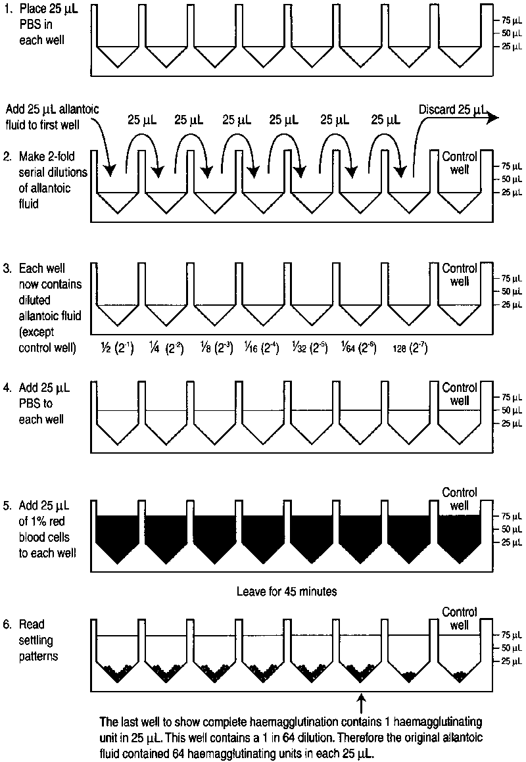

ISOLATION OF TOTAL RNA FROM SUSPECT SAMPLES USING THE TRIZOL LS REAGENT OR TRIS REAGENT

The 6 samples were analyzed for the EAV isolation.

Reagents and materials
Samples – secretions, suspensions, virus isolates
TRIzol LS reagent (Invitrogen) or Tris reagent (Sigma)
Chloroform
Isopropanol
75% ethanol
DEPC-treated water
Microcentrifuge
Microcentrifuge tubes
Racks for 1.5 ml tubes
Micropipettes: P1000, P200, P20
ART tips for P1000, P200, P20
Gloves
Container with chlorine to eject in tips

Procedure

- Pipette 750 µl of TRIzol LS reagent into 1.5 ml microcentrifuge tubes (in the clean lab).

- Add 250 µl of sample and mix by flicking the tubes. Incubate for 5 min. at room temperature.

- Add 200 µl of chloroform. Cap the tubes securely and shake them vigorously for 15 seconds, by hand. Incubate for 2-3 min. at room temperature.

- Centrifuge the tubes at 13 500 rpm for 15 min. in a refrigerated microcentrifuge. The mixture separates into a lower red, phenol-chloroform phase, an interphase and a colorless upper aqueous phase. The RNA is in the aqueous phase.

- Transfer the aqueous phase to a clean microcentrifuge tube. Add 500 µl of isopropanol. Mix the isopropanol and aqueous phase by inverting the tube.

- Incubate for 10 min. at room temperature (preferably at –20°C overnight).

- Centrifuge at 13 500 rpm for 30 min. in a refrigerated microcentrifuge. The RNA forms a gel-like pellet on the side bottom of the tube.

- Remove the isopropanol without disturbing the pellet.

- Wash the pellet once with 75% ethanol: put 1 ml of 75% ethanol and centrifuge at 10 000 rpm for 10 min. in a refrigerated microcentrifuge.

- Remove the ethanol without disturbing the pellet. Air-dry the pellet.

- Resuspend the RNA pellet in 20-50 µl RNAse-free water or DEPC-treated water (DEPC-H₂O), depending on the thickness of the pellet.

- Keep the tubes on ice while using them or freeze them at –70°C if not used immediately, or for long-term storage.

SYNTHESIS OF cDNA BY RANDOM PRIMING

First:

- Prepare the tube holders (1 for 1,5 ml tubes and 1for 0.5 ml tubes) and the tube openers in the RNA cabin in the Prep Lab. Have a box with ice also.
- Check that all needed reagents are available and prepared to working concentrations (ex: pdN6 has to be diluted 1:10; dNTP mix has to be prepared as a 10mM mix of each dNTP). Set the reactions (steps 1 and 2) in the Clean Lab, then take the tubes out to continue in the Prep Lab.

1) Denaturation reaction:

Mix the following reagents, per reaction, in a 0.5 ml tube

Components Per reaction
pdN6 (1:10) 2 µl
ddH₂O 3 µl

You can prepare this as a master mix and distribute 5 µl in each tube.

2) RT reaction mix

Mix the following reagents, per reaction, in a 0.5 ml tube

Components Per reaction
5x 1st strand buffer 4 µl
0.1 M DTT 2 µl
dNTP mix (10 mM) 2 µl
RNasin (32 U) 1 µl
M-MLV RT (200 U) 1 µl

3) Take the tubes to the Prep Lab and keep the RT reaction mix on ice.

4) Add 5 µl of RNA to each corresponding tube containing the denaturation mix.

5) Quick spin to collect the contents in the bottom of the tube.

6) Place the tubes in the thermoblock at 65°C for 10 min. to allow denaturation of the RNA

7) Take the tubes from the thermoblock and place them immediately on ice. Leave for at least 2 min.

8) Add 10 µl of the RT mix to the corresponding tube containing the denatured RNA. The total volume of the reaction is 20 µl.

9) Place the tubes on the thermocycler and run the RT program (RT2 or cDNA2). Att: the thermocycler should be at 22°C when you place the tubes in.
42°C/50 min; 72°C/20 min.

10) Remove the tubes from the thermocycler and keep the cDNA at +4°C while in use or at -20°C for long term storage (in Prep Lab).

Synthesis of single stranded cDNA by superscript II

1) Denaturation reaction:

Mix the following reagents, per reaction, in a 0.5 ml tube

Components Per reaction
Primer Reverse CO2 2 µl
ddH₂O 3 µl

You can prepare this as a master mix and distribute 5 µl in each tube.

2) RT reaction mix

Mix the following reagents, per reaction, in a 0.5 ml tube

Components Per reaction
5x 1st strand buffer 4 µl
0.1 M DTT 2 µl
dNTP mix (10 mM) 2 µl
RNaseOut (40 U) 1 µl
Superscript II RT (200 U) 1 µl

3) Take the tubes to the Prep Lab and keep the RT reaction mix on ice.

4) Add 5 µl of RNA to each corresponding tube containing the denaturation mix.

5) Quick spin to collect the contents in the bottom of the tube.

6) Place the tubes in the thermoblock at 65°C for 10 min. to allow denaturation of the RNA

7) Take the tubes from the thermoblock and place them immediately on ice. Leave for at least 2 min.

8) Add 10 µl of the RT mix into each tube.

9) Spin the tube to collect the contents at bottom.

10) Transfer the tubes to the thermocycler for RT Superscript II

Thermocycle Profile
42⁰C for 60 min. ( for reverse transcription)
70°C for 15 min. ( for enzyme inactivation)
4 °C forever

11) Add 1 µl of RNase H (2U) to each tube and incubate at 37 ⁰C for 20 min. Note. This step is optional if you are amplifying short targets (<1.0kb) in end-point PCR.

12) Chill the reaction on ice.

13) Keep the cDNA at +4°C while in use or at -20°C for long term storage
(in Prep Lab).

Synthesis of single stranded cDNA by superscript III

1) Denaturation reaction:

Mix the following reagents, per reaction, in a 0.5 ml tube

Components Per reaction
CO2 2 µl
ddH₂O 3 µl

You can prepare this as a master mix and distribute 5 µl in each tube.

2) RT reaction mix

Mix the following reagents, per reaction, in a 0.5 ml tube

Components Per reaction
5x 1st strand buffer 4 µl
0.1 M DTT 2 µl
dNTP mix (10 mM) 2 µl
RNaseOut (40 U) 1 µl
Superscript III RT (200 U) 1 µl

3) Take the tubes to the Prep Lab and keep the RT reaction mix on ice.

4) Add 5 µl of RNA to each corresponding tube containing the denaturation mix.

5) Quick spin to collect the contents in the bottom of the tube.

6) Place the tubes in the thermoblock at 70°C for 5 min. to allow denaturation of the RNA

7) Take the tubes from the thermoblock and place them directly on ice. Leave for at least 2 min.

8) Mix gently and spin the tube to collect the contents.

9) Transfer the tubes on the thermocycler preheated to 50 ⁰C. Incubate for 60 min.

10) Add 1 µl of RNase H (2U) to each tube and incubate at 37 ⁰C for 20 min. Note. This step is optional if you are amplifying short targets (<1.0kb) in end-point PCR.

11) Chill the reaction on ice.

10) Keep the cDNA at +4°C while in use or at -20°C for long term storage
(in Prep Lab).

PCR amplification of the S1 gene Infectious bronchitis Virus

PCR I reaction mix
Components Per reaction
ddH2O 34 µl
10x PCR buffer 5 µl
dNTPs (10mM mix) 1 µl
Primer CO1 (10 pmole/µl) 1 µl
Primer CO2 (10 pmole/µl) 1 µl
MgCl2 (25mM) 3 µl
Taq DNA polymerase (1:10) 2 µl
cDNA 3 µl

Total 50 µl

Cycling Profile
94⁰C/2 min
94⁰C/30 sec; 55⁰C/30sec; 72⁰C/1.30min 35 cycles
72⁰C/7 min; 4⁰C/inf

