Advance Operating System

Project Proposal

Operating System Support for Mobile, Interactive, Multi-Fidelity Applications

Submitted BY: Muhammad Asaf Khan

Submitted To: Dr. Sanam Shehla Rizwi

M.Phil Software Engineering

Preston University, Islamabad Campus

Abstract

The need for specialized operating systems to host mobile computers and provide application development opportunities has risen due to the proliferation of cell phone users. Because phones have become such pervasive and affordable mobile computers, developers and users need a development environment that allows more of its users to create unique and specialized applications that are affordable. This paper provides a comparison of Android, the Symbian Operating System and Apple's Mac Operating System that identifies the role of an operating system in forwarding a successful mobile technology. It also demonstrates the need for operating systems that are open-sourced and that provide an easier way to develop applications.
A mobile operating system, also referred to as mobile OS, is the Operating System that operates a smartphone, tablet, PDA, or other digital mobile device. Modern mobile operating systems combine the features of a personal computer operating system with other features, including a touchscreen, cellular, Bluetooth, WiFi, GPS mobile navigation, camera, video camera, speech recognition, voice recorder, music player, Near field communication and Infrared Blaster.
This paper also introduces and defines the notion of multi-fidelity computation, and makes the case that it is valuable approach to meeting the needs of interactive applications on mobile computers. These applications are constrained by the need for good interactive response, and efficient use of scarce resources such as user attention, battery power and wireless network. Multi-fidelity computation is an abstraction that captures a wide range of algorithms and techniques to trade output specification for resource consumption.

Objective
The ultimate aim of multi-fidelity system support is to enable real applications to run more effectively.

Applications
Mobile Phones comparisons with Market Share and Operating Systems are given below.
- Symbian OS
- Android
- Mac OS X (iPhone)
- Others (Windows Mobile, BlackBerry, Palm, Linux)
- Cross platform: Java ME

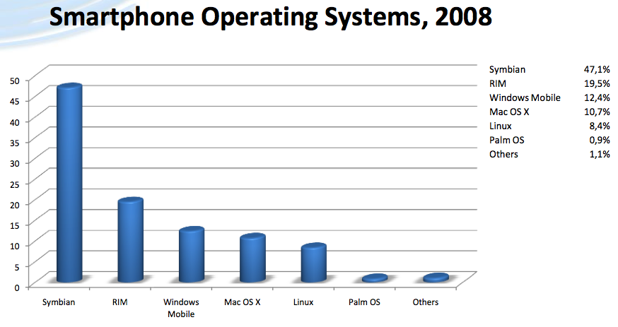

Fig: Smartphone Operating Systems Comparison

References
[1] S Pope. Application Migration for Mobile Computers. In Proceedings of the 3rd International Workshop on Services in Distributed and Networked Environments, pages 2027, Macau, June 1996 IEEE.
[2] B Rajagopalan. Mobility Management in Integrated Wireless ATM Networks. In Proceedings of Mobicom. Berkeley, 1995 IEEE.
[3] T Roscoe. The Structure of a Multi-Service Operating System. PhD thesis, University of Cambridge Computer Laboratory. April 1995

