Online Social Networks: Threats and Solutions
Syed Faran Sattar
Reg. number: 1093-313066
faranshahonline@gmail.com

Many online social network (OSN) users are unaware of the numerous security risks that exist in these networks, including privacy violations, identity theft, and sexual harassment, just to mention a few. According to recent studies, many online social network users readily expose personal and private details about themselves, such as relationship status, date of birth, school name, email address, phone number, and even home address. This information, if fallen into the wrong hands, can be used to harm users, both in the virtual and in the real world. These risks become even more severe when the users are children. In this proposal we propose a review of the different security and privacy risks which threaten the well-being of OSN users in general, and children in particular. In addition, we present an overview of existing solutions that can provide better protection,security, and privacy for OSN users. Moreover, we offer simple-to-implement recommendations for OSN users whichcan assist them in improving their security and privacy when using these platforms. We conclude this paper by suggesting future research directions.

Keywords:
Online Social Networks, Security and Privacy, OnlineSocial Network Security Threats, Online Social Network Security Solutions.

Introduction:
In recent years, global online social network (OSN) usage has increasedsharply as these networks become interwoven into people's everyday livesas places to meet and communicate with others. Online social networks,such as Facebook, Google, LinkedIn, Twitter, Tumblr have hundreds of millionsof daily active users. Facebook, for example, has more than1.15 billion monthly active users, 819 million of which are active mobileFacebook users as of June 2013.

As the use of online social networks becomes progressively more embedded into the everyday lives of users, personal information becomes easily exposed and abused. Information harvesting, by both the online social network operator itself and by third-party commercial companies, has recently been identified as a significant security concern for OSN users. Companies can use the harvested personal information for a variety of purposes, all of which can jeopardize a user's privacy. For example, companies can use collected private information to tailor online ads according to a user's profile, to gain profitable insights about their customers, or even to share the user's private and personal data with the government. This information may include general data, such as age, gender, and income.

These privacy issues become more alarming when considering the nature of online social networks: information can be obtained on a network user without even directly accessing that individual's online prole; personal details can be inferred solely by collecting data on the user's friends

Online Social Network Usage:

Today, many online social networks have tens of millions registered users.Facebook, with more than billion active users, is currently the biggest andmost popular OSN in the world. Other well-known OSNs are Google+,with over 235 million active users. Twitter, with over 200 million activeusers and LinkedIn, with more than 160 million active users. Whilesome experts insist that online social networks are a passing fashion and willeventually be replaced by another Internet fad, current user statistics concurthat OSNs are here to stay.

Threats:

With the increasing usage of online social networks, many users have unknowinglybecome exposed to various threats, both on their privacy and ontheir security. These threats can be divided into two main categories The first category relates to classic privacy and security threats,namely, threats that not only jeopardize OSN users but Internet users notusing social networks as well. The second category concernsmodern OSN threats, namely, threats that are mostly unique to the environmentof online social networks and which use the OSN infrastructure toendanger user privacy and security.
In recent years, social network operators, security companies, and academicresearchers have tried to deal with the above-mentioned threats throughproposing a variety of solutions (see Figure 1 and Figure2). I will provide complete details while my this proposal accepted in protecting the security and privacy of online social network users.

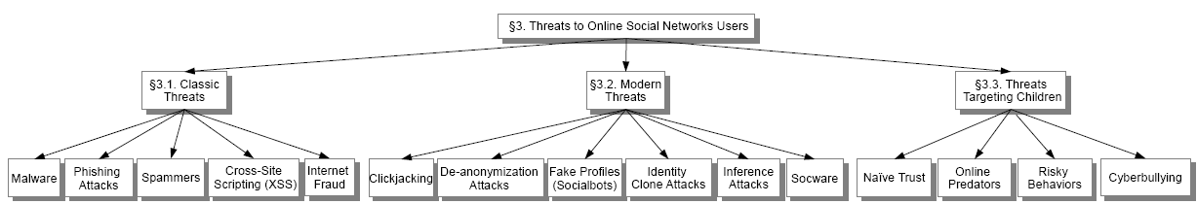

Figure 1: Classic and Modern Threats to Online Social Network Users.

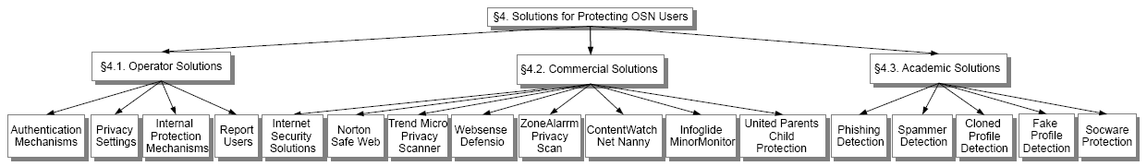

Figure 3: Security and Privacy Solutions for Online Social Networks.

References:

[1] Academia.edu. http://www.academia.edu/. [Online; accessed 08-September-2013].
[2] A. Acquisti and R. Gross.Imagined Communities: Awareness, Information Sharing, and Privacy on the Facebook. 2006.
[3] A. Aggarwal, J. Almeida, and P. Kumaraguru.Detection of spam tippingbehaviour on foursquare. In Proceedings of the 22nd internationalconference on World Wide Web companion, pages 641_648. InternationalWorld Wide Web Conferences Steering Committee, 2013.
[4] A. Aggarwal, A. Rajadesingan, and P. Kumaraguru.Phishari: Automaticrealtime phishing detection on twitter. In eCrime ResearchersSummit (eCrime), 2012, pages 1_12. IEEE, 2012.

