Laboratory of Virology and Infectious Disease (Rice Lab) 10/20/11

pTRIP.CMV.IVSB.Fluc[ISG].ires.TagRFP

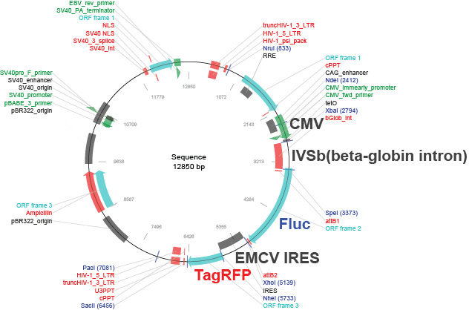

Clone information

Description
Bicistronic lentiviral vector for expressing a gene of interest (firefly luciferase, in this example) in the first cistron with TagRFP in the second cistron. This plasmid is derived from the parental DEST vector pTRIP.CMV.IVSB.ires.TagRFP-DEST. It was generated by performing an LR reaction with LR Clonase II (Invitrogen) and pENTR221.Fluc. This plasmid is used to generate lentivirus stocks in conjunction with pCMV-gag-pol and pCMV.VSVg.

NOTE: All ISG expressing plasmids have the same architecture as this Fluc expressing construct. An ISG expressing version can be generated in any plasmid software package by deleting the ORF for Fluc and replacing with the ORF for the ISG of interest.

Location of features
CMV promoter: 2411-2794
Beta globin intron: 2794-3373
Fluc: 3437-5089
EMCV IRES: 5147-5733
TagRFP: 5739-6452

Propagation in E. coli
Recommended host strains: MDS42Rec (from Scarab Genomics) or DH5α
Resistance: ampicillin (100 μg/ml)
Copy number: high

Lentivirus particle production

To generate lenti PP, three plasmids are needed: pTRIP, pCMV-VSVg, and pGag-pol.
For generating PP, The steps are as follows:

1. The day before transfection of DNA, split 293T and plate 400,000 cells/well on a 6 well plate that has been coated with poly-lysine.

2. The day of transfection, mix 6ul XtremeGene9 (Roche Cat# 06365809001) into 100ul Optimem (Invitrogen Cat# 51985-034) and let stand for 5 min…if there are many samples, a master mix can be made.

3. Aliquot DNAs into eppendorf tubes. The ratio of the plasmids for lentivirus production is:
pTRIP(GFP): 1.0ug
pCMV-VSVg: 0.2ug
pGag-pol: 0.8ug

4. Add 106 ul of the Optimem/XtremeGene9 mix to the DNA samples. Let this mix stand for at least 20 minutes at room temp.

5. During this 20min, change the media of the cells to DMEM (Invitrogen Cat#11995-065)/3%FCS/1%NEAA. Use 1.0ml media per well.

6. Add DNA mix to cells drop-wise and place back in incubator. Swirl plate to mix. 6 hours post-transfection, change media to 1.5 ml DMEM/3%FCS/1%NEAA.

7. 48 hours post-transfection, gently harvest the media from the cells. Add 1.5ml of fresh media (DMEM/3%FCS/1%NEAA) to the cells. Place the snap-cap tubes in a rack in the 4C fridge until the next day.

9. The next day (at 72 hours), repeat the harvesting as above. To each prep, add HEPES to a final concentration of 20mM and polybrene to final concentration of 4ug/ul.

10. Spin the 5ml tubes containing the supernatant at 1500rpm (520G) for 5 min in the table-top centrifuge to pellet cell debris. Alternatively, samples can be passed through a 0.45um syringe filter. Aliquot the supernatant into desired volume. Store at -80C.

References
A diverse range of gene products are effectors of the type I interferon antiviral response.
Schoggins JW, Wilson SJ, Panis M, Murphy MY, Jones CT, Bieniasz P, Rice CM.
Nature. 2011 Apr 28;472(7344):481-5

