Vetworks Eastern Africa
P.O. Box 10431-00200
Nairobi

16th August, 2014
Muhammad Munir
Editor-in-Chief
British Journal of Virology

Re: Cover letter for the revised case report manuscript

I do hereby request your Journal (British Journal of Virology) to publish our case report. I have attached in this cover letter the detail revisions
Attached please find a revised case report entitled “Clinical, pathological and molecular investigation of Peste des petits ruminants virus infection in goats from Turkana County in Kenya” for your review and publishing.

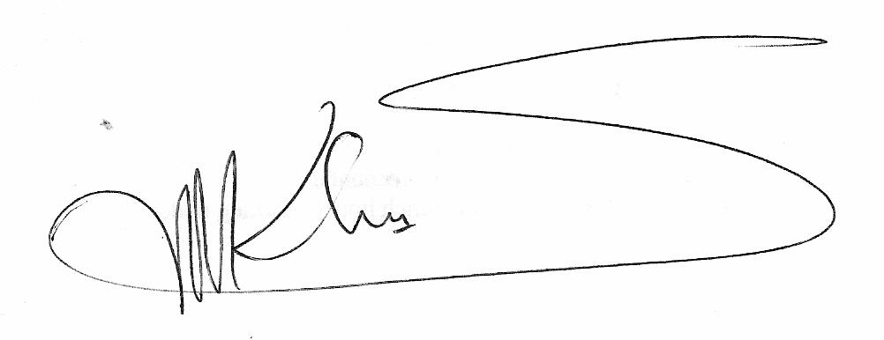

Best regards
Simon M. Kihu
Reviews ( line numbers related to older manuscript)
Page 2
Sentences in line 5,6 and 7 rewarded
Sentences in line 7, 8 and 9 deleted
Overall the abstract was reduced to 12 lines from 13 lines
Line 15 (key words) and 16 deleted
Line 27 and 28 deleted
Page 3
Line 1, 2 and 3 deleted
Line 9, 10, 11, 12 and 13 deleted
Line 14 to 25 were reorganized reworded and paragraphs joined.
Page 4
Lines 1, 2, 3, 4 and 5 being a paragraph was moved to end of this section.
Lines 6, 13, 22 deleted
Paragraphs starting from lines 7, 14 and 22 were joined.
Page 5
Lines between line 4 second sentence to line 25 were deleted.
Page 6
Lines 1, 2, 3, 4, 5, 11, 16, 19, 20 and 21were deleted
The paragraphs starting at line 6, 12, 17 and 22 were joined.
Line 17 was rewarded
Page 7
Lines 1, 2, 3, 14 and 24 were deleted
Lines 4, 15, 19 and 21 was reworded
Page 8
Lines 1, 2, 3, 22 and 23 were deleted.
Page 9
Line 15 to 19 were deleted

