Dear Editor in-Chief
I am submitting a revised manuscript entitled “Responses of antioxidative defense system and photosynthetic pigment composition of Brassica juncea L. to imidacloprid stress” in your esteemed journal “Biotic and Abiotic Stress Journal”. And I hereby declare that this manuscript has not been published or submitted to any other journal.
Please see the below attached rebuttal.

Thanking you in anticipation.
Best Regards
Mudasir Irfan Dar
Environmental Botany Section
Department of Botany
AMU, Aligarh - 202002
INDIA

Rebuttal
Reviewer#1
Comment: How was the application standardized? ……………………………..surface of leaves.
Response: Calculations for received chemical per plant
Imidacloprid (17.8% SL) 5, 10, 20 & 40 g active ingredient
5/0.178 = 28.08g /L for 5g active ingredients, (likewise 56.17g/L, 112.35g/L, 224.71g/L for 10, 20 & 40g active ingredients respectively)
For 5g.a.i, foliar spray of 3 ml solution/plant furnished 0.028g x 3 = 0.08g/plant. Likewise, other treatments received 0.168g, 0.337g, 0.674g/plant, respectively.
- The nozzle of the sprayer was adjusted in such a way that it pumped out 1 ml (approx.) in one sprinkle and each plant was sprinkled thrice (3 plants were maintained in each pot). Accordingly, each plant received 3 ml of DDW or insecticide solution.
- Surfactant “Tween-20” (0.5%) was mixed with each desired pesticide dose just before the spray to (1). enhance spreading of spray droplets on the leaf surface, (2). to facilitate even-absorption on leaf surface and (3). to delay the drying of leaf. Moreover, the spraying was done at the evening time to minimise the evaporation of solutions. Being systemic in nature, pesticide redistributes itself in the system evenly. (Added in material and methods section; Page 13, lines 306-315)
The amount of water which should be used to mix with the pesticide for spraying depends on plant size and plant density. The way to find out how much water is needed is to calibrate the sprayer.
Sprayer was calibrated by spraying DDW on separate set of plants which were of same age group and size. Through our calibration we found that approximately 3mL were needed to spray per plant. Each Pot contained 3 seedlings as described in Materials and Methods. 3mL of fluid spray were needed to completely wash all the leaves of one single seedling in each pot.
Since we used 4 replicates for each treatment. Therefore through our calibration and calculation we need to spray 09 mL (3 × 3) for each pot and 36 mL for each dose (9 x 4). But it was not possible to dissolve 168.53 g of insecticide in 36 ml. So we dissolved it in 1 litre of double distilled water.
Therefore the final concentration of the solution used to dissolve the required amount of insecticide for each dose was 1 litre DDW.

Comment: What is the logic behind first measurement being done on day 3 after the application? ………………….. exposed to sunlight?
Response: The half life of Imidacloprid is 3-5 days in sunlight (Mukherjee and Gopal, 2000) and was not detected after 7 and 15 days of foliar treatments from lower (20 g a.i/ha) and higher rates (40 g.a.i/ha) of application (Kumar and Dikshit 2001). Therefore, based on the findings of these authors and confirmed by preliminary tests (not shown in manuscript) measurement was done after 3, 7 and 15 days of foliar spray.
Comment: Fig-1, although it …….. ……………………………. be checked in this paper it is given as 5, 10, 20 and 40, perhaps it should be 10, 20, 30, 40(g/.ha)
Response: Although the figure-1 was not clear. Its label which shows the MDA content in nmol/g starts from 10 which created confusion. Actually control in this figure moves from 16.41 nmol/g (day-3) to 31.44 nmol/g (day-15) a rise of about 91% and not from 10 nmol/g (day-3) to 31 nmol/g (day-15). A new figure is incorporated in the form of bar graphs in which it is very clear that control moves from 16.41 nmol/g to 31.44 nmol/g from day 3 to day 15 respectively (the rise of about only 91% which is in good agreement with other test cases) Please see Fig.1.
As per suggestion of reviewer, the concentration of insecticide used in the experiment is checked and it is 5, 10, 20 and 40 g.a.i/ha.
Comment: Fig-2 has no variation ……………………………………. say 2 or 3 hours after application.
Response: On the basis of preliminary tests and findings of above mentioned authors day of application was standardized to start from day 3rd.
Comment: The discussion must make a mention of as to how the exposure on day-0 is sustained till 3, 7 or 10 days. Ref..
Response: Mentioned in Discussion section (page 7; line numbers 148-152)
Comment: The discussion has ……………………………………… content say that this could be because of antioxidative effects imidacloprid side chain!
Response: In MDA content, 91% increase was observed in control from (day-3) to day 15, which suggests that it is not so enormous. It favours the no change in proline content.
Comment: Fig-3 gives SOD activity ………………………… incremental change for control and test cases for any significant variation.
Response: SOD activity showed decline on day 15. It may be due to aging, acclimation (e.g metabolization of insecticide). However, the values were higher for treatments, compared to controls.
Comment: Units for ascorbate/dehydroascorbate content should be checked…is it mmol/g? One mmol of ascorbate is 176 mg.
Response: Erroneously it was typed mmol rather than micromole (µ mol). The typological error has been corrected in graph and text, wherever required.
Comment: Legend and figure do not match for fig-5 and fig-6
Response: As per suggestion of reviewer, the error has been corrected.

Reviewer#2
Comment: It is not …………………………………………….. The effects of the insecticide may last longer than 15 days post-treatment.
Response: The explanation has been given as above (query no. 02; please see lines 148-152 in Discussion section)
Control plants were sprayed with distilled water and surfactant Tween 20 (0.5%), which is now mentioned in the Materials and methods section (Page 13, line 308)

Comment: When 30 g/ha of ………………………………… really as a final concentration?
Response: The calculations of chemical used in different concentrations received by plants are illustrated in query no. 01.
Comment: While the authors talk about “growth stages”, ………………………………………… effects of the insecticide on plants at the different points of treatment.
Response: Now growth stages and number of plants are defined in material and methods section (page 14; line number 317).
Plants were watched every day after the treatment and some visible effects in the form of marginal necrosis of leaf were observed after 10 days of treatment at 40 g.a.i/ha (please see the jpg images attached on last page).
Image 1 shows marginal necrosis started developing in Brassica leaves after 10 days of foliar spray of 40 g.a.i imidacloprid.
Image 2 shows the marginal necrosis of Brassica leaves after 20 days of imidacloprid (40 g.a.i) treatment). Earlier on, no any visual effect was described in result section, but now above mentioned symptom is discussed in result section (2.1; page 4; lines 87-89) and also discussed in Discussion section (page 7; lines 153- 156).
Comment: Page 7, lines 6-10: “Like chlorophyll content, ……………………………… …………………………”. How these changes …….. .. the insecticide being used?
Response: Increase in chlorophyll and carotenoid contents have also been reported in previous studies by some authors
Parween et al. (2011). Assessing the impact of chlorpyrifos on growth, photosynthetic pigments and yield in Vigna radiata L. at different phonological stages.
Gonias et al. (2008). Physiologic Response of Cotton to the Insecticide Imidacloprid under High-Temperature Stress).
Baozhen et al. (2013). The effects of imidacloprid on maize chlorophyll contents at different application times. (Chinese abstract).
But it is yet unclear how imidacloprid cause such increments in photosynthetic pigments, though it could be presumed it might interfere with P metabolism to induce biosynthesis of carotenoid and xanthophylls pigments. Mentioned in discussion section, page 11; lines 256 to 262).
Comment: In the discussion ………………………………………… as there are some long sentences copied verbatim.
Response: Now the sentences have been paraphrased and totally changed from the original one (page 10; line numbers 233-237).
Comment: Figures: Absence of data relating to control in figure 1.
In my opinion, the ………………………………………… (fig-1, fig-2, etc.) and keep the figure numbers below the figure only.
Response: As per the suggestion of reviewer, Fig-1 has been rectified and has been shown in the form of bar graphs.
As per the suggestions of reviewer, the interpretation about small letters on bar graphs has been now clearly mentioned. (please see the red coloured portion of each caption).
Figure number from inside the figures is also removed.
Changes made in the Manuscript are highlighted with red colour.

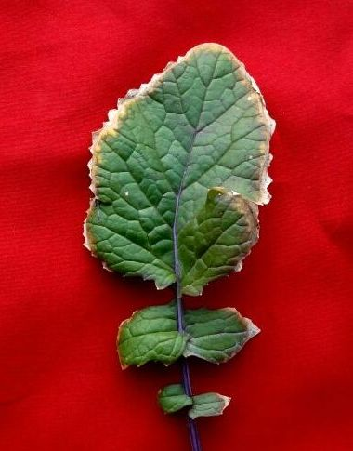
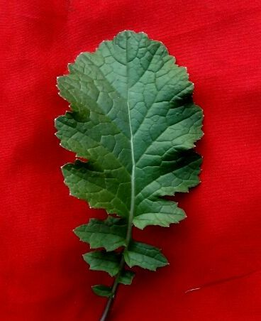
Image 2
Image 1

Image 1 shows marginal necrosis just started developing in Brassica leaves after 10 days of foliar spray of 40 g.a.i imidacloprid. Image 2 shows the area covered by marginal necrosis of Brassica leaves after 20 days of imidacloprid (40 g.a.i).

