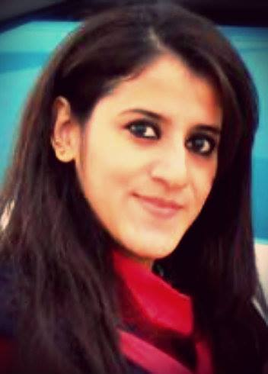
AYESHA MARYAM
Address: House No.P-105, st no 7, Ayub colony,
Jhang road. Faisalabad.
E-mail: maryam.ayesha_22@rocketmail.com
Contact no: 0300-9656313

0bjective
To apply my professional knowledge and skills in challenging environments with dedication and commitment leading to the growth and development of organization. To achieve professional, excellence and career oriented job in a professional environment where I can use my knowledge and skills and implement what I have gained and an environment to explore my creative propensity and provide growth opportunity. Looking for and willing to consider suitable position in either the private and government sector.
Personal Information
Father name : Abdul Razzaq
Date of birth : 23-07-1991
N.I.C : 33100-2720390-2
Marital status : Signal
Religion : Islam
Domicile : Faisalabad (Punjab) Pakistan.
Academic Qualification
Degree | Institution | Major Subjects | Division/CGPA | Year
M.Sc. (Hons) | University of Agriculture Faisalabad | Horticulture (postharvest) | 3.68 | 2016
B.Sc (Hons) | University of Agriculture Faisalabad | Agriculture Science (Horticulture) | 3.42 | 2014
Intermediate | BISE, Faisalabad | Pre-medical | 1st | 2010
Matriculation | BISE, Faisalabad | Science | 1st | 2008

Award and Achievements
Certificate of participation in Grand Annual Function held on (4th June 2012) organized by international club of UAF, Faisalabad.

Awarded by the certificate ‘Autumn flower show 2012’ held on (14-15 December 2012) organized by Institute of Horticulture Sciences at UAF-Faisalabad.
Awarded by Shabazz Sharif youth initiative laptop scheme held on (8 November 2012) at UAF-Faisalabad
Certificate of honour in Calligraphy for participating in Yom e Husain held on December 2012 at UAF-Faisalabad
Certificate of Honour ‘Annual Spring Festival 2013’ held on (28 march to 1 April 2013) organized by Institute of Horticulture Sciences at UAF-Faisalabad.

Awarded by the certificate with 2nd position in fresh flower arrangement in ‘Annual Spring Festival 2013’ held on (28 march to 1 April 2013) organized by Institute of Horticulture Sciences at UAF-Faisalabad.
Awarded by the certificate '' We and Natural Medicine '' from Institute of Horticulture Sciences at UAF- Faisalabad (2nd May, 2013)
Certificate for poster presentation (2nd international conference theme production and challenges and food security held on 18-20 Feb 2016) organized by Institute of Horticulture Sciences at UAF- Faisalabad.

Professional certificate of Tunnel Farming training course (8-13Feb 2016) organized by Pakistan society of Horticulture Sciences, Institute of Horticulture Sciences at UAF-Faisalabad.

Professional Certificate of Microsoft Office Training course held (7-8 march 2016) from the agrarian society, at UAF-Faisalabad.

Professional certificate of Mushroom cultivation training course (8-12 march 2016) organized by Pakistan society of Horticulture Sciences, Institute of Horticulture Sciences, at UAF-Faisalabad.
The 2nd international conference on Agronomy and Horticulture (ICAH-2016) held on 24-26 August 2016 in Xi’an, China are pleased to inform me regarding my abstract, Title: Role of pectin-esterase to improve the storage life of Kinnow fruit during cold storage. Has been accepted to make an oral presentation for the final program. Congratulations!

Research work
‘’Role of pectin-esterase to improve the storage life of Kinnow fruit during cold storage’’
Experience
Present working in Ayub Agriculture Research Institute (ARRI). Faisalabad as an internee w.e.f 13 march 2014 to 5 June 2014.
Abilities
- Excellent verbal skill
- Ability to adopt a multiplicity environment
- Full Commanded In Microsoft Office Word

LANGUAGES

- Punjabi
- Urdu
- English

REFERENCE

Reference will be provided on request.

