Name/Surname | 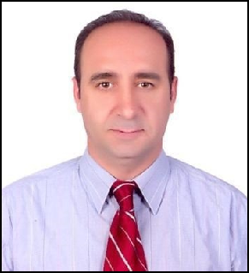  Assist. Prof. Engin KILIÇ
Department | Pharmaceutical Microbiology /  Faculty of Pharmacy / Erzincan Üniversity
cell phıne | +90 05075877012
E-mail | enginfk@gmail.com/ ekilic@erzincan.edu.tr

