CURRICULUM VITAE (In Brief)

PERSONAL DETAILS
Name | Dr. Abhinov Verma | 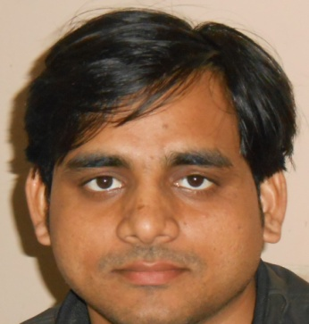
Designation | Assistant Professor
DOB | 28th December, 1983
Date of Joining in DUVASU | 1th July, 2014
Employee Code | 879
State Veterinary Council Registration No. | Reg. No. UPVC-5161
Address | Department of Veterinary Anatomy, College of Veterinary Science and Animal Husbandry, DUVASU, Mathura (U.P.) INDIA
Email | abhinovverma281283@gmail.com  professorana14@gmail.com
Contact (Phone/Mobile) | +91-8791881202  +91-7906144690
ACADEMIC QUALIFICATION

Sl. No. | Degree | Year | Institute/University
1. | B. V. Sc. & A.H. | 2010 | College of Veterinary Science and Animal  Husbandry, DUVASU, Mathura (U.P.) INDIA
2. | M.V. Sc. (Veterinary Anatomy) | 2012 | College of Veterinary Science and Animal  Husbandry, DUVASU, Mathura (U.P.) INDIA
3. | Ph.D. (Veterinary Anatomy) | 2021 | College of Veterinary Science and Animal  Husbandry, DUVASU, Mathura (U.P.) INDIA
PROFESSIONAL/ WORK HISTORY

Sl. No. | Designation | Department/Organization | Period
1. | Veterinary  Medical Officer | Department of Animal Husbandry, Government of  Uttar Pradesh, India | 05/03/2013 to 30/06/2014
2. | Assistant Professor | Department of Veterinary Anatomy, College of Veterinary Science and Animal Husbandry, DUVASU, Mathura (U.P.), India | 01/07/2014 to present date
AREA OF SPECIALIZATION: Gross Anatomy, Histology, Histochemistry and Embryology
PUBLICATION (No. Only)

Research Articles (National and International) | 40
Lead papers/ Papers presented in Conference, Seminar, Symposia | 52
Lectures Published in Extension Training books | 15
Manuals | 07
Technical Articles/Popular article | 05
ASSOCIATED WITH PROJECTS (No. Only)

Externally Funded | University Funded
01 | 02

NO. OF TRAININGS/WINTER/SUMMER SCHOOLS ATTENDED

National | International
05 | 02

NO. OF SEMINAR/SYMPOSIUM/CONFERENCE/WEBINAR/WEBINARS ATTENDED

National | International
18 | 05

PROFESSIONAL AFFILIATIONS AND MEMBERSHIP

Sl. No. | Society | Duration
 | Registered member of UP Veterinary Council, India | Life member
 | Indian Association of Veterinary Anatomists (IAVA), India | Life member
 | Society of Immunology and Immunopathology (SIIP) , India | Life member
 | Pashu Dhan Praharee | Life member
 | Indian society for sheep and goat production and utilization  (ISSGPU) | Life member

AWARDS
Sl. No. | Awards/Fellowships | Year
- . | Review Board Member in IRC Scientific and Technical Committee & Editorial Review Board on Animal and Veterinary Sciences(World Academy of Science, Engineering and Technologies) | 2021
 | Young scientist Award in Indian Association of Veterinary Anatomists (IAVA) conference | 2018
 | Best poster presentation award in Indian Association of Veterinary Anatomists (IAVA) conference | 2018
 | As a Reportear in Indian Association of Veterinary Anatomists  (IAVA) conference | 2018
 | Best poster presentation award in Indian Association of Veterinary Anatomists (IAVA) conference | 2016
 | Best paper presentation award in Indian Association of Veterinary Anatomists (IAVA) conference | 2014
8. | Qualify Indian Council of Agricultural Research - National Eligibility  Test (NET) | 2014

