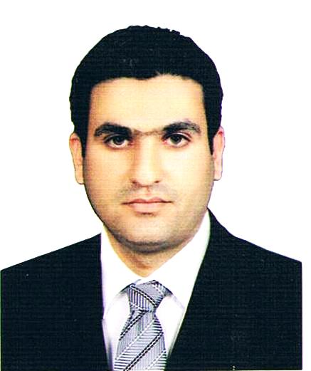

Curriculum Vitae

Name: Salwan Ali Abed Al Khanfar
Permanent Address: Al-Qadisiyah Governorate –Al-Zawraa St. Home No.2, P.O. Box.1895, Iraq.
Gender: Male
Marital status: Married
Cell phone No: + 964 (0) 7711788882
E-mail: Salwan.abed@qu.edu.iq
Salwan_ali2000@yahoo.com
Qualification:
Assist Professor in Biology / Environment, College of Science, University of Al-Qadisiyah
Education Background:
- B.Sc. Biology- University of Al- Qadisiyah -Iraq in 2006
- M.Sc. Environmental Sciences - Pune University-India in 2010
- Ph.D. Biology, University of Baghdad, Iraq, 2015
- Post-doctoral Researcher, Conservation Biology, University of Lund, Sweden, 2018 (https://www.biology.lu.se/salwan-ali-al-khanfar)

Relevant Qualification Course:
- Fulbright Visiting Scholar Program (June to September-2016) in University of Central Oklahoma / College of Mathematics and Science, Edmond, Oklahoma / United State of America.

Publications:
- Bio-Ecological study of marbled teal marmaronetta angustirostris in Hor Al-Dalmaj/Iraq.
https://www.researchgate.net/publication/319277672_BioEcological_Study_of_Marbled_Teal_marmaronetta_angustirostris_in_Hor_Al-Dalmaj_Iraq

- The status and conservation of the vulnerable Marbled Teal (AVES-ANSERIFORMES) in -Al-Dalmaj wetlands, Iraq.
http://www.journalresearchijf.com/wp-content/uploads/DISTRIBUTION-OF-THE-MARBLED-TEAL-MARMARONETTA-ANGUSTIROSTRIS-OVER-DIFFERENT-HABITATS-IN-AL-DELMEJ-WETLANDS-IRAQ-1.pdf
- Avifauna Diversity of Bahr Al-Najaf Wetlands and the Surrounding Areas, Iraq.
http://jjbs.hu.edu.jo/files/v10n3/Paper%20Number%204.pdf
- Occurrence of Anatidae in Sawa Lake: A Ramsar Wetland Site in Sothern Iraq.
http://jazindia.com/Manuscript/SalvaanAli.pdf
- Breeding observations of the Black-winged Kite Elanus caeruleus (Desfontaines, 1789) in Iraq.
https://www.tandfonline.com/doi/abs/10.1080/21658005.2017.1415833?journalCode=tzec20
- Status and conservation of ducks in -Al-Dalmaj wetlands, Southern Iraq.
http://www.journalijar.com/article/2585/status-and-conservation-of-ducks-in-dalmaj-wetlands,-southren-iraq/
- Fauna Diversity in Al-Teeb area, southeastern Iraq: An Approach for local biodiversity conservation.
- Field Environmental Observations in Hor Al-Ghumooga Wetlands, Southern Iraq
https://www.researchgate.net/publication/321062116_Field_Environmental_Observations_in_Hor_Al-Ghumooga_Wetlands_Southern_Iraq
- The First Record of Asian Pied Starling GRACUPICA CONTRA LINNAEUS, 1758 (AVES, STURNIDAE) in Iraq.
- The Immediate and Subsequent Effects of Climate Change on the Threatened Bird Species in the Marshes of Southern Iraq (Ahwar)
https://www.researchgate.net/publication/320798714_The_Immediate_and_Subsequent_Effects_of_Climate_Change_on_the_Threatened_Bird_Species_in_the_Marshes_of_Southern_Iraq_Ahwar

- Water Quality Assessment of Al-Gharraf River, South of Iraq Using Multivariate Statistical Techniques.
https://anjs.edu.iq/index.php/anjs/article/download/89/60
- Water Quality Index for Al-Gharraf River, Southern Iraq.
https://www.sciencedirect.com/science/article/pii/S1687428517300213
- Prediction the Tigris River water quality within Baghdad, Iraq by using water quality index and regression analysis
https://www.sciencedirect.com/science/article/pii/S2352186418301548
- ACCUMULATION DETECTION OF SOME HEAVY METALS IN SOME TYPES OF FRUITS IN THE LOCAL MARKET OF AL-DIWANIYAH CITY, IRAQ
http://dx.doi.org/10.7324/RJC.2017.1021641
- Ferruginous Duck (Aythya nyroca) in Iraq: The Current Status and Conservation Outlook
https://www.researchgate.net/publication/320820519_Ferruginous_Duck_Aythya_nyroca_in_Iraq_The_Current_Status_and_Conservation_Outlook
- Assessment the Performance of Al-Nassriya Water Purification Plant, South of Iraq
https://www.academia.edu/34115654/Assessment_the_Performance_of_Al-Nassriya_Water_Purification_Plant_South_of_Iraq

Memberships:
- Member of the Cornell lab of Ornithology.
- Member of IUCN species survivor commission.
- Member of the Iraqi Biology Association.
- Member of Pure Sciences syndicate.
- Member of Threatened Waterfowl Species Group (TWSG).
- CEO of the Iraqi Organization for Conservation of Nature (IOCN).
- Member of Mesopotamian Society for sustainable hunting.
- Member for Friends of Dalmaj (Local Conservation Group).

Training courses:

- Attending Basic field Course of Ornithology and Reporting, Jebayish- Iraq.
- Attending training course in field technique and ornithology survey, Sulaimaniya- Iraq.
- Biodiversity Conservation Training from Royal Botanical Garden Edinburg ,UK.
- Attending training course in Environmental impact assessment project on Dairy, Textile and Rubber industries, India.
- Attending training course in watershed management in Ahmed Nagar area, 2010, India.

Technical work:-
- Participated in the Key Biodiversity Area survey led by Ministry of environment and nature Iraq through the years 2005-2010.
- Participated in International waterfowl census (IWC) in southern Iraq, to assess the population of the waterfowl in the Iraqi marshes.
3- Participated in Eco-camp training in Dalmaj marsh led by Ministry of Environment.
4- Participated in the survey of the Wetlands of Iraq for publishing the Atlas of the Iraqi Wetlands.
5- Participation in the nationwide Key Biodiversity Areas in Iraq (2005-2010)

Honors:
  - Letter of Thanks and Appreciation from the Dean for 4-day eco-camp for the students in Diwaniya city.
  - Letter of Thanks and Appreciation from the university president for exceptional teaching efforts.
  - Letter of Thanks and Appreciation from the Minister of Higher Education & Scientific Research for the exceptional teaching efforts.
  - Letter of Thanks and Appreciation from Ministry of Tourism and Antiquities – Diwaniya Directorate for the program of education awareness in the Nippur Heritage site.

Experience and Skills:
    - Problem solving
    - Team player
    - Eager learner on culture
    - Field Team leader
    - Remote sensing & GIS

