Residence:  Makhdum Lodge, Faisal Colony,  Kot Addu. Distt. Muzaffargarh.  Post Code: 34050.  Office/ Postal Address:  Department of Economics,  Government College University, Faisalabad.  Post Code: 38000 |  | Cell 0092-3334446055  e-mail sohailmakhdum@hotmail.com  sohailmakhdum@gcuf.edu.pk | 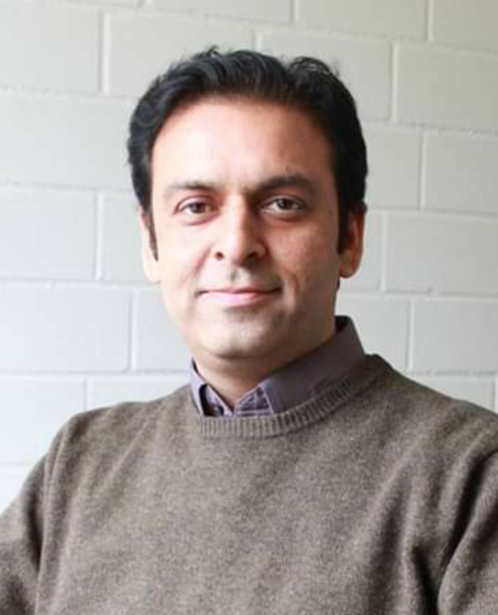
Dr. Muhammad Sohail Amjad Makhdum
Personal Data | Date of Birth : 01-04-1981  Nationality : Pakistan  Marital Status : Married
Employment Record | 2005–2005 Department of Agriculture, Punjab Pakistan  Water Management Officer (BPS-17).
2005–2011 Habib Bank Limited Pakistan
Assistant Manager
Functional Designation: Credit Marketing Officer
2011 – 2016 University of Kiel Germany
PhD Candidate
Worked as Research Assistant while continuing PhD.
2016 – update GCUF Pakistan
Assistant Professor
Department of Economics. Government College University, Faisalabad.
Academic Record | 2011–2016 Christian-Albrechts-Universität zu Kiel, Germany.  Ph.D. Agricultural Economics.  Microfinance and Rural Household Welfare in Pakistan:  An Empirical Investigation
2002–2004 University of Agriculture, Faisalabad, Pakistan
M.Sc. (Hons.), Agricultural Economics.
1998–2002 University of Agriculture, Faisalabad, Pakistan
B.Sc. (Hons.), Agricultural Economics.
1997–1998 Govt. Degree College, Kot Addu, Pakistan
F.Sc.
1995–1996 Govt. High School, Kot Addu, Pakistan
Matriculation.
Internship | Research Fellow at NARC (National Agriculture Research Centre), Islamabad, Pakistan. [01-06-2002 to 20-08-2002]
Research Projects | - Research project and report on “Water Distribution and Productivity on Private Mini Damin Rainfed Pothwar, Gujar Khan Distt. Rawalpindi.” Conducted at National Agriculture Research Centre, Islamabad, Pakistan.[01-06-2002 to 20-08-2002]  - Research Project and Thesis on “Negative Externalities of Water Infrastructure: Water logging and Salinity and its impacts on Wheat Productivity, A case study of Distt. Muzaffargarh.” Conducted at University of Agriculture, Faisalabad, Pakistan. [2002 to 2004]
Publications | - Usman, M., Kousar, R., Yaseen, M.R. et al. An empirical nexus between economic growth, energy utilization, trade policy, and ecological footprint: a continent-wise comparison in upper-middle-income countries. Environ Sci Pollut Res (2020). https://doi.org/10.1007/s11356-020-09772-3  - Ashfaq, M., Kousar, R., Makhdum, M. S. A., Naqivi, S. A. A., & Razzaq, A. (2020). FARMERS'PERCEPTION AND AWARENESS REGARDING CONSTRAINTS AND STRATEGIES TO CONTROL LIVESTOCK DISEASES. Pakistan Journal of Agricultural Sciences, 57(2).  - Naqvi, S. A. A., Hussain, B., Shah, S. A. R., & Makhdum, M. S. A. (2020). Effects of Diabetes on The Output of Farmer and Its Policy Implications. Kesmas: National Public Health Journal, 15(1), 1-6.  - Intisar, R. A., Yaseen, M. R., Kousar, R., Usman, M., & Makhdum, M. S. A. (2020). Impact of Trade Openness and Human Capital on Economic Growth: A Comparative Investigation of Asian Countries. Sustainability, 12(7), 1-19.  - Kousar, R., Makhdum, M. S. A., Razaullah, A. S., Usman, S., & Sadaf, T. (2020). Empirical investigation of impact of land fragmentation on crop productivity in Punjab, Pakistan. Sarhad Journal of Agriculture, 36(1), 217-223.  - Kousar, R., Makhdum, M. S. A., Naqvi, S. A. A., Asif, M., & Sadaf, T. (2019). A Time Series Analysis of Energy Consumption, Energy Prices and Economic Growth in Pakistan. European Online Journal of Natural and Social Sciences, 8(4), pp-687.  - Kousar, R., Sadaf, T., Makhdum, M. S. A., Iqbal, M. A., & Ullah, R. (2019). Competiveness of Pakistan’s selected fruits in the world market. Sarhad Journal of Agriculture, 35(4), 1175-1184.  - Hussain, B., Naqvi, S. A. A., Makhdum, M. S. A., & Shah, S. A. R. (2019). INFLUENCE OF INFRASTRUCTURE DEVELOPMENT ON ECONOMIC GROWTH IN BRICS COUNTRIES. Management Theory and Studies for Rural Business and Infrastructure Development, 41(3), 305-317.  - Ansari, S., Naqvi, S. A. A., Kousar, R., Makhdum, M. S. A., & Shah, S. A. R. (2019). Microfinance and women empowerment: an endogenous switching regression analysis. Amazonia Investiga, 8(20), 719-728.  - Kousar, R., Makhdum, M. S. A., Sadaf, T., Naqvi, S. A. A., & Nadeem, A. M. (2019). Economic Analysis of Organic Wheat Production in Pakistan: Adoption and Return on Investment. European Online Journal of Natural and Social Sciences, 8(3), pp-564.  - Kousar, R., Makhdum, M. S. A., Abbas, A., & Nasir, J. (2019). Issues and Impacts of the Apricot Value Chain on the Upland Farmers in the Himalayan Range of Pakistan. Sustainability, 11(16), 4482.  - Makhdum, M. S. A., Kousar, R., Asif Ali Naqvi, S., Maqsood, H., Hussain, B., & Shah Bukhari, S. A. R. (2019). Smoking and Human Health: Socio-economic Analysis. European Online Journal of Natural and Social Sciences: Proceedings, 8(3 (s)), pp-34.  - Kousar, R., Makhdum, M. S. A., & Abbas, Q. (2018). SECURED LAND RIGHTS, HOUSEHOLD WELFARE AND AGRICULTURAL PRODUCTIVITY: EVIDENCE FROM RURAL PAKISTAN. Pak. J. Agri. Sci, 55(1), 243-247.  - Yousaf, F., Ali Naqvi, S. A., Amjad Makhdum, M. S., & Laeeq, M. (2018). Material Well-being triggered by Macro-Economic Variables: Evidence from South Asia. European Online Journal of Natural and Social Sciences: Proceedings, 7(3 (s)), pp-174.  - Kousar, R., Sadaf, T., Makhdum, M. S. A., & Ijaz, A. (2017). Determinants of household’s education and nutrition spending. Humanomics.  - Kousar, R., Makhdum, M. S. A., Abbas, Q., Ashfaq, M., & Saghir, A. (2017). HOUSEHOLD-DECISIONS OF TIME ALLOCATION AND WAGE DETERMINATION IN PAKISTAN. Journal of Agricultural Research (03681157), 55(3).  - Makhdum, M. S. A., & Ashfaq, M. (2008). An economic evaluation of negative impact of water-logging and salinity on wheat productivity. Soil & Environ. (Pakistan), 27(1), 112-115.  - Kousar, R., Makhdum, S. A., Yagoob, S., & Saghir, A. (2006). Economics of energy use in cotton production on small farms in district Sahiwal, Punjab, Pakistan. Journal of Agricultural Social Science, 2, 219-221.  - Kousar, R; Makhdum, M.S.A; Ashfaq, M; Saghir, A. and Ajaz, A. (2016). Impact of Land Ownership on Agricultural Productivity and Women Empowerment in Pakistan: A Gender Based Empirical Analysis. Paper prepared for presentation at the “2016 World Bank Conference on land and Poverty”, The World Bank-Washington DC, March 14-18, 2016.
Training Programs | - Watercourse Improvement and Construction under National Program for Improvement of Watercourses at In-service Agricultural Training Institute, Sargodha, Pakistan. [07-03-2005 to 16-04-2005]  - Basic Banking Training in Operations, Consumer Products and service Excellence at HBL Management Development Institute, Karachi. [16-11-2005 to 31-12-2005]  - Learning and Development program on KYC/ Anti Money Laundering. Conducted by the Management Development Institute, HBL, Karachi, Pakistan. [2007]  - HBL Small Business Training Program Conducted by Learning & Development group in Association with Commercial and Retail Lending, Management Development Institute, Lahore, Pakistan. [2009]  - Assessing Climate Vulnerability and Projecting Crop Productivity conducted by AgMIP Mid Term Workshop Phase II. University of Agriculture, Faisalabad. [20-12-2017 to 22-12-2017]

