Curriculum Vitea FAWAD ALI

CAREER OBJECTIVE
Seeks a position in a result-oriented and well-reputed organization that looks for a highly motivated and career-conscious person, where acquired knowledge, Skills and Education will be utilized towards continued growth and advancement.

PERSONAL DATA
- Father Name: Jamsheed Khan
- Religion: Islam
- Nationality: Pakistani
- CNIC #: 16102-7268675-5-5
- Domicile: Mardan
- Marital Status: Single
- Date of Birth: March 11^{thrd} , 1990
- Contact 923149628203 , 923459194744
- Email fawadali@wumardan.edu.pk fawadali_std@bkuc.edu.pk
- Address Village Dheria p/o Hathian Tehsile. Takht Bahi Distt. Mardan (KPK) Pakistan.

EDUCATION
- Ph.D ( Biotechnology) defense Remaining Bacha Khan University Charsadda
- M.phil (Biotechnology) Bacha Khan University Charsadda Pakistan.
- M.S.C Abdul wali khan University Mardan.
- B.S.C (University of Peshwar (KPK) Pakistan.
- F.S.C ( Pre-Medical) BISE Mardan (KPK) Pakistan.
- Matriculation BISE Mardan (KPK) Pakistan.

Professional Education
- MEd (Abdul wali Khan University Mardan.
- B.Ed. Allama Iqbal Open University, Islam Abad.
- C.T (Sarhad University of Science and information Technology Peshwar.

Academic Record
S.No | Degree | Marks obtained/CGPA | Total Marks/GPA | %age
1 | S.S.C | 728 | 1050 | 69%
2 | F.Sc  C.T | 665  797 | 1100  1200 | 60%  66%
4  5 | B.S.C  B.Ed | 276  601 | 550  900 | 50%  67%
6  7  8  9 | MSC (zoology)  M.phil (Biotechnology)  ME.d  PhD Biotechnology | 1491  3.30 GPA  894  3.7 GPA | 2100  4 GPA  1200  4.0GPA defence remaing | 71%  78%  74%

MSC RESEARCH PROJECT

Birds Fauna and its Diversity of Sudhum Game Reserve Distt Mardan.

M PHIL RESEARCH PROJECT
Detection of Dengue virus in Suspected Patient in District Swat

Ph.D RESEARCH PROJECT

Characterization and evaluation of exotic Brassica germplasm in Mardan based on morphological, biochemical, and molecular markers

EXPERIENCE

Four year Experiences as zoology Lecture in Allama Iqbal school and college sakhtkot Malakand Agency from 2013 to 2016
Working as Lab Assistant, also work in ORIC, QEC, Tender and Purchase of Lab Instrument in Women University Mardan from 2017 to Still Date

PUBLICATION
- Biochemical identification, antibiotic sensitivity and resistance pattern for salmonella typhi and salmonella paratyphi
- Irrational use of antibiotics as major cause of drug resistance in developing and developed countries
- Frequency distribution, Histopathology of H. pylori among dyspeptic patients from Peshawar and associated risk factors analysis.
- Effect of sodium salt stress on the growth of elymus repens
- Biomedical applications of different green synthesized nanoparticles as a potent anticancer agent
- Prevalence of hepatitis B in Kpk Province Pakistan

Detection of Dengue virus in suspected patients of 2013-2014 Dengue outbreak in district Swat of khyber pakhtunkhwa, Pakistan

Influence of Macronutrients, Phytohormones and Organic manure on Gladiolus grandiflorus L. Growth, Flowering and Cormels" for publication onwards".

Effect of sodium Choride stress on the adaptation of Zea Mays Seedling at the Expense of growth

Assessment of DNA damage due to Water Pollution in selected fish species Chana punctatus & Shizothorax pelageostomus"

Evaluating the antimicrobial potential of Methanol (CH3OH) and Carbon tetrachloride (CCl4) extracts of Paratiopsis Jacquemontii against Hemophillus Influenza

Molecular evaluation of non-coding snps of Interleukin-17Fgene in rheumatoid arthritis

rational drug therapy of peptic ulcer disease in patients admitted to gastroenterology ward of LRH peshawar khyber pakhtunkhwa, pakistan

To associate the fetal distress, IUD and IUGR observed in normal, diabetic and hypertensive pregnancies

effects of sand and clay compositions on growth and biochemical aspects of hordeum vulgare (l) and soil physico-chemical properties

phytochemical screening and pharmacological evaluation of psammogeton biternatum from district bannu, pakistan

evaluation of antibacterial activity of commonly used antibiotics and different brands of honey against multi drug resistant bacteria isolated from surgical site infection

prevalence and phenotypic characterization of extended spectrum beta lactamase and metallo-beta lactamase producing morganella, enterobacter and escherichia coli species isolated from urinary tract infection patients.

Adaptation of brassica campestris seedlings to various biotic and abiotic stresses under dark and light regimen

Phenotypic Detection of Antibiotic Resistance and Production of ExtendedSpectrum Beta-Lactamases in E. coli isolated from Urinary Tract Infected patients at Hayatabad Medical Complex

Susceptibility Pattern of Pathogenic Bacteria Pseudomonas aeruginosa to various Antibiotics isolated from Post-Surgical Wound of Diabetic Patient at Hayatabad Medical Complex Peshawar.

Occurrence and Distribution of Diabetes Mellitus in Mardan, Pakistan

effects of sand and clay compositions on growth and biochemical aspects of hordeum vulgare l. and soil physico-chemical properties.

stability of iodine in differently iodised salts

impact of heavy metals and salt stress on brassica napus growth and development

Isolation and identification of UV absorbing compounds from cynobacteria (Synechocystis) of District Mardan

A study of student’s perception about semester system practices in public sector universities of Khyber Pakhtunkhwa

Screening Of Breast Cancer Patients For Known Genetic Variations In Selected Candidate Micro Rna Genes In The Selected Area Of District Swat Kp Pakistan"

Association Of GSTT1 AND GSTM1 Polymorphism With Anti TB Drug Induced Hepatotoxicity"

Identification Of Multiple Bacterial Blight Resistant Genes And Fragrance Gene In Rice Through Sts Marker

Morphological And Biochemical Study Of Allium Sativum L. Under The Selected Micronutrients

Prevalence Of Obesity In Diabetic Females Of Mardan KP Pakistan

A Review on toxoplasmosis in humans and animals from Khyber pakhtunkhwa, pakistan.

Estimation of mid parent heterosis and heterobeltiosis for yield and yield contributing traits in wheat crosses

Association between Gastroesophageal Reflux Disease symptoms and dietary factors among adult males and females in District Mardan

Role of cytokinins to alleviate the salinity stress through the production of secondary metabolites

Role of Cytokinins in alleviating the Copper toxicity in maize plant

Accepted Paper

PLANT COMMUNITY STRUCTURE AND ANTHROPOCLIMATIC STRESSES FACED BY THREATENED OAK WOODLANDS IN BIAKAN VALLEY, SWAT, PAKISTAN"

SYNTHESIS OF COPPER NANO PARTICLES USING BRINJAL FRUIT EXTRACT, THEIR CHARACTERIZATION AND DYES DEGRADATION PROPERTIES"

Review Paper

- 20 Research papers under Review Stage

TECHNICAL SKILLS
- Use of Real Time PCR for Quantitative and Qualitative Analysis
- Use of a number of Lab Equipment’s such as Micropipette, PH Meter, Orbital Shaker, Autoclave, UV trans illuminator, Spectrophotometer, Chromatography, Oven, PCR & Gel Electrophoresis, Vertex Machine, Centrifugation, Magnetic Hot plate, etc.
- DNA isolation, Plasmid Isolation.
- RNA Extraction.
- Bacteria growth
- Culturing, Isolation, Purification and Staining Techniques.
- Isolation of Nucleic Acids & Protein’s.
- Mutation detection assays.
- Fermentation Techniques.
- Clinical Microscopy.
- Preparation of Culture Media.
- Culturing, Isolation, Purification and Staining Techniques.
- Techniques for Identification of known & Unknown Microbes.

MAJOR SUJECTS STUDIED

S.S.C
1). Mathematics 2). Biology 3). Chemistry 4). Physics.

F.Sc
1) Biology 2). Chemistry 3). Physics.

B.S.C

1) Botany 2). Zoology 3). Chemistry

MSC
1).Biochemistry | 2).Cell &Molecular Biology | 3).Developmental Biology
4).Animal Diversity | 5).Principal of Biosystamatic | 6).Physiology
7).Ecology | 8).Genetics | 9)Palaeontology & Zoogeography
10)Basic Biotechnology | 11).Fundamental Microbiology | 12).Research Methodology
13).Animal Behaviour | 14).Endocrinology | 15).Fish Biology
16).Applied Fisheries | 17).Mammalogy | 18). Biostatistics
19)Medical Entomology | 20).Parasitolgy | 21). Evolution & Paleontology

M PHIL BIOTECHNOLGY
1).Biochemistry | 2).Agriculture Biotechnology | 3).Element of Biotechnology
4).Tissue Culture | 5).Molecular Genetics | 6). Microbiology
7). Biostatistics | 8).Recombint DNA Technology | 9) Gens Expression & Gens Regulation

PhD BIOTECHNOLGY

Genetic Cloning and Genetic Engineering 2. plant Genetic Engineering

3. Advance Genetics 4. Advance Molecular Biology 5. Molecular Biology 6. Research Technique Bioethics 7. Molecular and Microbial Genetics

KEY SKILLS
- Punctual, Responsible and hard working.
- Can manage critical situations.
- Having good public relation & Interpersonal Skills.
- COMPUTER SKILLS
- One year Diploma in information Technology From Trade Testing Boards Peshwar.
- Windows s8/2000/XP (Installation & Trouble Shoot).
- Microsoft Office (Word, Excel, PowerPoint).
- Software Installation and Management.
- Internet Surfing and Usage.
- 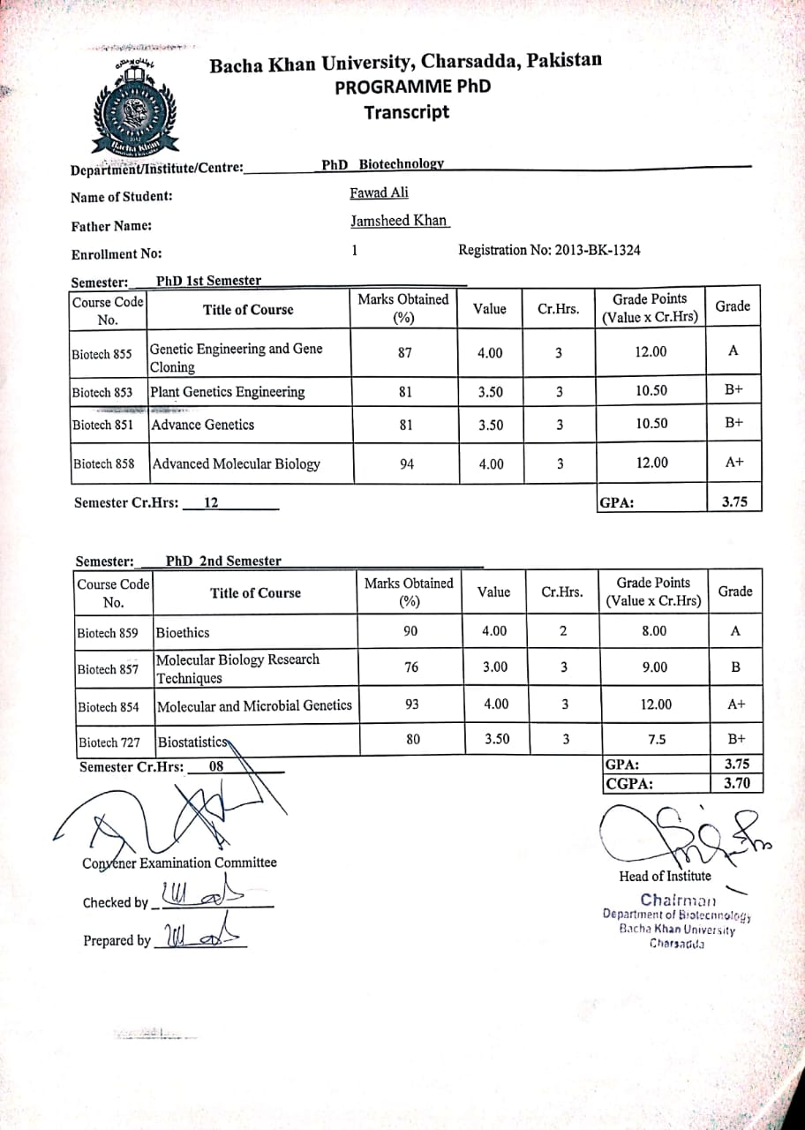

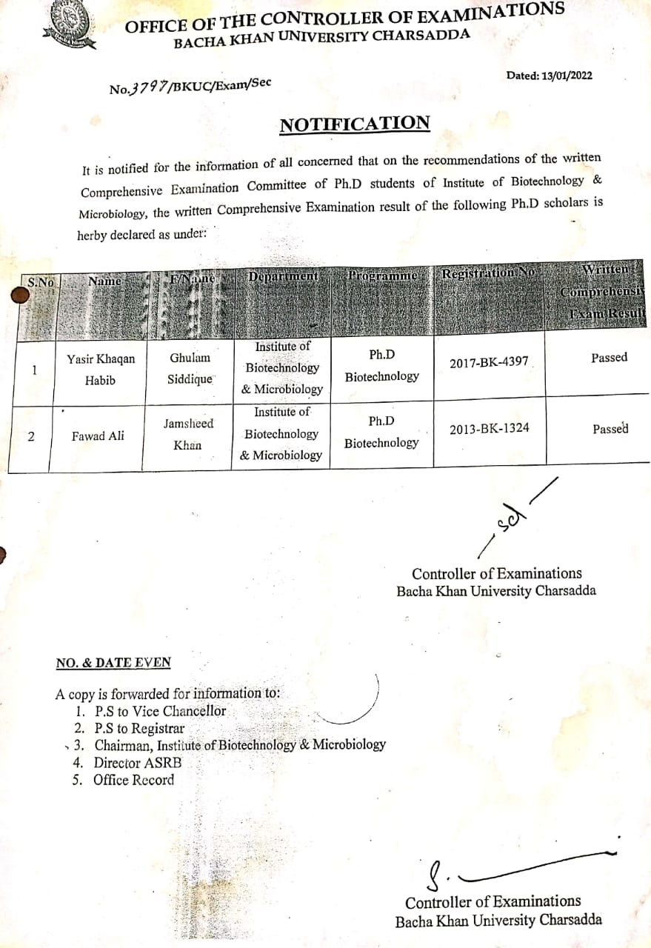

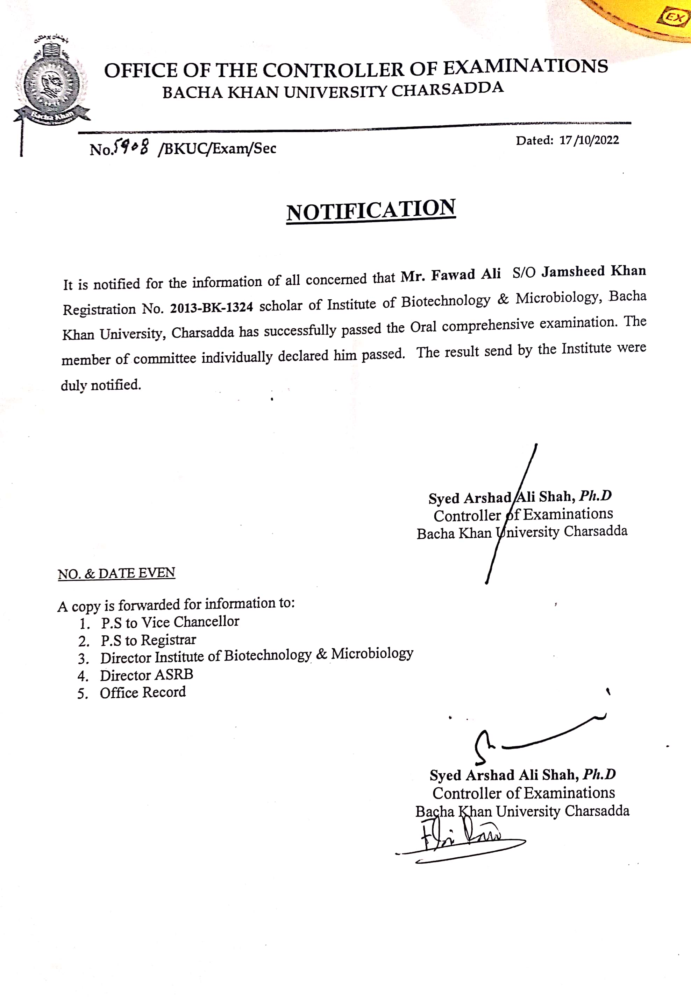

https://tianjindaxuexuebao.com/0493-2137-tju-v55-i11/

