DR. M.I. QADIR Résumé
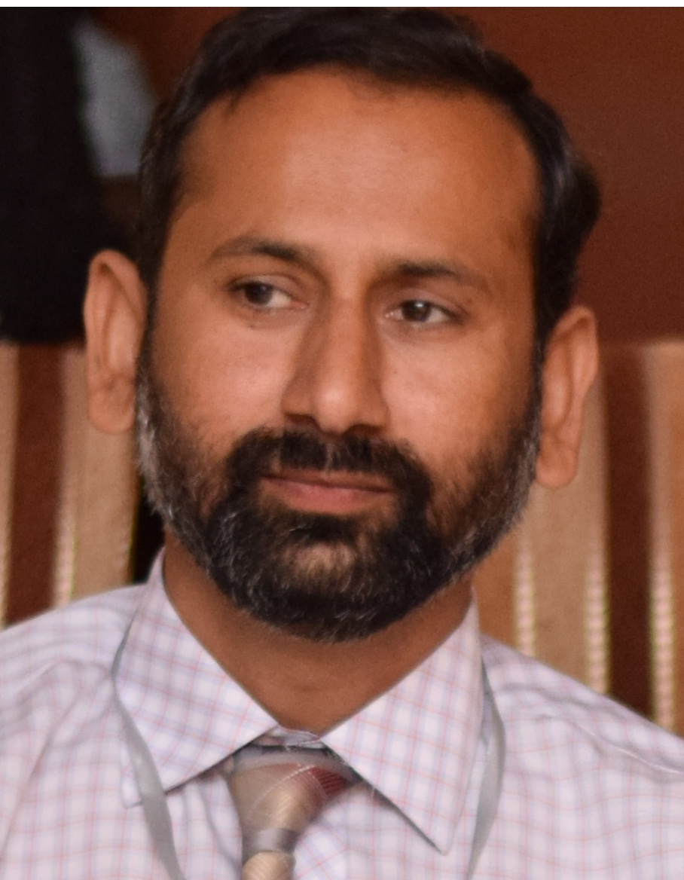
Dr. Muhammad Imran Qadir

TOP PHARMA SCIENTIST
Pakistan Council for Science and Technology, RPA Award (2017)
BEST YOUNG SCHOLAR Higher Education Commission, Pakistan (2016)

Education
Degrees
2011, Ph D (Molecular Biology), Quaid-i-Azam University, Islamabad, Pakistan
2005, M Phil (Molecular Biology), Quaid-i-Azam University, Islamabad, Pakistan
2001, B Pharm, Bahauddin Zakariya University, Multan, Pakistan
Diplomas
2010, MD (Alternative Medicine), OIUCM, Colombo, Sri Lanka
2008, DHMS (Homeopathy), Rawal Homeopathic Medical College and Hospital, Rawalpindi, Pakistan
2005, DIMS (Hikmat), National College Farogh-e-Hikmat, Lahore, Pakistan
2003, MAcF (Acupuncture) OIUCM, Colombo, Sri Lanka

Positions Held
2014-Present
Assistant Professor
Institute of Molecular Biology and Biotechnology, Bahauddin Zakariya University, Multan, Pakistan
2008-2014
Assistant Professor, College of Pharmacy, GC University, Faisalabad
2008-2008
Assistant Professor, The University of Faisalabad, Faisalabad
2006-2008
Assistant Professor, University of Lahore (Islamabad Campus), Islamabad
2002- 2006
Lecturer, Riphah International University, Islamabad
2001-2002
Production Pharmacist, M. S. Enterprises Ltd. (Pharmaceutical Division), Lahore

Medical Scientist
Assistant Professor
Institute of Molecular Biology and Biotechnology,
Bahauddin Zakariya University, Multan, Pakistan
Cell: +92-301-6515613
email: mrimranqadir@hotmail.com
ResearchGate: https://www.researchgate.net/profile/M_Qadir

Inventions & Discoveries - Innovations in Real Life:
Qadir test Cancer diagnostic test
Qadirphages Alternative to antibiotics
Qadir theory Viruses are cause of cancer
Qadir-C34 Drug for AIDS
Qadirvirtide Drug for AIDS
Qadir’s pronunciation Pronunciation of alphabets
Pentandraol Isolated and structure elucidated
Pentandradione Isolated and structure elucidated
Drug delivery problems Solved by polymer technology
Mechanisms identified For better management of diseases
Local plants Their scientific use for diseases

Research Publications:
Articles in ISI indexed Journals 107
Other International Publications 80
Local Publications 25
Books/Laboratory Manuals 16
Book chapters 40
Data-set published 203
Abstract Published 42
Citations
Cumulative Impact Factor 110
Total Citations 2032
h-Index 24
i10-Index 70
Student Supervision:
M Phil (Completed) 38
PhD under Supervision 03
M Phil under Supervision 04
Continuing Education
Conferences/Workshops/Seminars 22
Certificates/Training courses 64
Religious Courses 04

Memberships:
Registration of Councils 02
Membership of Societies 20
Editorships:
Associate Editor 02
Member Editorial Board 15
Reviewed Articles 250
Research Projects:
HEC Funded 01
BZU Funded 03
Administrative Assignments:
Head of Department 01
Incharge of College 01
Member of Committees 05
Honours/Awards:
RPA Award - PCST 04
Productive Scientist - PCST 04
Best Young Scholar - HEC 01
Performance Based Increment 04
Performance Based Honorarium 04
Fields of Interest
Virology, Oncology, Phage therapy

Selected Publications:
1. Qadir MI, Malik SA (2011) Genetic variation in the HR region of the env Gene of HIV: A perspective for resistance to HIV fusion inhibitors. AIDS Res Hum Retrovir, 27(1): 57-63.
2. Qadir MI, Murad MSA, Ali M, Saleem M, Farooqi AA (2014) Hepatoprotective effect of leaves of aqueous ethanol extract of Cestrum nocturnum against paracetamol-induced hepatotoxicity. Bangladesh J Pharmacol, 9: 167-170.
3. Qadir MI, Hasan I, Mobeen T (2018) In-silico study of potential carboxylic acid derivatives as D-glutamate ligase inhibitors in Salmonella typhi. Kuwait J Sci. 45(1): 100-107.
Qadir MI (2018) Hepatitis in AIDS Patients. Rev Med Virol. 28:e1956

