Curriculum vitae
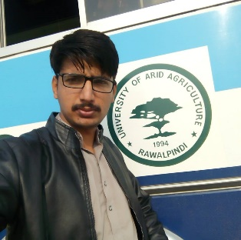Hassan Muhammad

 03037464641
Email Adress:hassanramay4@gmail.com

Objective

- For reaearch, I can grow in terms of skills and knowledge.

Qualification

Degree | Institute | Marks Obtained | Year of Completion
SSC (Science) | Misali Zakariya higher secondery school Muzaffar.Garh | 908/1050 | April, 2011
HSSC (Peri medical) | Misali Zakariya higher secondery school Muzaffar.Garh | 920/1100 | June, 2014
DVM(doctor of veterinary medicine) | ARID ARICULTURE UNIVERSITY RAWALPINDI | 7th SEMESTER | 2019

Personal Details

 | Liaqat ali
  Father’s Name
Permanent Address | :chack no608/TDA,tehseel kot addu, district Muzaffar Garh
Postal Address | :chack no608/TDA,tehseel kot addu, district Muzaffar Garh
Date of Birth | : | 17/03/1998
C.N.I.C No. | : 32303-7203340-1
Domicile | : | Muzaffar garh (Punjab)
Marital Status | : | Single
Languages | : | English, Urdu, Punjabi

