Data mining in cloud computing

Muhammad Asaf Khan
Department of Computer Science,
Registration Number: 1093-113114
Preston University Islamabad, Pakistan
asif.khan077@yahoo.com

ABSTRACT
This paper deals with the study of how data mining is used in cloud computing, Data mining is a process of discovering patterns in large data sets. The overall goal of the data mining process is to extract information from a data set and transform it into an understandable structure for further use. The integration of data mining techniques has become common in today's world. We daily face the targeted advertising also businesses are using data mining activities to save costs and time for the most effective results. Data mining applications can derive much information concerning customers that was previously not known or hidden in the data. The implementation of data mining techniques through Cloud computing will allow the users to retrieve meaningful information from a data warehouse that reduces the costs of infrastructure and storage.
Keywords: Data mining, what is cloud computing, how data mining are used in cloud computing

- Introduction

Data mining is the process of taking out of secret/hidden information from large databases. It is a powerful new technology to help different organizations focuses on the most important information in data warehouses. As data sets are increased in size and complexity, direct hands on data analysis has increasingly improved with automatic data processing. This has been aided by other discoveries in computer science such as neural networks, cluster analysis, genetic algorithms (1950s), decision trees (1960s) and support vector machines (1990s). [1]
A major goal of data mining is to discover previously unknown relationships among the data, especially when the data come from different databases. [2]
Cloud computing is becoming more popular due to use of its mobility, huge availability and low cost, On the other hand it brings more threats to the security of the company’s data and information. Many companies are interesting in building their own IT infrastructure to host databases or software on third party servers, so the company can access to its own data and software over the Internet. [2]
End-users and companies are facilitating due to use of computational resources such as software, storage and processing capacities belonging to other companies (cloud service providers) over cloud computing. Cloud services include Infrastructure as a Service (IaaS), Platform as a Service (PaaS), and Software as a Service (SaaS) [3]
The sections defined in this paper are as follow;
Section 2: What is cloud computing?
Section 3: Data mining in cloud computing.
Section 4: Data mining parameters in cloud computing.
Section 5: Eliminating cloud mines.
Section 6: Some aspects regarding cloud computing
Section 7: Conclusions
- What is cloud computing?
Cloud computing is a general term for anything that involves delivering hosted services over the Internet. These services are broadly divided into three categories: Infrastructure as a Service (IaaS), Platform as a Service (PaaS) and Software as a Service (SaaS). The name cloud computing is often used to represent the Internet in flowcharts and diagrams. Until the 1990s the actual term "cloud" borrows from telephony in telecommunications companies, who offered dedicated point-to-point (P2P) data circuits, also began offering Virtual Private Network (VPN) services with comparable quality of service at a much lower cost. “In early 2008, Eucalyptus became the first open source, AWS API-compatible platform for deploying private clouds. In early 2008, Open Nebula, enhanced in the RESERVOIR European Commission-funded project, became the first open-source software for deploying private and hybrid clouds and for the federation of clouds”. [1]

- Data mining in cloud computing
The data mining in Cloud Computing allows organizations to centralize the management of software and data storage, with assurance of efficient, reliable and secure services for their users. [2]
Data mining is one of the fastest growing fields in computer industry that deals with discovering patterns from large data sets. Mining is preferably used for a large amount of data and related algorithms often require large data sets to create quality models. As cloud is a massive source of centralized data, data mining gives attackers a great advantage in extracting valuable information and thus violating client’s data privacy [3].
Data mining parameters in cloud computing

- Association - Looking for patterns where one event is connected to another event.
- Sequence or path analysis - Looking for patterns where one event leads to another later event
- Classification - Looking for new patterns
- Clustering - Finding and visually documenting groups of facts not previously known
- Forecasting - Discovering patterns in data that can lead to reasonable predictions about the future. This area of data mining is known as predictive analytics.

- Eliminating cloud mines
In this section, it is first discussed that the data mining based privacy threats to the single provider cloud architecture. Then give an overview of the state-of-the-art distributed approach to prevent data mining based privacy attacks on the cloud. [3]
- Some other aspects regarding cloud computing
Cloud computing represents both the software and the hardware delivered as services over the Internet. Cloud Computing is a new concept that defines the use of computing as a utility, that has recently attracted significant attention. In Figure 1 below it is illustrated the computing paradigm shift on the last half century through six distinct phases: [2]
Phase 1: People used terminals to connect to powerful mainframes shared by many users.
Phase 2: Stand-alone personal computers became powerful enough to satisfy users’ daily work.
Phase 3: Computer networks allowed multiple computers to connect to each other.
Phase 4: Local networks could connect to other local networks to establish a more global network.
Phase 5: The electronic grid facilitated shared computing power and storage resources.
Phase 6: Cloud Computing allows the exploitation of all available resources on the Internet in a scalable and simple way.
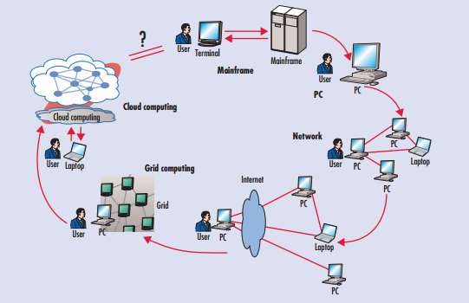

- Conclusions
In this paper, we have described a cloud based infrastructure designed for data mining large distributed data sets over clusters connected with high performance wide area networks. An overview of the necessity and utility of data mining in cloud computing is described in the paper. As the need for data mining tools is growing every day, the ability of integrating them in cloud computing becomes more and more stringent.

- REFERENCES
[1]. Ambulkar B., Borkar V., “Data Mining in Cloud Computing”, MPGI National Multi Conference 2012 (MPGINMC-2012) 7-8 April, 2012
[2]. PETRE R., “Data Mining in Cloud Computing”, 3/2012
[3]. Dev H., Sen T., Basak M and Ali M., “An Approach to Protect the Privacy of Cloud Data from Data Mining Based Attacks”, Dhaka, 2012

