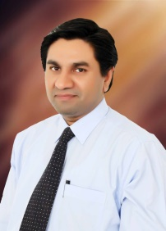
CURRICULUM VITAE

PERSONAL INFORMATION
Name | Dr. Hussain Ahmad
Address | Current address: Room #08, Foreign Faculty Hostel, Baghdad ul Jadeed Campus, The Islamia University Bahawalpur, Pakistan.  Permanent address: Qutab street #39, House # 13 Andron Nawankot Multan road Lahore, Pakistan.
Mobile No. | +923214012777
E-mail | hussainahmad52@gmail.com
Education
2009- 2012 | PhD in Animal Nutrition and Feed Science
Name of Institute | Nanjing Agricultural University, Nanjing, P. R. China
2002-2005 | Master of Science in Animal Nutrition
Name of Institute | University of Veterinary & Animal Sciences, Lahore, Pakistan
1998-2002 | Doctor of Veterinary Medicine
Name of Institute | University of Veterinary & Animal Sciences, Lahore, Pakistan
1998 | Intermediate, FSc (Pre Medical)
Board | BISE Lahore
1994 | Matriculation, Science
Board | BISE Lahore

APPOINTMENTS
Jan 2020-at present  Oct 2007-Jan 2020 | Associate Professor  University College of Veterinary & Animal Sciences,  The Islamia University Bahawalpur, Pakistan  Lecturer  University College of Veterinary & Animal Sciences,  The Islamia University Bahawalpur, Pakistan
Jan 2013- Jan 2015 | Post-doctorate Fellow, Preventive Medicine, College of Veterinary Medicine, Nanjing Agricultural University, Nanjing, P. R. China
Feb 2006-Sept 2007 | Research Fellow, Department of Animal Nutrition, University of Veterinary & Animal Sciences, Lahore, Pakistan

