CURRICULUM VITAE
Personal Information
First Name: |  | Farhad | 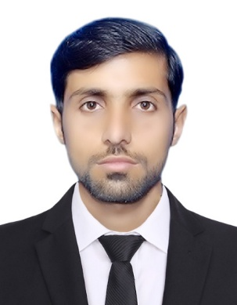
Last Name: |  | Badshah
Professional Title/Position: |  | Ph.D scholar
Highest Degree: |  | Mphil Zoology
Affiliation:  (Please don't use any acronyms) | Department/Division: | Zoology
Affiliation:  (Please don't use any acronyms) | University/Institute: | Abdul Wali Khan University
Affiliation:  (Please don't use any acronyms) | City: | Mardan
Affiliation:  (Please don't use any acronyms) | Country: | Pakistan
Educational Qualifications: I have completed my Mphil in Zoology with 3.75/4cgpa from Abdul Wali Khan University Mardan. My specialization is molecular genetics. Moreever, now I am doing Ph.D from Abdul Wali Khan University Mardan, KPK.
Professional Experience: I am echnical and academic writer with 4 years of experience in these fields. I have a deep understanding of various statistical software, including SPSS and R programming, and are able to apply this knowledge to analyze and interpret data in the health and biological sciences. In addition to my writing and statistical analysis skills, I also have experience as a research paper reviewer in the health and biological sciences. This experience has given you expertise in evaluating the quality of research methodology, study design, and data analysis, as well as an understanding of the importance of clear and concise scientific communication. As a potential reviewer or editor for a surgery journal or other health/biological science publication, I would bring a broad and deep understanding of the field and a critical eye for evaluating the quality of scientific research..
Academic Achievements / Publications: Interrelation of Bood Type, Character, and Diseases. Doi: 10.48047/NQ.2022.20.21.NQ99023

