RESUME
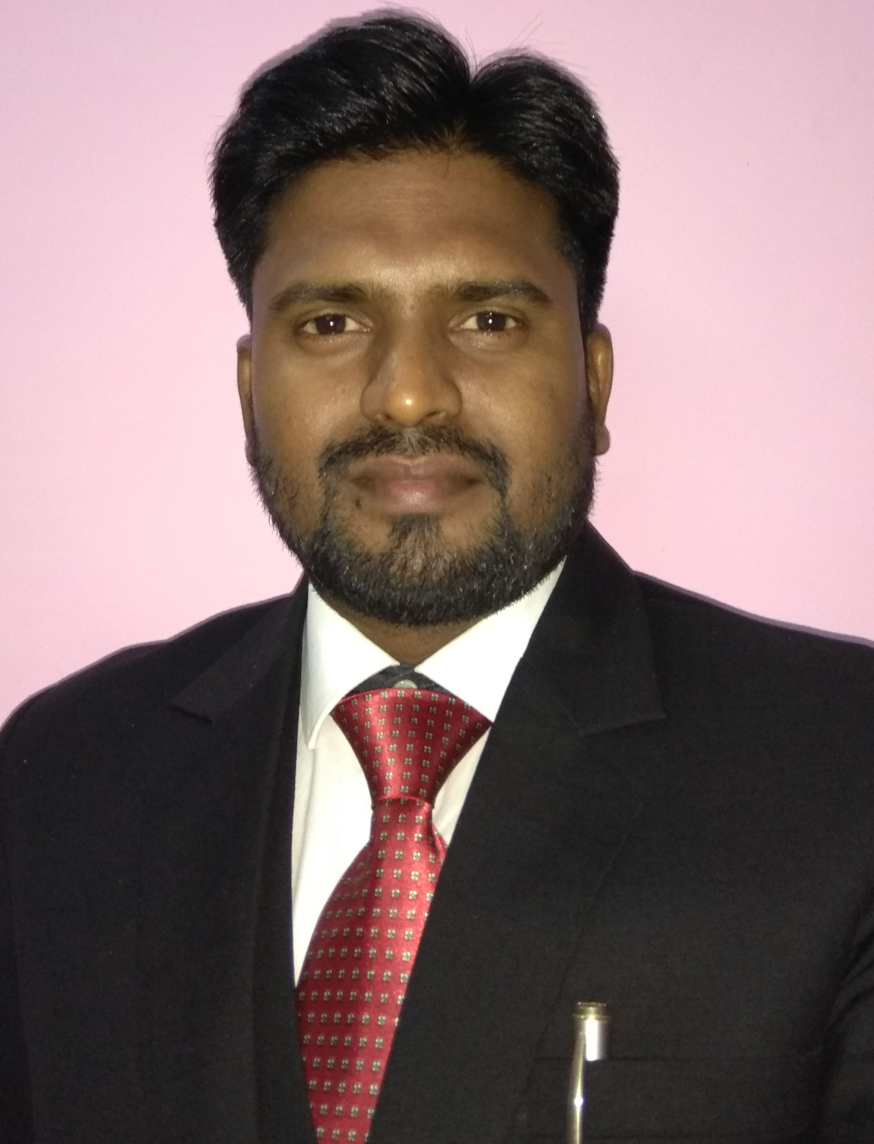

Dr. Kunwar Dhananjay Singh

B.V.Sc & A.H.,
ANDUAT, Ayodhya, U.P.

M.V.Sc. (L.P.M.)

ANDUAT, Ayodhya, U.P.
Registration No.U.P.V.C.- 4646

Permanent Address: Correspondence Address:

Village -Daudpur Assistant Professor

Post - Senapur Department of LFC

District - Jaunpur (U.P.) C.V.Sc.&A.H., ANDUAT

Pin Code -222148 Kumarganj, Ayodhya, U.P., India

E-mail: kd.vet007@gmail.com Mob. No. : 09918388007

Personal Information

Date of Birth : 10/10/1981
Religion : Hindu
Nationality : Indian
Marital Status : Married
Languages Known : English, Hindi
Interest : Animal care & welfare

Academic Details:

Qualification | Institute/University | OGPA/ % | Division | Year of Passing
High school | U.P. Board | 67.66% | First | 1996
Intermediate | U.P. Board | 53.8 % | Second | 1998
B.V.Sc. & A.H. | ANDUAT, Kumarganj, Ayodhya,UP | 68.11% | First | 2007
M.V.Sc. (L.P.M.)  With Gold Medal | ANDUAT, Kumarganj, Ayodhya,UP | 80.65% | First | 2009

Awards

- Gold Medalist in M.V.Sc. (Livestock Production and Management)

TITLE OF THESIS: “Effect of Stocking Density on Growth Performance of Broiler Chicken.”

- Young Scientist Award in the year 2017 awarded by Society for Agriculture Innovation and Development (SAID), Ranchi (Jharkhand) India.
- Young Teacher Award in the year 2017 awarded by Science and Technology Society for Integrated Rural Improvement, Thorrur, Warangal, Telangana, India.

- Young Teacher Award in the year 2017 awarded by JMD Educational Society, Etah, Uttar Pradesh, India.

- Excellence in Research Award in the year 2018 by Society for Agricultural Innovation & Development (SAID), Ranchi (Jharkhand) India.

Research Experience

Working as Assistant Professor (Senior Scale) in the Department of Livestock Farm Complex and conducted various research activities in the field of Avian Production Management & Livestock Production and Management. Worked as Guide and Co-guide of more than 15 M.V.Sc. scholars in the field of Livestock Production and Management & Avian Production Management. Published more than 20 research papers in various reputated NASS rated Research Journals along with various Popular/Technical Articles and Abstracts. Author of a book entitled “Ik'kq & if{k;ksa ds fo’kk.kq tfur jksx o mudk izcU/ku” With ISBN: 978-93-5335-029-1. Published more than 20 book chapters in various books with ISBN having ISBN-No. Working as Co-Principal Investigator of a RKVY project on poultry. Received awards from various societies for teaching and research in the field of Avian Production Management & Livestock Production and Management. Participated in 14 Seminar/Symposium/Workshop/Conferences/International Conference in India and also participated in one International Conference at Kathmandu, Nepal Organized by Society for Agriculture Innovation and Development Ranchi (Jharkhand) India. Attended one ICAR sponsored 21 days CAFT Training programme at Hisar, Haryana on topic “Development of Validated Diagnostic Assays and Accreditation of Diagnostic Laboratories”. Attended one ICAR sponsored 21 days CAFT Training programme at IVRI, Bareilly, U.P. on topic “Acclimatization and Adaptation of High Altitude Livestock in Changing Climatic Scenario.”

Professional Membership

- Lifetime Membership of Indian Society of Animal Production and Management.
- Lifetime Membership of Indian Veterinary Association.
- Lifetime Membership of Indian Poultry Science Association.
- Lifetime Membership of Society for Agriculture Innovation and Development Ranchi (Jharkhand) India.

Declaration:

I, Dr. Kunwar Dhananjay Singh declare hereby that all above mentioned facts in this resume are true. In case of any dispute, I will be responsible.

(Kunwar Dhananjay Singh)
Assistant Professor
Place: Ayodhya Deptt. of LFC, CVSc &AH
Date: 20/01/2020 A NDUAT, Ayodhya, UP

