SYED INAMULLAH
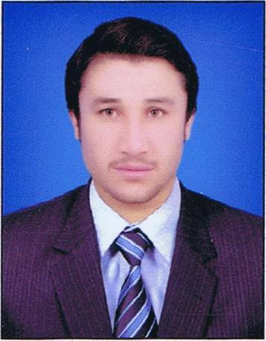
Meraj Medical Store Jinnah road Quetta, Pakistan +923013365033, +923138250705
syedinam411@gmail.com

Personal statement

I am committed, determined and self-motivated zoologist with experience of studying native and migratory birds in all type of territories and experience in biodiversity of scorpion with its identification and sting victimization.
Key Skills

- Insects collection, rearing and identification
- Animal behavior and ecology
- Fisheries and aquaculture
- Limnology
- Biodiversity conservation
- Field works
- Scorpion capturing
- Birds capturing
- Birds identification
- statistical analysis

Employment History

Researcher (MPhil), University of Balochistan, Quetta.
(March 2017 –December 2020)

Project Researcher, on Migratory birds and Wildlife Department Govt of Balochistan, Quetta.
(June 2020 – Present)

Lecturer Zoology, Govt Degree College Pishin Edu dept: Govt of Balochistan.
(Julu 2018 – Present)

Internee lecturer in prime minister youth scheme
(June 2017– July 2018)

Education

University of Balochistan, Pakistan
(March 2017 – December 2020)
M.Phil. (Zoology specialization in Fisheries)
University of Balochistan, Pakistan
(2014 – 2016)
M.Sc. (Zoology specialization in Fisheries and limnogy)
University of Balochistan, Pakistan
(2016 – 2017)
M.Ed. (Education)

University of Balochistan, Pakistan
(2014 – 2015)
B.Ed. (Education)

University of Balochistan, Pakistan
(2013 – 2014)
B.Sc. (Science)
Govt. Science College, Pakistan
(2010 – 2011)
F.Sc (Medical)
High School hurramzai, Pakistan
(2008-2009)
Matric (Science)

Research Interests

- Insects Collection and identification
- Animal behavior
- Fisheries’ and aquaculture
- Limnology
- Avian Biodiversity
- Wildlife conservation
- Scorpion studying
- Molecular genetics
- Field work
- Articles reading

Seminars

- One-day seminar on Wildlife conservation (University of Balochistan Quetta).
- One-day seminar on Migratory birds and strategies for their restoration (Forest and wildlife department, Balochistan).
- One day online seminar on Biodiversity importance and it’s role for economy

Research Publications

- Syed Inamullah Some new record of scorpion fauna found in different regions of district Pishin (Balochistan) Pakistan. International Journal of Biosciences Vol. 16, No. 2, p. 312-322, 2020.
- Syed Inamullah Incidence of intestinal protozoan infection in the children of urban and pre-urban areas of Quetta district. Int. J. Biosci. 16(5), 54-59, May 2020. http://dx.dSyed Inamullah Scorpions of Pishin, Orthochirus carinatus pishinis(Buthidae, arachnida) a new record in scorpion fauna of (Baluchistan) Pakistan. International Journal of Biosciences Vol. 16, No. 2, p. 124-129, 2020.
- oi.org/10.12692/ijb/16.5.54-59.
- Syed Inamullah Effect of feeding frequency on food consumption and growth of goldfish (Carassius auratus) in man-made pond at Kb Ahmad Shah Nasarn District, Pishin, Balochistan Int. J. Biosci. 16(2), 523-528, February 2020. http://dx.doi.org/10.12692/ijb/16.2.523-528.
- Syed Inamullah. Transmission of COVID 19 by passenger’s destination from Iran, China and Afghanistan: higher risk of novel corona virus into Balochistan Pakistan. European Journal of Biology. Vol.5, Issue 1 No.1, pp 1-8, 2020.
- Syed Inamullah COVID 19: a global alarm, intra Country travelling, the root cause of COVID 19 spreading in Pakistan after international importation European Journal of Biology. Vol.5, Issue 1 No.1, 2020.
- Syed Inamullah Migratory birds biodiversity, and Factors responsible for declining avian fauna in bandkhushdil khan Lake District Pishin, Pakistan. (Pipeline)

Computer Skills

- MS office
- MS word
- Excel
- Power point
- Typing

Languages

- English
- Urdu
- Pashtoo

References

- Prof: Dr, Asmatullah kakar chairperson (Department of Zoology University of Baluchistan, Quetta.
Email: asmardanzai@yahoo.com

- Prof: Dr,Ghulam Dastagir (Department of Zoology University of Baluchistan, Quetta.
Email: dastagir76@gmail.com
3. Dr. Syed Ashraf Uddin (Ph.D Germany)
Email: aghaashraf000@gmail.com

