Curriculum vitae
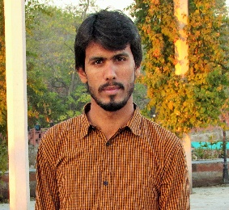
Muhammad Yaseen

 03036745848

Email Adress : yaseen_muhammad49@yahoo.com

Objective

- For research purpose and to facilitate researcher and students
- To enhance write up skills of veterinary graduates
- To Publish research data

Qualification

Degree | Institute | Marks Obtained | Year of Completion
SSC (Science) | Shaheen force public secondary school Muzaffar Garh | 932/1050 | April, 2011
 |  | A+ Grade
HSSC (Peri medical) | Misali Zikrya Academy Muzaffar Garh | 936/1100 | June, 2014
DVM(doctor of veterinary medicine) | Pmas ARID ARICULTURE UNIVERSITY RAWALPINDI | 7th SEMESTER

Personal Details

 | Haji Muhammad
  Father’s Name
Permanent Address | Basti jalal abad tehsil and district Muzaffar Garh
Postal Address | Mehria Boys Hostel Near Marium Hall Dhok Kala Khan Shamsabad Rawalpindi
Date of Birth |  | 15/12/1995
C.N.I.C No. | 32304_2112128_7
Domicile |  | Muzaffar Garh (Punjab)
Marital Status |  | Single
Physical Fitness | Never been to severe illness, physically fit.
Languages |  | English, Urdu, Punjabi

Expert in
Biology & Chemistry of Matric
Biology of intermediate
Experience
1 year Teaching Experience of Matric and intermediate Classes in Science Jinah Acedmy Shamsabad Rawalpindi
s
IT Skills

- Computer Literate

- Ms Office (Word, Power Point, Excel)

- Email & Internet Browsing

References

Will be furnished on demand.

