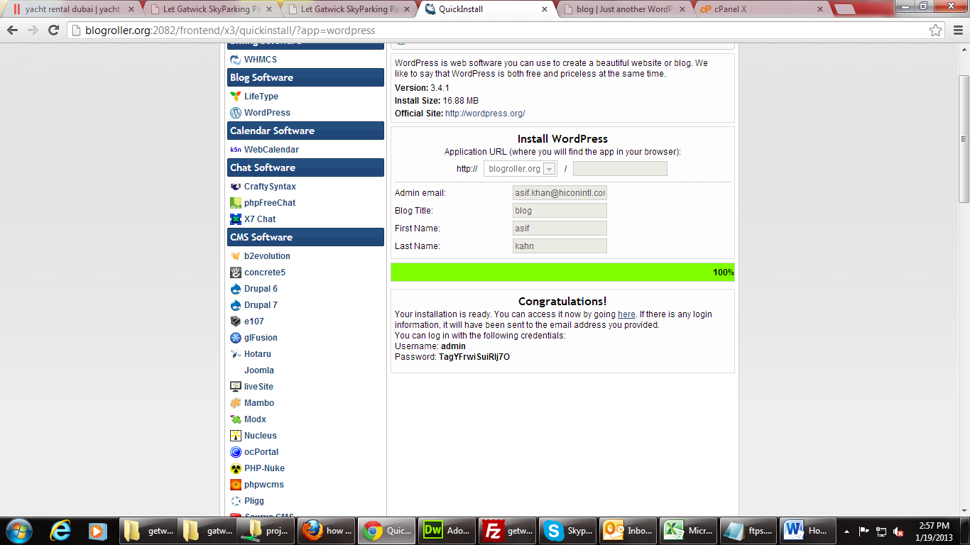
Domain: blogroller.org
Username: admin
Password: TagYFrwiSuiRIj7O

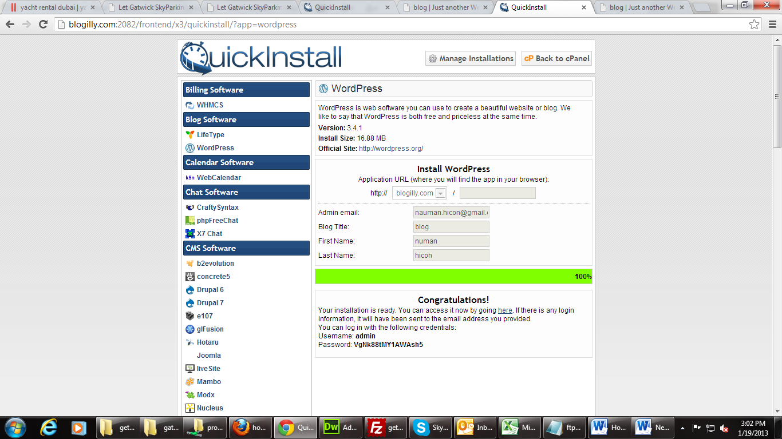
blogilly.com

Username: admin
Password: VgNk88tMY1AWAsh5

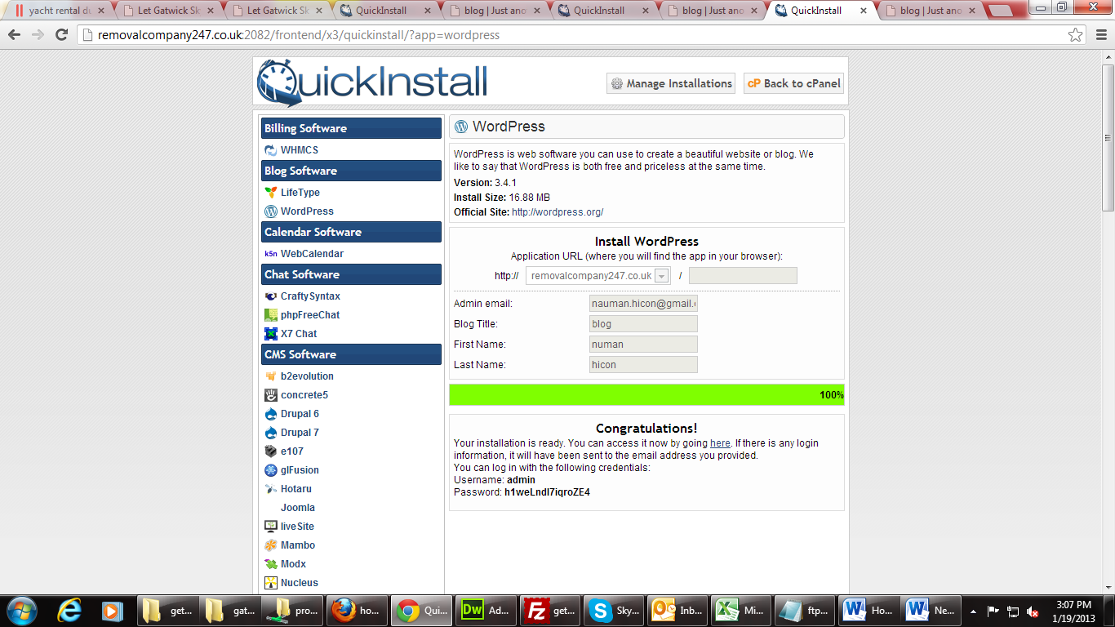
removalcompany247.co.uk

Username: admin
Password: h1weLndl7iqroZE4

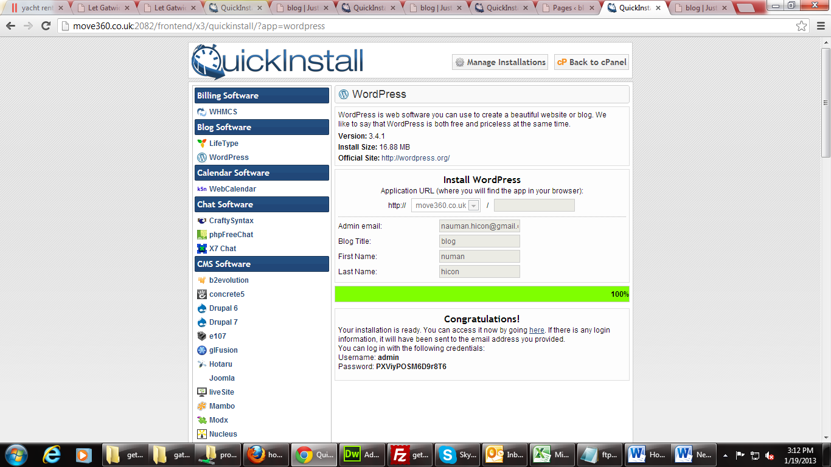
move360.co.uk

Username: admin
Password: PXViyPOSM6D9r8T6

