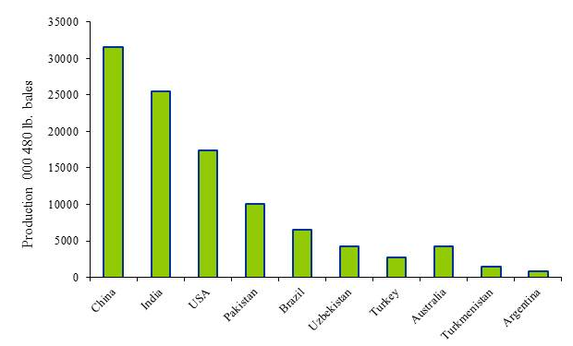
Figure 1: Main cotton growing countries in 2012
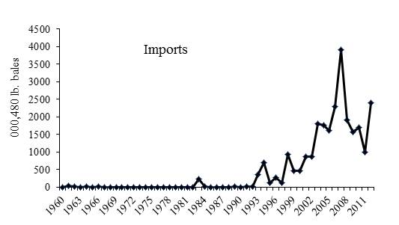
Figure 2: Cotton import trends in Pakistan
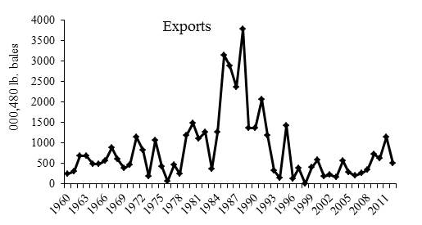
Figure 3: Cotton export trends in Pakistan

