A Scientific approach to the God and the Religion
A Lilliputian Spiritual Stroll with Contemporary Sciences, on an Indic Chemist Slant
Author and affiliation

“I proffer, spirituality is the only co-ordinate bond that can amalgamate Science and Religion, scientifically as well as religiously”
“author”

I had perused a crew of articles in newspapers, on internet, on the motif, “The Religion and the Science,” deliberations, contends on national and international eminence. Why do people concern so much about the debate over science and religion? Does science alone have all the answers? Does religion alone have all the answers? I intrinsically vibes that the virtual motif for deliberation would be, “The God, the Religion and the Science”, because I reckon that there is a conceptual disparity between the Religion and the God. Before clearing the idealistic conceptual disparity, first let us have a confabulation on, What is God ? Who is God ? ……A Self who executes all the cosmos ……..responsible for everything, cogenial or uncongenial in the universe. How a scientist see a God ?…what is the conception of God in his/her mind? Is his/her conception of God is different from a non-scientific person’s conception of God? If yes …whether actually that digression exist or matters …. Does science secure all the vindications ? There are many imperative spheres of human knowledge that are intrinsically impassable to science, so, many queries at this particular moment, but I have to be brief and concise …otherwise publisher will charge for printing…… I envisage so…….taking that on a light note…..
So, a number of queries are there …the cardinal is, how will you define God ?.... and another is, how could you distinguish God and religion idealistically and how would these two ideologies will be on the same wavelength with science, I strive…..
Being a chemist, rather a researcher in chemistry, pursuing my Doctorate in chemistry, I think , imagine, surmise, conceive and also realize a lot about the chemistry of universe, astronomy, nature, laws of nature, natural forces, supernatural forces…..almighty, so called The God. There is a lot to mention, to express, to put into words, to divulge and also to assert…. from my erudition, but, here to be laconic, I will procure only my outlook.
Let us have a glance on, one of the largest surveys of its own kind, the American views on religion and science, commissioned by the AAAS Dialogue on Science, Ethics and Religion (DoSER) project, presented on February 16, 2014 in Chicago, suggests that the scientific and religious communities may be less pugnacious than is commonly portrayed in the politics and in media¹. The pictorial view of the results are

Now my idea about mentioning this survey was, that human race from the significant centuries, from the time of Galileo to Stephen Hawkings, why there is always an idea of biifurcating religion and science?, Why do people care so much to deliberate over science and religion ? why not the idea of consolidate? Consolidation of religion and science is the ultimate truth, biifurcation is a flaw.
Now I will define God although this is my intellectual conceptual definition,”God is the perpetual eternal existence (a satta in Hindi) of whole being, from planets, galaxies, universe, electron, quarks to mystical secrets of life and creation, absolute truth, highest scientific and religious knowledge.
Science says evolution, based on facts and evidences,
Religion says creation, based on faith and beliefs,
But I pronounce “It is the creation by evolution”. GOD, ALMIGHTY, SUPERNATURAL FORCE has fabricated the cosmos very scientifically, in a very systematic disciplined manner, under a protocol and science is trying to understand that protocol. Science is the intellectual aversion to the God. I have read somewhere about the doctrine of personel God especially in the west, I think that personel God is the personel intellectual aversion to the God. I know I am speaking on the most controversial topic of the scientific and religious worlds, but my aim is not to complicate the things, I am just giving my bit, a tiny drop in the ocean.
Science and religion probes God at different scales and levels of understanding, but probe the God only. Science believe it until it doesnot work, Religion work (with Faith) until it doesnot believe. So both are working and believing. There is a famous quote that there are many religions in the world but GOD IS ONE. I will strive to impart a Lilliputian chemistrial exemplary elucidation of the concept…so with the help of science Ideology

Getting personal with chemistry
As a chemist, I know that everything in this universe is ultimately made up of electrons. So the basic elementary particle is same and identical in whole universe but only arrangement differs and so the different matter. Similarly take an example of Milk, Curd and Cheese, milk is in all three substances but all the substances (Curd, Cheese) are not in the milk, On the similar platform, there are many religions, every religion has its own personel God (doctrine of personel God)……. O.K…… Take the example of water ….its three physical forms
◊ Liquid water
◊ Solid Ice
◊ Vapour (Gas)
Now there are different ways to get three different physical forms of water
◊ At normal temperature…not going into the details of chemistry of temperatures, water is liquid
◊ At 0⁰C water is solid ice
◊ At 100⁰C water is vapours (gas form)
Now here water is GOD, all the three forms Liquid water, Ice and Vapours are three different religious Gods and the different routes (Heating, melting, Freezing) are the religions… that is all …..so simple.

From this pictorial presentation, a shalok of Shrimad Bhagwat Geeta is striking in my mind in which Lord Krishna , tells Arjuna that
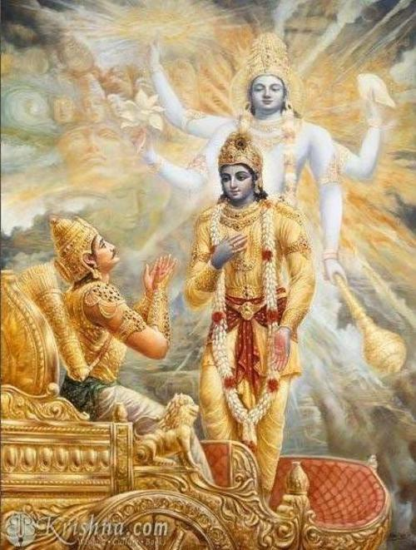

न च मत्स्थानि भूतानि पश्य मे योगमैश्वरम्‌ ।
भूतभृन्न च भूतस्थो ममात्मा भूतभावनः ॥ (Sanskrit Version)
na ca mat-sthani bhutani
paśya me yogam aisvaram
bhuta-bhṛn na ca bhuta-stho
mamatma bhuta-bhavanaḥ (English Version)
Shrimad Bhagwat Geeta (9.5)
And yet everything that is created does not rest in Me. Behold My mystic opulence! Although I am the maintainer of all living entities and although I am everywhere, I am not a part of this cosmic manifestation, for My Self is the very source of creation. (Purport)
So simple to grasp the point, water is in all three form (Liquid, Ice, Vapour) but yet all the forms are not in water……..
Getting personal with mathematics
Now by Profession I am a chemist, but I relish Mathematics. I comprehend the Mathematics as a real science…other sciences are also real, every branch has its own unmatchable significant space, but in the sense that, universe is written in mathematics, nature talks mathematics. Now broadly speaking mathematics is a science of only ten digits 0, 1 ,2, 3, 4, 5, 6, 7, 8, 9.
Now I would say , the digit 0 is the God’s digit. Endeavor to perceive… my point, here I will mention few lines, from Yajurveda, one of the four Vedas, the HINDU Religious Holy Scriptures.
ॐ पूर्णमदः पूर्णमिदम् पूर्णात् पूर्णमुदच्यते |
पूर्णस्य पूर्णमादाय पूर्णमेवावशिष्यते || (Sanskrit Version)
Om poornamadah poornamidam
poornaat poornamudachyate
Om poornamadah poornamidam
poornaat Poornamudachyate (English Version)
Isha Upanishad (Yajurveda)

Om (sound of God), that is complete, from the completeness comes the completeness, If completeness is taken away from completeness, only completeness remains. (Purport)
Now scientifically speaking that implies to the digit 0, 0 is the digit that is complete in itself, it is the only digit from which it is subtracted, its completeness remains that is why I called it, “God’s digit.”.

0-0 =0 | 0+0=0 | 0×0=0 | 0÷0=Indefinite

The concept of nothingness, emptiness, vaccum are the physical significance of digit ‘0’ or can be mathematically written as 0 i.e. A+0=A. On religious grounds, the great Albert Einstein was highly impressed by Buddhism. Buddhism talks about “Sunyata” concept (Sanskrit noun from the adj. sunya or shunya: "zero, nothing") is usually translated as "emptiness". .
Religion says “God is infinite”. Science itself has the term “infinity”(∞).
From classical Newton mechanics to modern Quantum mechanics all calculations involve “Zero” and/or “Infinity” and religion talks about these concepts thousands years ago, so where is the bifurcating paths of science and religion, they both meet or overlap somewhere and/or everywhere. My point is, that all the digits, infinity (∞), words, concepts, great inventions exist already in the universe and the same idea, religion says. When you put your mind to the ideas, facts, evidences of science you are not making them...they already exist and you are just searching them in a new unique way, you understand its function from your own point of view that is why I think in science it is called “Re-search”.
On the similar grounds, if we outlook the medical vista , the human body the most complex and fantastic scientific work of GOD, a human brain, millions of occults hidden, yet to perceive utterly. At present when I am writing this article, I am under treatment of Segmental Enteritis, recovering at home, the idea of this article clicks in my mind when I was in hospital and after four, five days of severe condition, I got steady, doctor came for routine visit, I asked him that will I get completely restorative soon, he said remarkable words ”Doctor only cares, God cures”. Scientifically he said that we just help the human body system, it heals itself. (God protocol heals it). We can have so many examples which interconnect the God, the Religion, and the Science. So, Where is the difference ? I never understand……
Getting personnel with Physics
I am not an expert in physics, but I can define it as, “Physics is the research to fathom the physical laws of universe. I am a freak fan of force of gravity, gravitational force, it is such an phenomenal, bizarre and weird force which holds the universe as it is. Albert Einstein's theory of general relativity tells us that gravity is a curve in the fourth dimension of space and time -- and there's proof to back him up (Not going into details here)…… means gravity is such a grotesque which can wrap/bend the light, space and even time…On religious edge what a thought provoking idea. Religion says there are number of universes exist, written in holy scriptures thousands years ago. Astronomy says there are millions of galaxies…..So both are telling same idea but in different language.
When I was a child , I remembered a TV program on Einstein in which different scientists were giving their opinions on Einstein and one of them, I don’t remember the name, said that “Einstein was so genius that he knows the mind of God” So this is the point that always strikes my mind that no one is nearer and dearer to God than scientists. The more you study science, the more you come closer to God. According to me science is the study of God and Scientists are near and dear to God, same as religious people, because both are doing the same work but with different routes and as Swami Vivekanad say “Truth can be stated in a thousand different ways, yet each one can be true”.
‘So the day the religious people and scientists will/would come together on the same platform, to work together whole heartedly, that very much day we will get a unified theory, for Universe and God’. Science and religion can help each other, can hybridise to understand the cosmos, the God and here comes the concept of spirituality.
Spirituality is the perfect, optimised combination/overlap of science and religion that definitely leads/understands/interprets the God, Cosmos….any name you want to give… Spirituality is the hybridisation of science and religion, chemists/science people know that hybridization always give optimised results …i.e. The Truth nothing less nothing more…..that is why I quoted….“Spirituality is the only co-ordinate bond that can amalgamate Science and Religion, scientifically as well as religiously”.

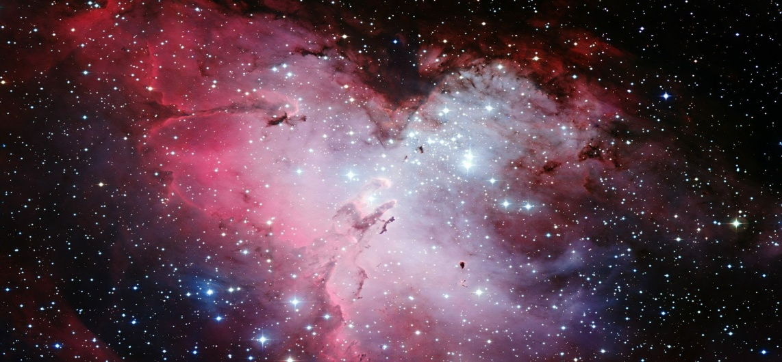
GOD/COSMOS/SUPERNATURAL FORCE
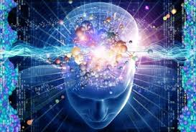
SPIRITUALITY
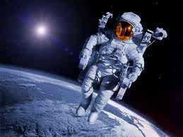
SCIENCE RELIGION

On the concluding part of the article
I say “ Science and Religion are the two names of God, one is nick name and other is official name, which is which, depends upon the individual visitor”.

As I had talked about a very sensitive topic, I had just put my point nothing else. These are the thoughts, questions, wisdom, science, spirituality to be discussed, debated with the people of intellect, those deserve to be the part of debate as said by Charles Darwin, the exemplar of scientific spirit “I feel the whole subject is too profound for human intellect”, and at once wrote that ‘A dog might as well speculate on the mind of Newton. Let each man believe and hope what he can” and is well written in the 18th chapter of Great Hindu Scripture Shrimad Bhagwad-Gita….. clearing the illusion
इदं ते नातपस्काय नाभक्ताय कदाचन ।
न चाशुश्रूषवे वाच्यं न च मां योऽभ्यसूयति ॥ (Sanskrit Version)

idam te naatapskaaya naaabhaktaaya kadaachana |
na chaashushrooshave vaachyam na cha maam yobhyasooyati II (English Version)
This confidential knowledge may never be explained to those who are not austere, one without penance, one who is not a devotee , one without service nor to one who is envious of Me (God).(Purport)

Reference.
1. http://www.aaas.org/news

