Figure 1

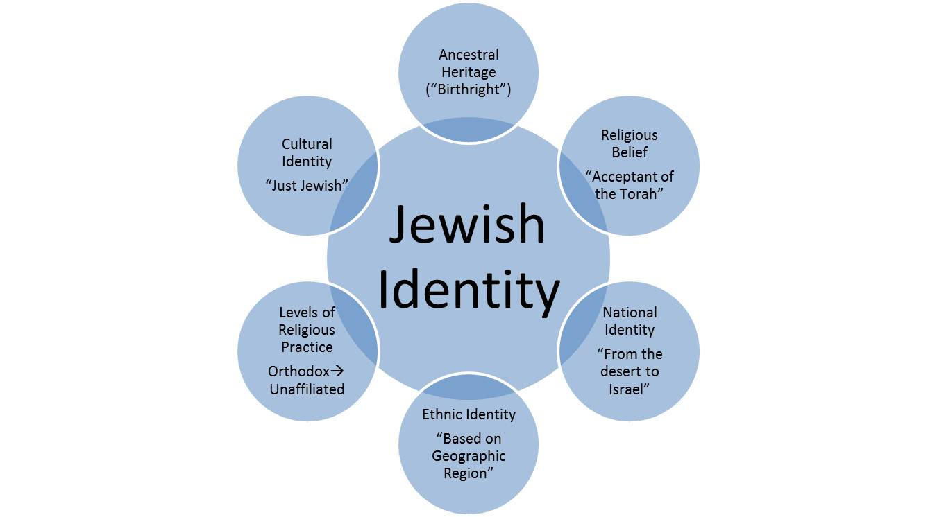

Figure 2
Years | Time Period | Jewish Identity Characteristic
3761-2705 BCE | 10 Generations from Adam to the Birth of Noah | Pre-Judaism
2705-1815 BCE | 10 Generations from Noah to Abraham | Pre-Judaism
1815-1522 BCE | Forefathers and Foremothers | Ancestral Heritage
1522-1312 BCE | Descent to Egypt
1312 BCE | Acceptance of the Torah | Establishment of Judaism as a Formal Religion
1312-1272 BCE | Exodus from Egypt
1272-930 BCE | From the Entry into the land of Israel until the First Temple Era | National Identity
930 BCE-586 BCE | First Temple Era
516 BCE- 70 CE | Second Temple Era
10-220 CE | Tannaim
220-500s CE | Amoraim
500s-700s CE | Savoraim
700-1038 CE | Gaonim
1038-1500s | Rishonim | Ethnic Identity
1500s-Present | Acharonim | Religious Practice
1800s | Reform Movement
1920s | Conservative Movement
2000s | Modern Era | Cultural Identity

