Fig.1. HDAC6 centrality to biological functions,e.g Viral recognition,Immune synapse modification etc.

Fig.2. Homology between yeast Hda1 and human HDAC6

Fig.3. HDAC6 functional domain
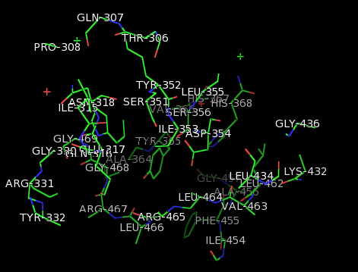
Fig.4. The amino acid residue of the mologous regions and the active sites of HDAC6.

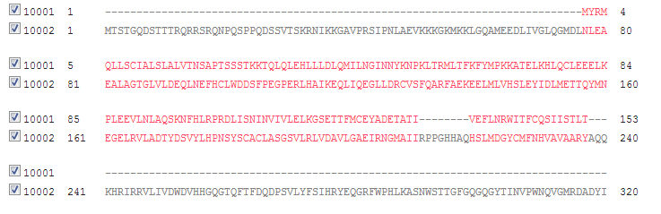
Fig.5. Multi protein alignment of HDAC6 and IL-6 using CLUTALWO.
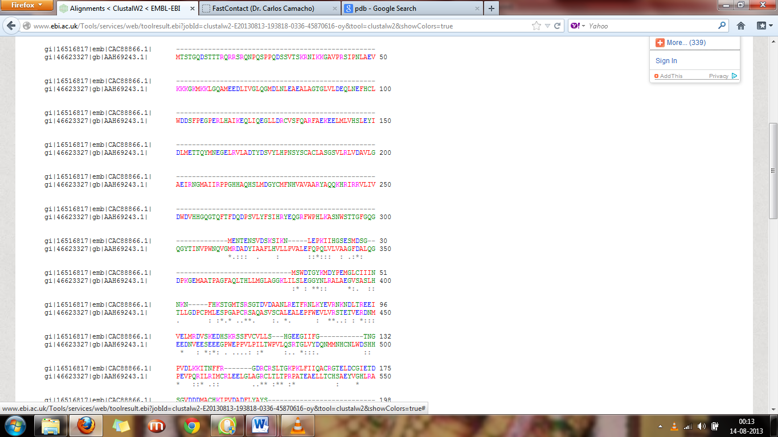

Fig.6. CLUSTALWO between HDAC-6 and Caspase 3.

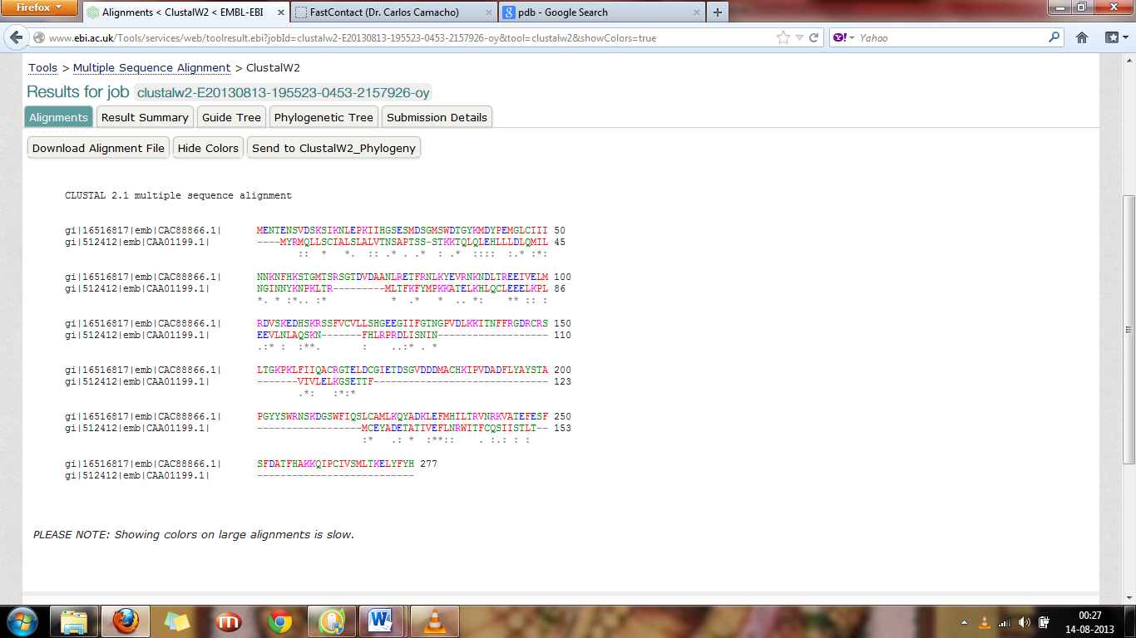
Fig.7. CLUSTALWO between IL-6 and Caspase 3.

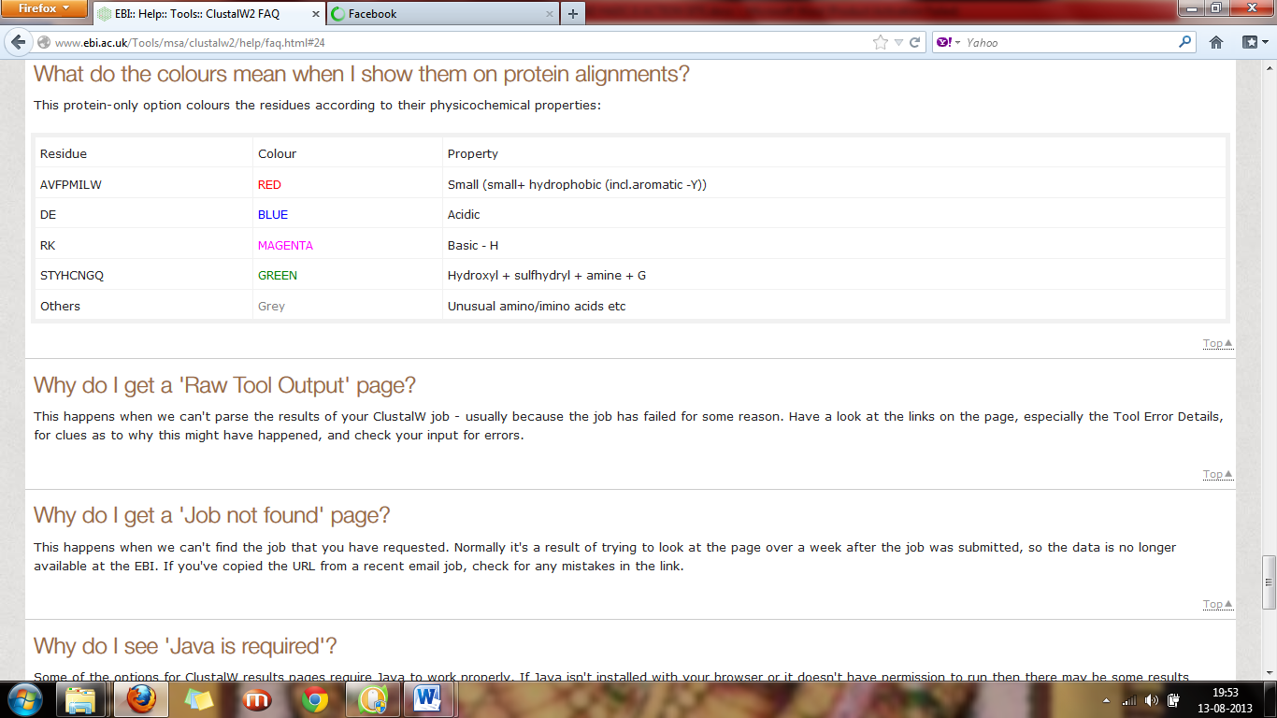
Fig.8. Color code used in the CLUTALWO
Fig.9. Sequence comparison of different tubulin and HADC 6 action site.
Fig. 10.Cascade of events post Viral infection at the cytosol- nucleus interface and in the cytosolic periphery.

Fig. 11.Cascade of events post Viral infection inside the nucleus and production of IFNγ.

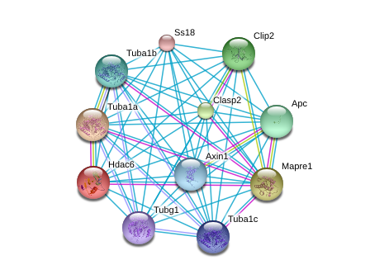
Fig.12. Interaction of HDAC6 with other putative proteins in stressed condition using Protoinfo.

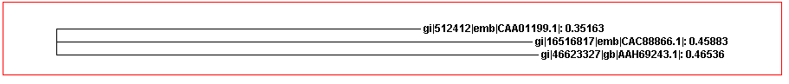
Fig.13. Phylogenetic relation betweenIL-6 , HDAC6and caspase3 in chronological order.

