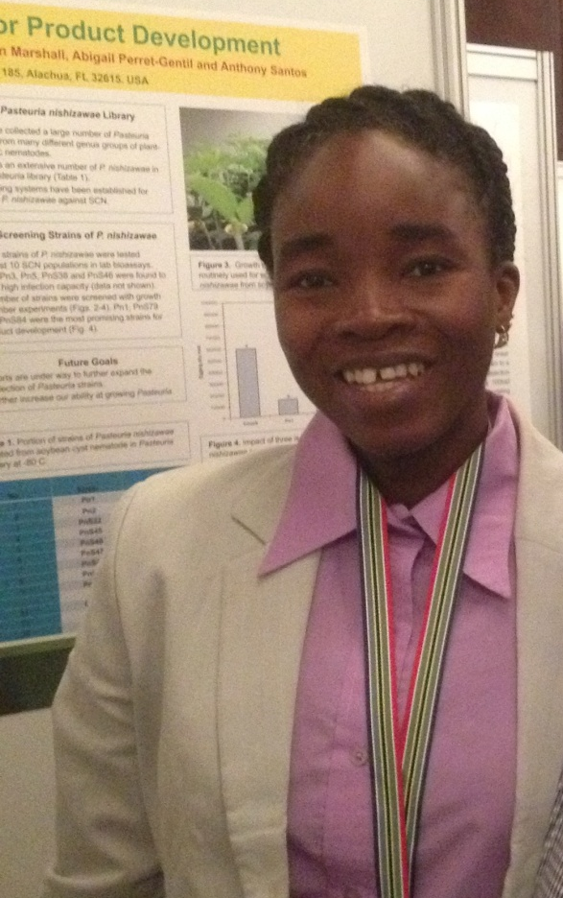
Dr. (Mrs) Fabiyi, Oluwatoyin Adenike
Nematologist/Toxicologist

