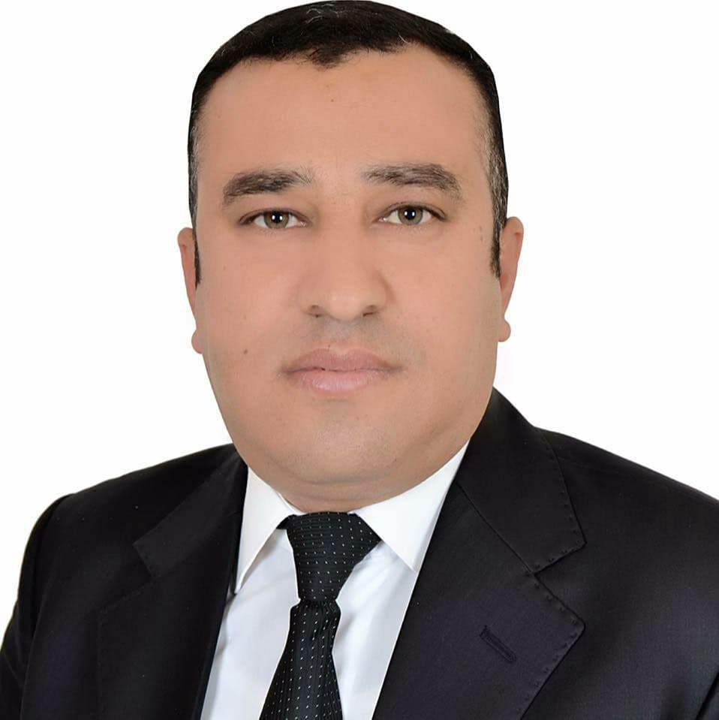ة



Basic Information
 |  |  | Ibrahim Omar Saeed Malgo Al-Hamdany | Full Name
 |  |  | Professor | Academic Rank
 |  |  | Biology/ Ecology | Field (General)
 |  |  | Plant Ecology | Field (Specialization)
 |  |  | Dr.ibrahim1977@tu.edu.iq | Email
 |  |  | Science | College

Research Interest
Ecology and pollution
Biodiversity
Plant Ecology
Conservation Ecosystem
Phytoremediation
Wastewater Treatment
Bioaccumulation of Heavy Metals
Heavy Metal Pollution
Community Ecology
Natural Resource
Management Plant
Biodiversity
Water Quality
Fresh water
Tap water

Work Experience
1- He worked for 6 years in the examination committee and many committees at the department, college and university levels
2- Associate Dean for Scientific Affairs and Postgraduate Studies of the College of Science from 2014 to 8 of 2017 years
3- Editor-in-chief and scientific evaluator - Editor-in-chief and scientific evaluator in the Arab Journal for Science and publication of research in Gaza in Palestine.
4- Editor-in-chief of Al-Alutroha Journal for Environmental Sciences
5- Member of the editorial board of the Swedish magazine Lund Sustainable Resources Management Journal (ISSN 2002-6145)
6-A member of local and international scientific societies.

Links of Academic webpages
Google Scholar | Research Gate | Orcid | Publons | Scopus
https://2u.pw/Kfnlw | https://2u.pw/Ibrahim-Omar-Saeed | https://2u.pw/buZJo | https://2u.pw/dM8Mg | https://2u.pw/VwqhV
Link | Link | Link | Link | Link

